Selection activity

### Task 1: Predict

With your partner, take some time to read the code below. Predict what you think will happen. This is not a test so don’t worry about your prediction being correct.

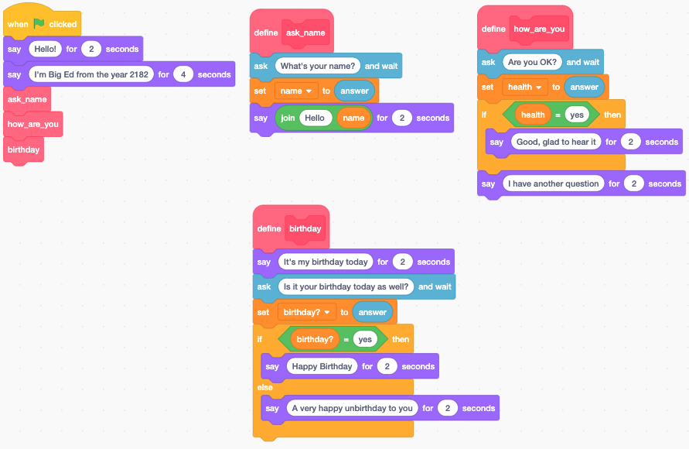

What do you predict will happen when the green flag is clicked? Be as precise as you can (discuss **exactly** what you think will happen).

Open the following Scratch program and select **See inside** — [ncce.io/biged2](https://ncce.io/biged2)

| **Questions** | **Your answers** ▿ |
| --- | --- |
| Now run the code.   * Were your predictions correct? |  |
| * Did anything surprise you about what happened when the code was executed? |  |
| * Did you miss anything out? |  |

### Task 2: Investigate

Answer the following questions with your partner by experimenting with the code in order to investigate how it works.

| **Questions** | **Your answers** ▿ |
| --- | --- |
| What is the purpose of the following three blocks of code? |  |
| Explain what the following block of code does: |  |
| What happens if you say “No” when asked “Are you OK?” |  |
| What happens if you say “No” when asked if it is your birthday?  What happens if you say “Yes” when asked if it’s your birthday? |  |
| What is the difference between the following two blocks of code:  Block 1:    Block 2: |  |
| From which menu on the left-hand side of the screen would you find the **If** blocks? |  |
| From which menu on the left-hand side of the screen would you find the following blocks? |  |

### Task 3: Modify

### 3.1 The Big Ed ‘Easter egg’

| **Questions** | **Your answers/screenshot of your modification** ▿ |
| --- | --- |
| An Easter egg in a computer program is extra (hidden) functionality.  Add an Easter egg to the ‘ask_name’ subroutine that responds with the following, only if the user says their name is “Ed”. |  |

### 3.2 What if I’m not OK?

| **Questions** | **Your answers/screenshot of your modification** ▿ |
| --- | --- |
| Change the ‘how_are_you’ subroutine so that if the user says “no” to the question “Are you OK?” then it responds with the following:    **Note:** Your program should still say “Good, glad to hear it”, if the user says “Yes”. |  |

### 3.3 The Big Ed ‘Easter egg’ part 2

| **Questions** | **Your answers/screenshot of your modification** ▿ |
| --- | --- |
| Modify the code that you have just added so that it will say the same message if the user says their name is either “Ed” or “Big Ed”. |  |

Resources are updated regularly — the latest version is available at: [ncce.io/tcc](http://ncce.io/tcc).

This resource is licensed under the Open Government Licence, version 3. For more information on this licence, see [ncce.io/ogl](http://ncce.io/ogl).