Name: Class: Mark:

# The first sound pattern below has been recorded three times using different digital sampling settings.

**Recording A**

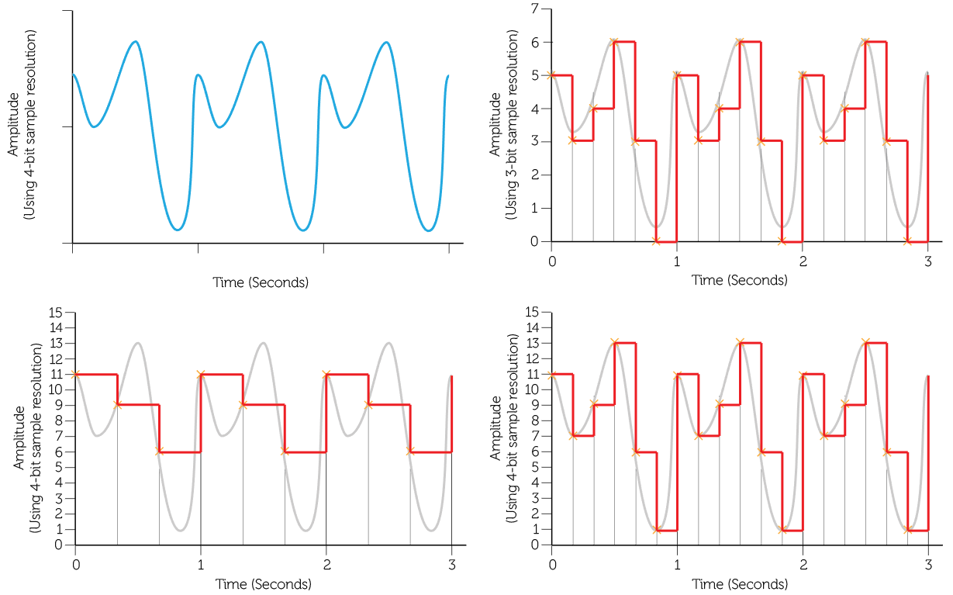

**Recording C**

**Recording B**

Calculate the file size of the each of the recordings A to C: (Show your workings) [6]

A: _____________________________________________________________________

B: _____________________________________________________________________

C: _____________________________________________________________________

# Which of the recordings above will be of the highest quality? [1]

# State one device that is used to capture an analogue sound signal. [1]

# The length of a recording will heavily influence the size of the sound file. State two factors other than recording length that determine the file size of a recording. [2]

# A portable sound recorder is used to record an interview. The recorder uses the following settings:

# Frequency: 20 kHz

# Resolution: 20 bits

# Time: 1 minute 40 seconds

# Calculate the file size of the interview in megabytes. [5]

[Total 15 marks]