**FINDING OUT ABOUT YOURSELF**

One of the best ways in which we can get to know ourselves is to ask questions and make honest replies. Try to answer these questions as honestly as you can.

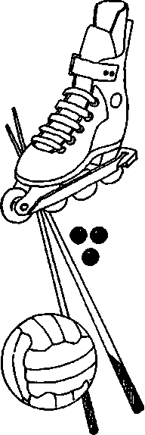

**Likes and Dislikes**

**What are your favourite foods?**

**Which sports do you most enjoy playing?**

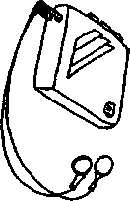

**What clothes do you most like ?**

**Which TV programme do you most enjoy watching?**

Of course, what you dislike is just as important as what you like.



**What are your least favourite foods?**



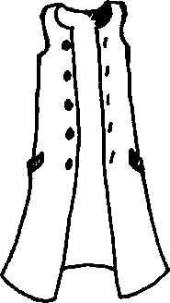

**Which TV programmes do you least enjoy?**



**Which sports do you least enjoy?**



**What clothes do you dislike wearing?**



It is always a good idea to know why we like or dislike things. Fill in the following boxes:

**At School**

**What are your favourite subjects? What do you like about them?**

**What are your least favourite subjects?**

**What do you dislike about them?**

**Outside School**

**List what you like doing.** Can you give any reasons?

**­­­­­­­­­­­­­­­­­­­­________________________________________________________________________________________________________________________________________________________________________________________________________________________________________________________________________________________________________________________________________________________________________________________________________________________________________________________________________________________________________________________________________________________________________________________________________________________________________________________________________________________________________________________________________________________________________________________________________________________________________________________________________________________________________________________________________________________________________________________________________________________________________________________________________________________________________________________________________________________________________________________________________________________________________________________________________________________________________________________________________________________________________________________________________________________________________________________________________________________________________________________________________________________________________________________________________________________________________________________________________________________________________________________________________________________________________________________________________________________________________________________________________________________________________________________________________________________________________________________________________________________________________________**

**Skills and Talents**

We are better at doing some things rather than others. List some things that you are good at doing.

**In School**

**Outside School**

Now list some things you would like to be able to do better and say why.

**In School Outside School**

**Personal Qualities**

What we do is influenced by the kind of person we are. How would you describe yourself? Tick where appropriate.

*At School*

**Always**

**Usually**

**Sometimes**

**Rarely**

**Helpful________________________________________________________________________**

**Cheerful_________________________________________________________________________**

**Polite_________________________________________________________________________**

**Honest_______________________________________________________________________**

**Hard-working____________________________________________________________________**

**Tidy______________________________________________________________________________**

**Argumentative_________________________________________________________________**

**Friendly________________________________________________________________________**

**Sensible______________________________________________________________________**

**Adaptable_____________________________________________________________________**

**Shy_____________________________________________________________________**

**Confident______________________________________________________________________**

**Tactful____________________________________________________________________________**

**Reliable_______________________________________________________________________**

**Considerate___________________________________________________________________**

**Patient_________________________________________________________________________**

**Trustworthy_______________________________________________________________________**

**Cheeky_________________________________________________________________________**

**Calm______________________________________________________________________________**

**Sociable______________________________________________________________________**

**Caring_____________________________________________________________________________**

**Witty_______________________________________________________________________________**

**Responsible___________________________________________________________________**

**Quiet__________________________________________________________________________**

**Lazy______________________________________________________________________________**

**Sympathetic_____________________________________________________________________**

**Organised_______________________________________________________________________**

**Punctual_________________________________________________________________________**

**Sensitive_______________________________________________________________________**

**Enthusiastic**____________________________________________________________________

*Outside School*

**Always**

**Usually**

**Sometimes**

**Rarely**

**Helpful _________________________________________________________________________**

**Cheerful__________________________________________________________________________**

**Polite_________________________________________________________________________**

**Honest________________________________________________________________________**

**Hard-working_____________________________________________________________________**

**Tidy____________________________________________________________________________**

**Argumentative___________________________________________________________________**

**Friendly_________________________________________________________________________**

**Sensible______________________________________________________________________**

**Adaptable______________________________________________________________________**

**Shy_____________________________________________________________________**

**Confident______________________________________________________________________**

**Tactful____________________________________________________________________________**

**Reliable______________________________________________________________________**

**Considerate___________________________________________________________________**

**Patient_________________________________________________________________________**

**Trustworthy_______________________________________________________________________**

**Cheeky_________________________________________________________________________**

**Calm_____________________________________________________________________________**

**Sociable______________________________________________________________________**

**Caring____________________________________________________________________________**

**Witty_____________________________________________________________________________**

**Responsible___________________________________________________________________**

**Quiet__________________________________________________________________________**

**Lazy_____________________________________________________________________________**

**Sympathetic_____________________________________________________________________**

**Organised_______________________________________________________________________**

**Punctual_________________________________________________________________________**

**Sensitive______________________________________________________________________**

**Enthusiastic____________________________________________________________________**

**Use this space below to add any other qualities that you think you have:________________________________________________________________________________________________________________________________________________________________________________________________________________________________________**

**Possibilities for change**

**I liked listening to**

**My favourite TV programmes were**

**In my spare time I liked to**

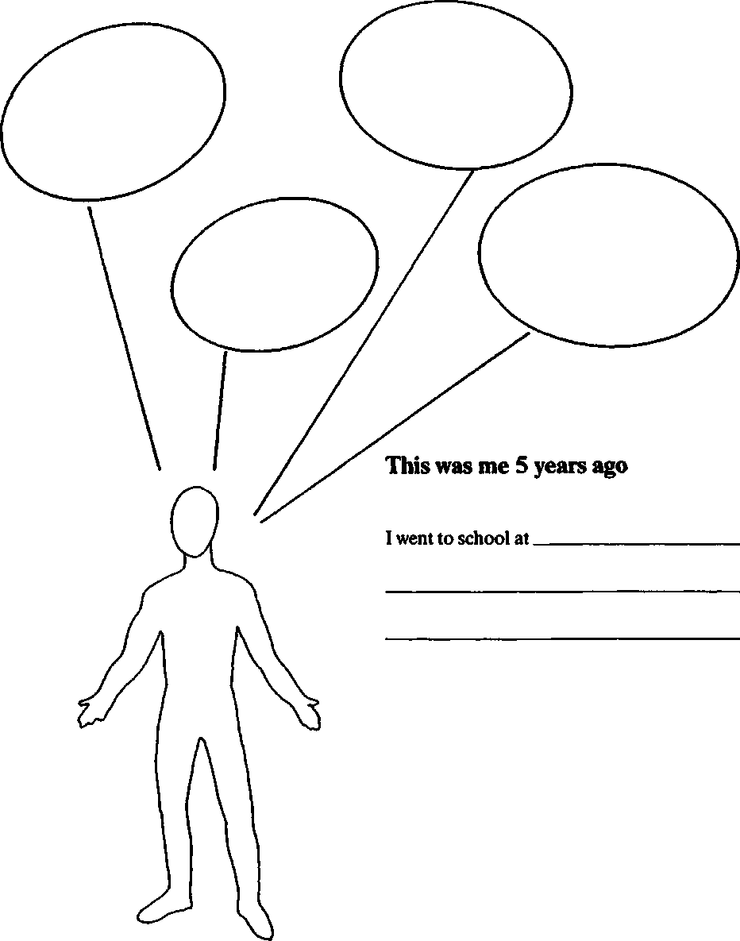

**Possibilities for Change**

**Where might I be?**

**What might I be doing?**

**This may be me in 5 years time**

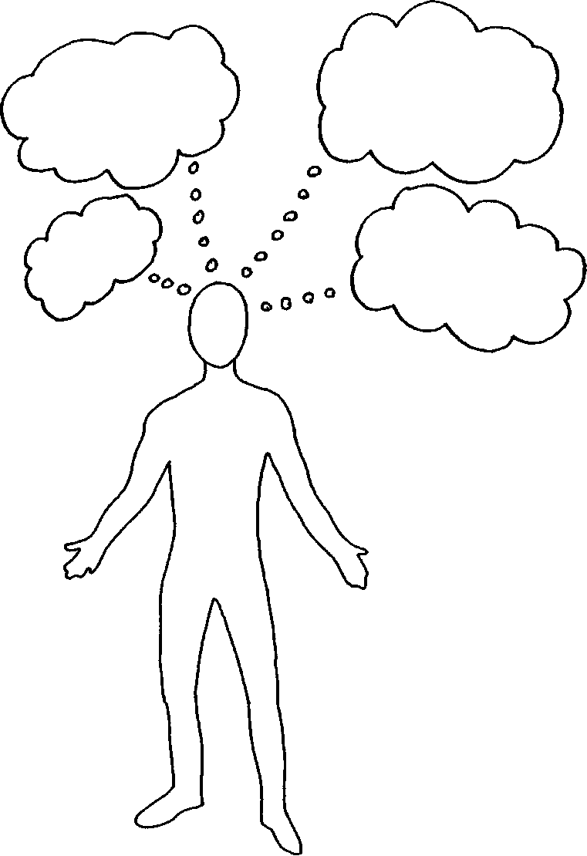**What responsibilities might I have?**

**What ambitions might I have?**

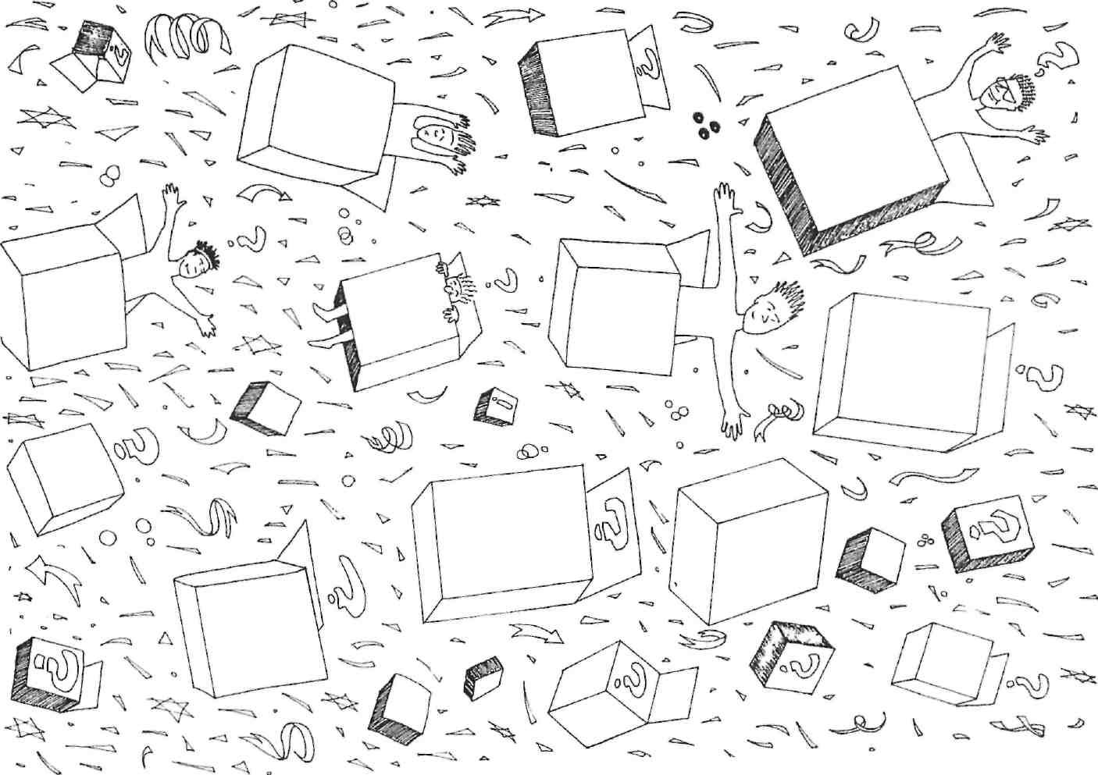

o 0>

**A Winning Combination**

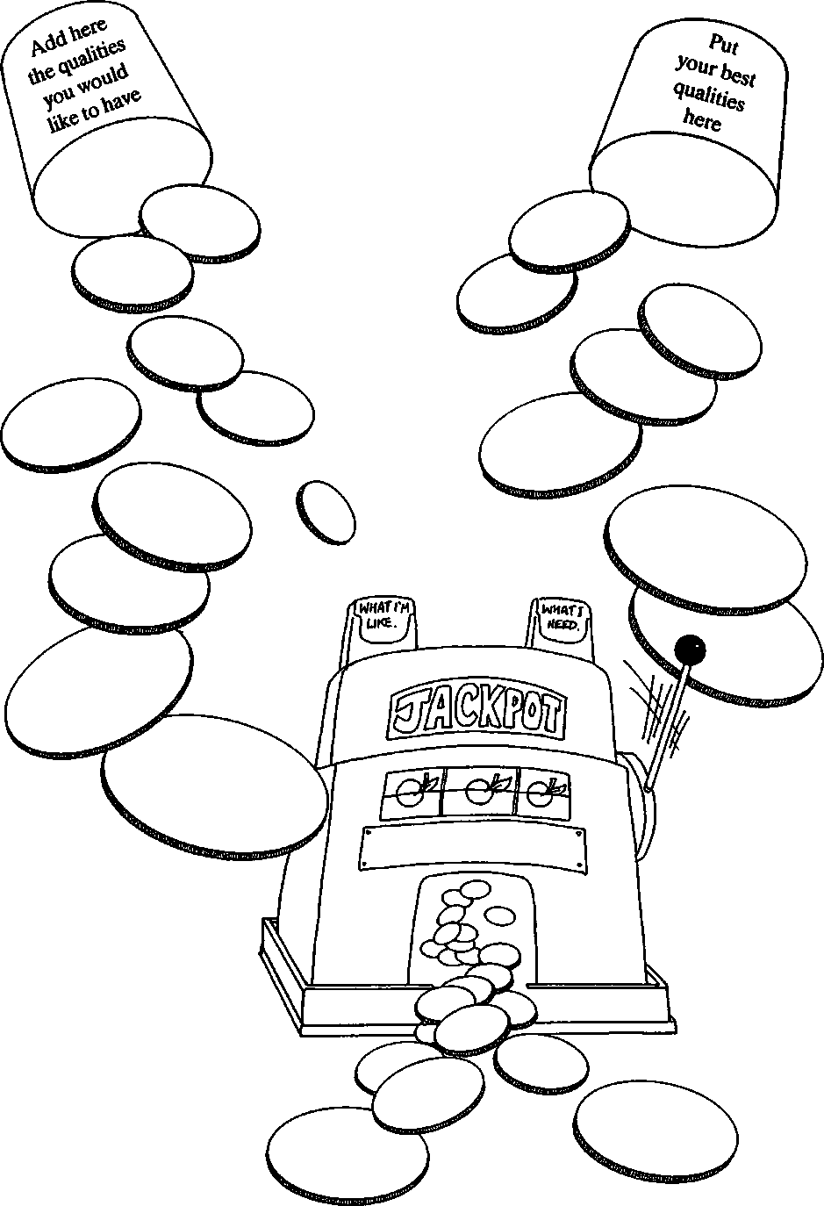

**Action Planning**