Name: Class: Mark:

1. Pupils at a secondary school were asked in a survey to tick whether they like cycling, swimming or running. The survey allows the pupils to tick more than one of these sports.

Shade the areas of the Venn diagram below that represent pupils who like:  
**Running OR Swimming but NOT Cycling**: [3]

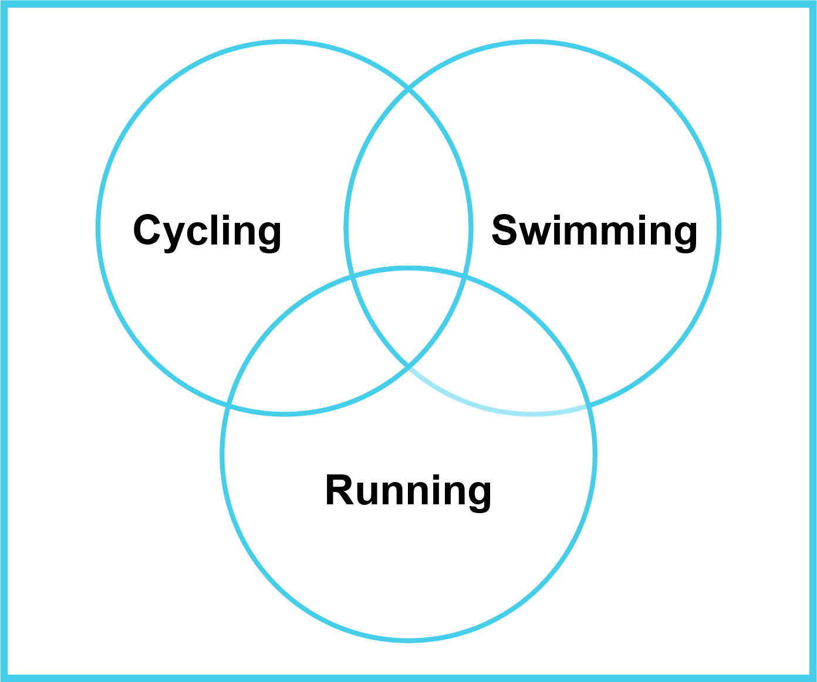

2. Use the following statements to solve the puzzle of which athletes have won the gold, silver and bronze medals: [3]

* Grace did not win the bronze
* Lucas did not win the silver
* Manisha did not win the gold
* Grace did better than Lucas

|  |  |  |
| --- | --- | --- |
| **Gold** | **Silver** | **Bronze** |
|  |  |  |

3. A giraffe has the following features:

* A giraffe has a long neck AND long legs AND patches on its coat (fur)
* A giraffe may live in the wild OR a zoo

Look at the three photos below. Use logic to make deductions about whether a photo shows a giraffe or not. The first photo is given as an example. [6]

|  |  |
| --- | --- |
| **Is this a giraffe?** | **Deduction** |
|  | It does NOT have a long neck  It has long legs  It does NOT have patches on its coat  To be a giraffe, all three of these must be True  Therefore, it is NOT a giraffe |
|  |  |
|  |  |

[Total 12 marks]