# Worksheet 6 Client server model

**Task 1**

1. For the following client server models, think of three scenarios and complete
   1. the client software making the request,
   2. the request that is being made, and
   3. the data response provided by the server.

The first has been completed for you.

|  |  |  |
| --- | --- | --- |
| C:\Users\Rob\AppData\Roaming\PixelMetrics\CaptureWiz\Temp\48.png | **Software:** | Operating system |
| **Request:** | Access to file |
| **Response:** | Requested file |

|  |  |  |
| --- | --- | --- |
| C:\Users\Rob\AppData\Roaming\PixelMetrics\CaptureWiz\Temp\48.png | **Software:** |  |
| **Request:** |  |
| **Response:** |  |
| C:\Users\Rob\AppData\Roaming\PixelMetrics\CaptureWiz\Temp\48.png | **Software:** |  |
| **Request:** |  |
| **Response:** |  |
| C:\Users\Rob\AppData\Roaming\PixelMetrics\CaptureWiz\Temp\48.png | **Software:** |  |
| **Request:** |  |
| **Response:** |  |

1. A web developer is creating several web applications using free services available on the Internet. For the following Web API functions suggest how each app may make use of the service:

|  |  |  |  |
| --- | --- | --- | --- |
| **Web app** | **Web service** | **API function** | **Use in app** |
| Tourist trail | Map service | Return geographical coordinates of item of interest |  |
| Social media summariser | Social media site |  | The app could receive updates for a given user to display popular posts. |
| Video editor | Online video service | Post video to user’s account |  |
| Weather app |  |  |  |

**Task 2**

A RESTful web application has been developed to interface with an online clothes shopping website. Label the web page below identify and describe where HTTP methods PUT, GET, POST and DELETE could be used to interact with the database.

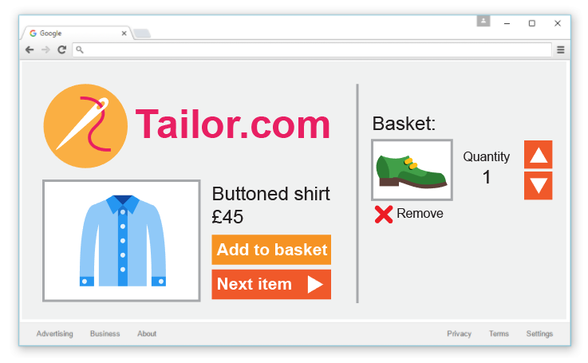

**Task 3**

A lead developer wants to use XML to handle data in a web application a company is developing. A junior developer thinks JSON would be a more appropriate alternative.   
  
Write an email to the lead developer explaining why JSON might be a better choice.