Debugging

The program below asks the user which times table they would like to know. The Scratch cat program should then say the times table for them. Unfortunately, this program doesn’t output the correct data.

Run the program for yourself.

The program can be found here: [times table program](https://ncce.io/TimesTableDebugging) (ncce.io/TimesTableDebugging)

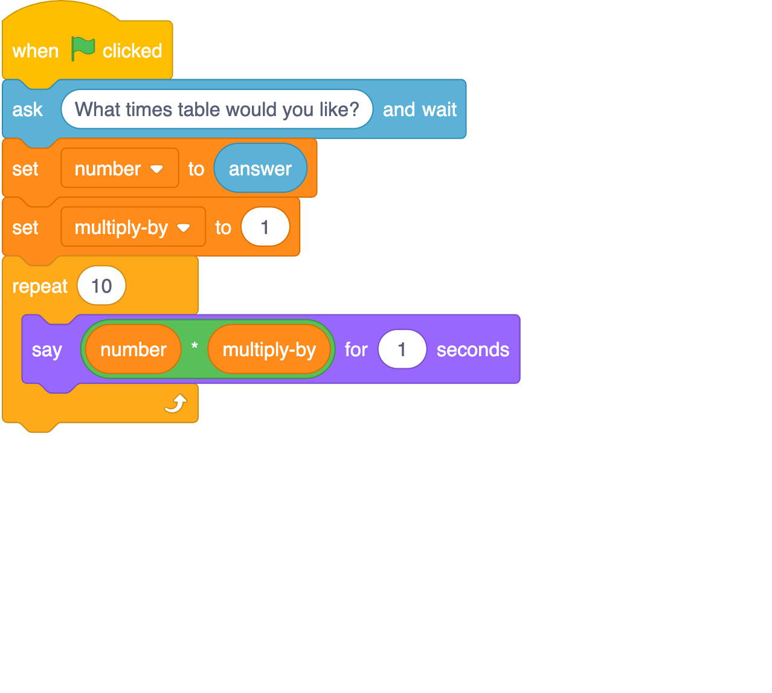

|  |  |
| --- | --- |
| **Questions** | **Your answers** ▿ |
| * Describe what happens when you run the program. |  |

### 

One technique you can use to help you debug code is to add lines of code that show the variables that may play a part in the bug.

Add two lines of code that ‘say’ the value of your variables each time the program iterates. It should now look like the following:

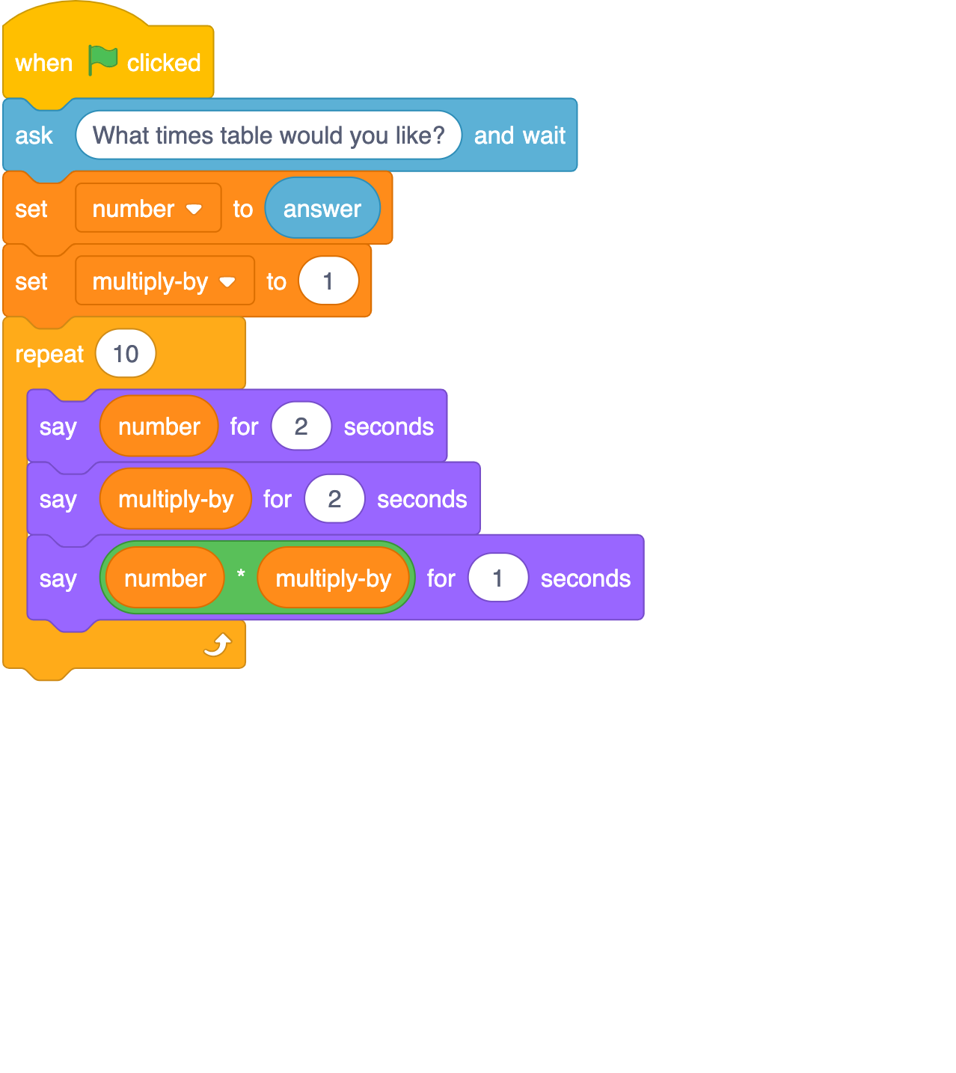

For this exercise, assume that when asked ‘What times table would you like?’ a number ‘2’ was entered. Note the values of the two variables and the final output just for the first four iterations.

|  |  |  |  |
| --- | --- | --- | --- |
| **Iteration** | **Value of:** | **Value of** | **Output** |
| 1 |  |  |  |
| 2 |  |  |  |
| 3 |  |  |  |
| 4 |  |  |  |

**Program code here to test out the theory.**

|  |  |
| --- | --- |
| **Questions** | **Your answers** ▿ |
| * What did you discover was the bug/error with the program? |  |
| * Can you recommend a way of fixing this bug? |  |

### 

### Explorer tasks

1. Remove the two print lines from the code
2. Fix the bug so that you have a working program

Resources are updated regularly — the latest version is available at: [ncce.io/tcc](http://ncce.io/tcc).

This resource is licensed under the Open Government Licence, version 3. For more information on this licence, see [ncce.io/ogl](http://ncce.io/ogl).