Name: Class:

Task 1

Facial recognition uses measurements taken between key points on the image of a face. These can be turned into ratios. For example, the distance between the pupils of the eyes (blue line) divided by the width of the nose (red line).

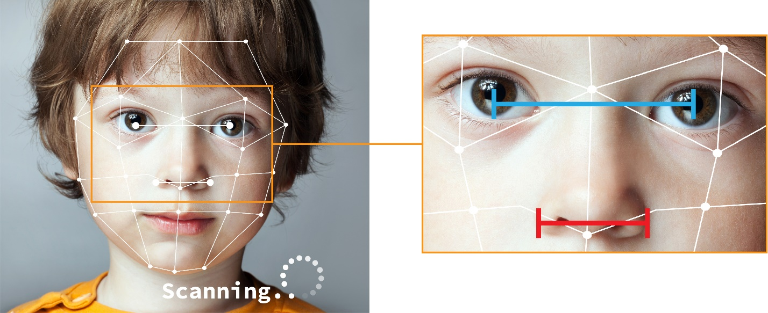

The following three faces have had their measurements taken by a computer.

(a) Calculate the ratio of eye distance to nose width for each of the faces.

|  |  |  |  |
| --- | --- | --- | --- |
|  |  |  |  |
| **Person** | A | B | C |
| **Eye distance** | 85 | 96 | 133 |
| **Nose width** | 50 | 69 | 80 |
| **Ratio** |  |  |  |

The following image has come into a police database.

|  |  |
| --- | --- |
|  | Eye distance: 79  Nose width: 49 |

(b) Calculate the ratio for this image.

(c) Which face would this image be matched too?

(d) How could the accuracy of the facial recognition be improved?

(e) There are currently more than 10 million crimes committed every year. A new facial recognition system says that it is 99.9% effective. The system will be used for detecting criminals and the company selling the system is pleased with its effectiveness.

Explain why there would be an ethical problem with using just this evidence to show someone had committed a crime.

(f) Discuss with a partner the ethical issues of using facial recognition. Make notes below.

Task 2

Developers of programs need to carefully consider the effects that they may have. Naturally, computer systems must always try to carry out the least harm possible. Sometimes, computers may have to make difficult ethical decisions. The following task asks you to consider some difficult ethical dilemmas. Of course, the best solution is to create a program that avoids these dilemmas in the first place.

(a) Visit the Moral Machine at: <https://www.moralmachine.net/>

Click the ‘Start Judging’ button to go through the scenarios.

(b) What ethical results did you find from your choices?

Task 3

Write down a job that currently exists and is done by a human but may in the future become automated.

Job:

Discuss with a partner why you think this job will be automated in the future. Make notes of your reasons below.

Task 4

AI builds its intelligence from training data. It is possible that this can create biases against people due to reasons such as their age or a disability.

(a) Perform **three** image searches in a search engine and complete the table below.

|  |  |  |  |
| --- | --- | --- | --- |
|  | **Image search for ‘woman’** | **Image search for ‘man’** | **Image search for ‘person’** |
| For the top 100 results, how many people with physical disabilities (such as a wheelchair) are shown? |  |  |  |
| What is the typical age of the people shown? |  |  |  |

In the UK, there are currently 1.2 million wheelchair users. The UK population is 66.8 million. This means that wheelchair users make up 1.7% of the population.

People over 60 make up over 30% of the UK population.

(b) What biases, if any, do you feel that the image results have against people with physical disabilities or older people?

(c) Discuss with a partner how you think the biases have occurred.

(d) Discuss with a partner whether you think it would be right to alter the image search algorithms to display older people or more people with disabilities.

**Sources:**

<https://www.england.nhs.uk/wheelchair-services/>

<https://www.ons.gov.uk/peoplepopulationandcommunity/populationandmigration/populationestimates>

<https://www.ons.gov.uk/peoplepopulationandcommunity/birthsdeathsandmarriages/ageing/articles/livinglongerhowourpopulationischangingandwhyitmatters/2018-08-13>