**Homework 1: Basics**

1. Here is a screenshot of part of a new spreadsheet.

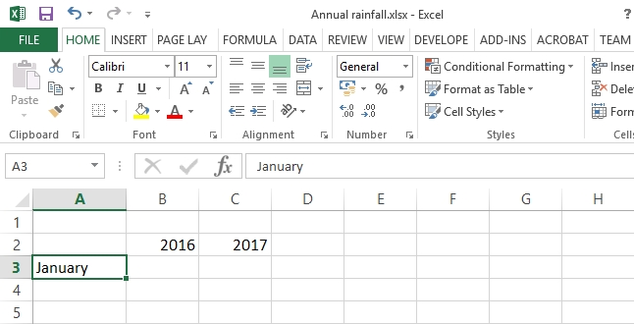

(a) The numbers 1, 2 …5 down the left-hand side are called row headers. On the screenshot, circle column header E. [1]

(b) In cell C1 of the screenshot, write the text Annual rainfall. The text can overflow into the the adjacent cells. [1]

(c) Explain how, in a spreadsheet, you could widen cell C1 so that the heading   
fitted into a single cell. [1]

(d) Describe how you could quickly enter the month names February to December   
in the cells underneath January. [2]

(e) Explain how you could insert an extra row between rows 2 and 3. [1]

(f) Explain how you could delete Row 2. [1]

(g) Explain how you could **centre** the headings **2016** and **2017**. [2]

(h) The spreadsheet Annual rainfall.xlsx has already been saved. Explain how   
you would quickly save any changes you made to the spreadsheet. [1]

2. The spreadsheet below shows the takings at four stands at a school Fun Day.

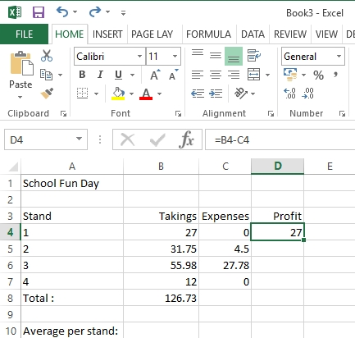

(a) Explain how you would format the currency amounts. [1]

(b) What is the formula in cell B8? [1]

(c) What formula needs to be written in cell B10? [1]

(d) What will happen to the figures in cells B8 and B10 if you insert an extra row after Row 7 for Stand 5, takings £10.00? [1]

(e) If the formula in cell D4 is copied down the column to cell D8, what will the formula in cell D8 be? [1]

[Total 15 marks]