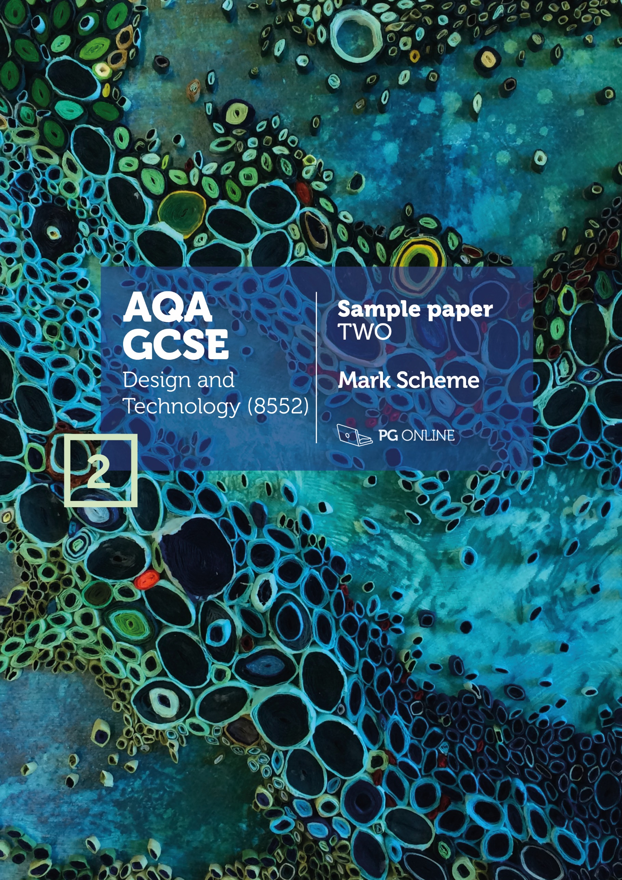

**Copyright**

© 2018 PG Online Limited

The contents of this pack are protected by copyright.

The pack and all the other associated files distributed with it are supplied to you by PG Online Limited under licence and may be used and copied by you only in accordance with the terms of the licence agreement between you and PG Online Limited. Except as expressly permitted by the licence, no part of the materials distributed with this pack may be used, reproduced, stored in a retrieval system, or transmitted, in any form or by any means, electronic or otherwise, without the prior written permission of PG Online Limited.

**License agreement**

This is a legal agreement between you, the teaching institution, and PG Online Limited. PG Online Limited grants to you a non-exclusive, non-transferable, revocable licence to use this supplement and all other associated files distributed with it in the course of teaching by your teachers and/or employees.

The materials distributed with this pack may be copied and used by your teachers and/or employees on a single site only in the course of their teaching. You warrant that you shall not, and shall procure that each of your teachers and/or employees shall not, share in any way any of the materials or part of the materials with any third party, including users on another site or individuals who are teachers and/or employees of a separate institution. You acknowledge and agree that the materials must remain with you, the teaching institution, and no part of the materials may be transferred to another institution. You also warrant that you shall not, and shall procure that each of your teachers and/or employees shall not, procure, authorise, encourage, facilitate or enable any third party to reproduce these materials in whole or in part without the prior permission of PG Online Limited.

In consideration of the licence granted to you, you shall indemnify PG Online Limited against all liabilities, costs, expenses, damages and losses (including but not limited to any direct, indirect or consequential losses, loss of profit, loss of reputation and all interest, penalties and legal costs and all other professional costs and expenses) suffered or incurred by PG Online Limited arising out of or in connection with the exercise by you of your rights granted under this licence.

GCSE Design and Technology

Sample paper 2 mark scheme

This sample paper and mark scheme has been carefully compiled and checked to ensure parity across the six specialist areas. It is the normal process for the mark schemes of live papers to go through a standardisation process where students’ responses are analysed and any answers not covered in the mark scheme are discussed and legislated for. As this is a sample paper only, this process has not been undertaken. Whilst this paper and mark scheme have been technically proofread, there may be additional responses that are worthy of marks. Teachers discretion should be applied in these circumstances.

Instructions for level of response marking

Descriptors are provided for different levels of response along with appropriate marks for each level. Read through a students’ answer, annotating to show the qualities that have been achieved, before applying the level based mark scheme.

Determining a level

Start with the lowest level of response in the mark scheme and assess if the different qualities indicated have been met. If they have, move to the next level and check to see if these have been met. Continue the process until you can match the level with the answer. With repetition it becomes easier and quicker to work up through the levels of the mark scheme.

The principle of ‘best fit’ should be adopted and if small elements of a level are missing but the majority has been covered, then this is the appropriate level to award.

Determining a mark within a level

Having decided on the level, the mark within the level must be determined. Use the descriptors to help with this along with the indicative content. Where there is any doubt, it is advisable to read back through the answers again and reapply it to the indicative content. Students do not need to cover all of the indicative content to reach the top marks. Additionally the indicative content is not designed to be exhaustive and alternative appropriate answers may well be taken into consideration.

Student answers that do not contain any relevent content must be awarded zero marks.

SECTION A - Core Technical Principles

# 1. Natural gas [1 mark]

# 2. Compression [1 mark]

# 3. 1.5 volts [1 mark]

# 4. Photochromic pigment [1 mark]

# 5. Lamp [1 mark]

# 6. Oscillating [1 mark]

# 7. 2.5kg [1 mark]

# 8. Snail [1 mark]

# 9. Low carbon steel [1 mark]

# 10. Pulley and belt [1 mark]

# 11. Award 1 mark for each property up to 2 marks maximum. [2 marks]

Accept any alternative correct response.

* Flat and rigid
* Comes in large sheets
* Good compressive strength
* Cost effective to cover a large area
* Easy to bond onto veneers/melamine for aesthetic effect
* Easy to machine/mill/route to add features and pre-drilled locations for fittings
* No natural defects/uniformly consistent material e.g. no knots

12. **Award 1 mark for each reason** **up to a maximum of 2 marks.** [2 marks]

* It is very hard therefore it can cut through softer materials/metals
* It can withstand high temperatures
* Effective at high speed under load
* Keeps its cutting edge well

13.1 **Award 1 mark for each reason up to a maximum of 2 marks** [2 marks]

**Indicative content:** Accept any alternative reasonable response.

* More efficient heating systems
* Low wattage lighting
* More micro green energy generated by households – solar panels, wind turbines, biofuel heating systems, geothermal heating
* More efficient appliances with better standby options
* More people switching off appliances when not in use
* Lower temperature / more efficient washing machines and dishwashers
* Better thermal insulation in dwellings / homes becoming more efficient / upgraded

13.2 **Award 1 mark for each reason up to a maximum of 2 marks** [2 marks]

**Indicative content:** Accept any alternative reasonable response.

* Purchase efficient home appliances
* Routine for switching off electrical items or have automatic sensors fitted
* Low energy lamps throughout
* Lower heating temperature
* Don’t waste food and compost any waste
* Eat less meat and dairy
* Have an allotment/grow food
* Don’t take/reduce air travel
* Swap to better transport option such as cycling, walking or car sharing

13.3 **Award 1 mark for the correct working out and 1 mark for the correct answer.**

12.8 – 4.5 = 8.3

8.3 / 12.8 x 100 = 64.8% [2 marks]

SECTION B - Specialist Technical Principles

14. **Award up to 2 marks for each correct reason with an example** [2 x 2 marks]

|  |  |
| --- | --- |
| 2 marks | A complete description applying both knowledge and understanding of why tolerances are used in design and/or manufacture. An appropriate example is given. |
| 1 mark | A simple description with some errors and misunderstanding of why tolerances are used in design and/or manufacture. A weak or no example given |
| 0 marks | Nothing worthy of credit |

**Indicative content:** accept alternative suitable response.

To ensure correct fitting: flat packed furniture goes together correctly and robustly / clothes fit well / PCB fits into casing / letter fits an envelope / nut fits on a bolt

To ensure a product works/performs correctly: a drill of the wrong size will drill incorrect holes / wrong tolerance with components can lead to errors in timing etc.

Other responses: systems / machines / products have standardised components and adhering to fine tolerances allows components / parts to be interchanged.

15.1 **Award up to 2 marks for two different features.** [2 x 2 marks]

|  |  |
| --- | --- |
| 2 marks | A complete description applying both knowledge and understanding of why the selected product, material or component is suitable for CAM |
| 1 mark | A simple description with some errors and misunderstanding of why the selected product, material or component is suitable for CAM |
| 0 marks | Nothing worthy of credit |

**Indicative content:**

|  |  |
| --- | --- |
| **Product, material or components** | **Features that are suitable for computer aided manufacture** |
| Laser cut clothes | Many fabrics are suitable for use in a laser cutter  Garment design may be too complex to cut by hand. Complex CAD files can be run on laser cutters  Some fabrics prone to fraying are automatically sealed around the edges when laser cut  Textiles can be cut in layers creating numerous identical parts with one pass saving time  Large bed laser cutters are available for larger component parts |
| Laser cut metal signage | Many metals are suitable for use in a special laser cutter powerful enough to cut through metal  Sign design may be too complex to cut by hand. Complex CAD files can be run on laser cutters  Thin metals can buckle and warp with heat, lasers reduce this  Laser cutting is faster and more accurate than hand processing  Large bed laser cutters are available for larger component parts |
| 3D printed  polymer parts | Many different polymers are available for 3D printers  They allow small to medium sized components to be made from CAD files  They are very accurate and can produce complex designs from CAD files  Repetitive accuracy can be assured  Post processing software creates layers for the 3D printer to follow  A fine tolerance can be achieved for parts  CAD files can be “open source” and therefore manufactured by third parties. |
| CNC routed furniture | Many different materials can be used with CNC routers  Different cutting tools can be used allowing for a variety of profiles, patterns and finishes to be applied to the material  They allow all sized components to be made from CAD files as large bed routers are available for larger furniture components  They are very accurate and can produce complex and intricate designs from CAD files that would be impossible by hand  Extraction can be used to ensure dust levels are kept low  CNC routing is faster and more accurate than hand processing  Repetitive accuracy can be assured |
| Laser cut card stationary | Most paper and boards are suitable for use in a laser cutter  Some designs may be too complex to cut by hand. Complex CAD files can be run on laser cutters  Paper and board can be cut in layers creating numerous identical parts with one pass saving time  Large bed laser cutters are available for larger component parts  Laser cutting is faster and more accurate than hand processing  Cheaper than die cutting / does not require expensive tooling / able to achieve a much more intricate detailing than die cutting / stamping |
| CNC routed PCB | Both the routing (isolation method) and drilling of different sized holes can be achieved with a CNC router  They allow all sizes of boards to be processed from CAD files  They are very accurate and can produce complex and intricate designs from CAD files that would be difficult by hand  Extraction can be used to ensure dust levels are kept low  CNC routing is faster and more accurate than hand processing  Repetitive accuracy can be assured |

15.2 **Award up to 4 marks for explaining a CAM process.   
Notes or sketches alone can get up to a maximum of 3 marks.** [4 marks]

|  |  |
| --- | --- |
| 4 marks | A complete explanation of a CAM process is well presented/explained. It is accurate and shows all stages in the correct order. Thorough knowledge and understanding of how a material(s) is processed. Excellent use of correct technical terminology and appropriate tooling/resources for the process to be performed. |
| 3 marks | A good explanation of a CAM process. It is presented/explained with a good level of accuracy. Most stages are shown and mostly in the correct order. Good knowledge and understanding of how a material(s) is processed. Good use of technical terminology and appropriate tooling/resources for the process to be performed. |
| 2 marks | A simplistic description with some errors/gaps and/or poorly explained. It shows basic knowledge and understanding of how a material(s) is processed. A basic attempt at technical terminology and tooling/resources used to perform the process is given. |
| 1 mark | A very basic description of a CAM process that may have stages or information missing. Incorrect sequence and terminology used. The process may not be named correctly. |
| 0 marks | Nothing worthy of credit. |

**Indicative content:** The answers in the table give some areas where the students may have explored. Award credit for the use of diagrams and descriptions that are appropriate to the chosen process. The processes are not necessarily material specific and could be answered with an appropriate material for the process.

|  |  |
| --- | --- |
| **Product** | **Processes requiring hand finishing** |
| Laser cut clothes | Preparation of materials / cutting to bed size / production post processing of CAD file / set up of laser - autofocus, speed and power / material held in position if required / extraction / running file / monitoring cut / QC / removal of materials |
| Laser cut metal signage | Preparation of materials / cutting to bed size / production post processing of CAD file / set up of laser - autofocus, speed and power / material held in position if required / extraction / running file / monitoring cut / QC / removal of materials |
| 3D printed polymer parts | Installation of appropriate polymer cartridge/materials / preparing build bed for adhesion / production/post processing of CAD file / set-up 3D printer – nozzle size, temperature and resolution / rafting/support provision / running file / monitoring print for failure / QC / removal of material from bed / clean-up of rafting/support / post print finishing if required |
| CNC routed furniture | Preparation of materials / cutting to bed size / production of CAD file / set up of CNC router – interchangeable heads/bits, speed and feed rate / material held in position clamp/vacuum bed / extraction / running file / monitoring cut / QC / removal of materials |
| Laser cut card stationary | Preparation of materials / cutting to bed size / production of CAD file / set up of laser - autofocus, speed and power / material held in position if required / extraction / running file / monitoring cut / QC / removal of materials |
| CNC routed PCB | Preparation of materials / cutting to bed size / production of CAD file / set up of CNC router – interchangeable heads/bits, speed and feed rate / PCB held in position clamp/vacuum bed / extraction / running file / monitoring cut / QC / removal of materials |

16.1 **Award up to 2 marks for a correct answer in each of two   
different areas.** [4 marks]

|  |  |
| --- | --- |
| 2 marks | A correctly stated functional and/or aesthetic characteristic of the material and a complete reasoning of why it is appropriate for the intended use. |
| 1 mark | A stated characteristic or physical property that may be simplistic or incomplete with some reference as to why it is acceptable for the intended use. |
| 0 marks | Nothing worthy of credit. |

**Indicative content:** accept alternative suitable functional and/or aesthetic characteristics and an appropriate response.

|  |  |
| --- | --- |
| High impact polystyrene (HIPS) – for moulded yoghurt pots | Malleable when heated – so that it can be formed to shape  Tough– so that it can withstand knock/bumps in transportation or use / hold the weight of the contents  Available in a variety of colours – attractive to users  Food safe – safe contact with the contents  Recyclable – can be recycled at the end of use avoiding waste |
| Bleed proof paper – for drawing rendered designs with marker pens | Sized surface – so that the ink from the markers pens sits on the surface / giving a deeper/richer/less faded colour / marker won’t go through the paper staining the worksurface/material underneath  Non-absorbent – good for water and spirit based colours  Smooth surface – giving a high-quality finish |
| Stainless steel – for a cutlery set | Sheet material – available for pressed cutlery  Resistant to rust – meaning that it won’t corrode/rust  Hard – meaning that it will keep its shape/edge in use  Tough – meaning it will withstand knock and bumps in use  Food safe – avoiding any contamination with food  Durable – Can withstand very high-water temperatures when being washed/sterilised |
| Beech – for a child’s wooden train set | Fine and dense grain – to withstand pressure exerted when used or when dropped/thrown and durable/resists splitting / holds paint and stains well  Tough – to withstand wear and indentation in use / resists chipping and splintering / due to a tight/even grain structure  Natural pinkish hue – attractive aesthetics when unfinished |
| Cotton – for a pair of hiking socks | Easily spun into yarn – so that it can be woven/knitted into fabric / can be blended with other fibres for improved properties  Naturally derived insulation – so that it is warm to wear  Breathable – to prevent/reduce perspiration  Comfortable – so that the wearer can use the socks over a long period  Reasonably hard wearing – the sock will last without breaking/wearing out |
| Buzzer – for use in a battery operated electronic quiz game | Compact/small – so that less space is required on PCB/in casing  Low power – meaning that battery lasts longer  Loud output – meaning that the users of the game will notice the sound |

16.2 **Award 1 mark for one correct primary source material.**  [1 mark]

|  |  |
| --- | --- |
| **Material or component** | **Primary source** |
| High impact polystyrene (HIPS) | Oil or gas |
| Bleed proof paper | Trees / wood / other source of cellulose fibre |
| Stainless steel | Iron ore / chromium / manganese. Accept silicon / carbon |
| Beech | Beech tree |
| Cotton | Cotton boll / cotton plant |
| Buzzer | Plastic shell from oil or gas.  Internal parts from copper and/or steel / aluminium |

17. **Award up to 8 marks for an analysis of the use of lifecycle   
assessments.** [8 marks]

|  |  |
| --- | --- |
| 7-8 marks | A coherent and logical analysis featuring a range of points with excellent understanding of issues surrounding the use of a lifecycle assessment for gauging impact. Detailed analysis and evaluation of all five areas leads to conclusions that designers and manufacturers could use to reduce the environmental impact of a product. |
| 5-6 marks | A logical discussion which includes a good understanding of issues for most of the five areas of a lifecycle assessment. Good analysis and evaluation of points raised, leads to some conclusions being drawn as to how designers and manufacturers could reduce environmental impact of their products. |
| 3-4 marks | The response shows a good understanding of some issues surrounding the use of a lifecycle assessment, however one or two areas may be weak. A few points, raised with some analysis/evaluation from a designer and/or manufacturers point of view. Arguments may lack coherence & conclusions may be weak or unsubstantiated and any benefits may be tentative. |
| 1-2  mark | Some understanding of the key issues is covered with limited awareness of a lifecycle assessment for gauging environmental impact of a product. One or two points showing limited analysis and/or evaluation although lacking coherency. Little or no conclusion drawn. |
| 0 marks | Nothing worthy of credit. |

**Indicative content:**Indicative content listed is provided to illustrate points that students may make about the examples given in the question, which would demonstrate their understanding of why lifecycle assessments are conducted and the benefits they give. Students may refer to some or all of the examples or they may offer alternative responses in their answer. Marks should be awarded for anything worthy of credit.

The five stages of a lifecycle assessment (LCA) and the influence on product design:

# Extraction – energy required, and carbon released for raw materials to be extracted from the ground or to be farmed and harvested / can cause destruction through mining / desertification / deforestation / pollution / physical and social issues for communities / reduce amounts of raw materials needed / rethink, refuse and use alternatives / source more sustainably / use recycled materials

# Production/manufacture – energy used while making usable stock forms from the raw materials and in the making of the product / use fewer types of material / use less material / use recycled materials / use of efficient machinery / efficient working practices / energy saving systems / use green energy / reuse and recycle waste including heat / staff engagement and training

# Distribution – energy needed for the packaging and movement of the stock materials and products to and from factory/warehouse/wholesalers/retailers to user / reduce product mileage where possible / production based near main market and/or resources / use efficient transport/shipping methods / use efficient routing / reduce, lighten packaging

# Use – the energy and consumables used during the products working life / make product efficient in use / rechargeable if appropriate / avoid need for finite consumables / make it repairable / upgradable / last a long time if appropriate to the product type / strong and tough so as not to break

# End of life – the energy required to recycle or dispose of the product and any waste / make it reusable / recyclable / compostable / designed for easy separation of materials

SECTION C – Designing and Making Principles

18. **Award up to 4 marks for each of the three sections of the question.**

|  |  |
| --- | --- |
| 3-4 marks | Well described and justified analysis containing full evaluation, drawing conclusions having considered both positive and negative factors. |
| 1-2 mark | Brief points mentioned but not fully explained. Analysis present but limited evaluation / conclusions drawn. May have focused solely on either positive or negative factors. |
| 0 marks | Nothing worthy of credit. |

**Indicative content** for the evaluation of the walking aids in terms of the   
following points:

18.1 Suitability for the user [4 marks]

# Arm cups for support and convenience

# Handles to support weight

# Waterproof materials used which allows for use when outdoors

# Easy to use and change height making it adaptable for different heights/ages

# Lightweight so that it is comfortable to use for long periods of time

# Soft material on handle to ease pressure on hand

# Rubber stoppers on base to provide grip so safe on most surfaces

# Robust enough to resist knock, bumps, wear and tear

# Might be awkward to change the height

# May be uncomfortable on the hand due to lack of padding

18.2 Ergonomics [4 marks]

# Hand grips are rounded and shaped to fit a range of hand sizes

# Flexible and anatomically designed arm cups to offer support

# The walking aids are lightweight / comfortable when used for long periods of time

# Adaptable for different heights and ages

# Rubber stoppers positioned to prevent slipping

# Plastic arm cup/handle next to the skin may be uncomfortable and cause sweating

# Plastic arm cups could slide off walls/surfaces when propped up and not in use

19.1  **Award up to 4 marks for an explanation of the term design fixation.** [4 marks]

|  |  |
| --- | --- |
| 3-4 marks | Student demonstrates a clear knowledge of what design fixation is and a good understanding of how designers can avoid it happening. Relevant points will be used to illustrate the strategies designers use as per the indicative content. |
| 1-2 mark | Student demonstrates some knowledge of what design fixation is but understanding of strategies to avoid it is limited and points to illustrate these strategies may be weak. |
| 0 marks | Nothing worthy of credit. |

**Indicative content:** allow for levels of subjectivity if content is viable**.** Design fixation is a common condition where designers become stuck/blinkered and can only produce a range of similar designs and become blind to the alternatives. It can be caused by playing safe / not taking risks.

Not limited to, but reference to the following strategies may be included in responses:

# Working with others – use collaborative design to exchange ideas / peer review

# Force a new starting point – Take an alternative/abstract approach such as working in a different medium/size of paper/use or don’t use CAD / scale up/down / any change is good

# Start modelling & stop drawing or vice versa – physical modelling can change perspective

# Get some failures completed – acknowledge that ideas come only after many failures

# Avoid too much research / take a risk or a hunch / go for the wacky idea

19.2  **Award 1 mark for each valid test up to a maximum of 2 marks   
and award 1 mark for each valid justification up to a maximum   
of 2 marks** [2 x 2 marks]

|  |  |
| --- | --- |
| 2 marks | A correctly described physical test of the walking aid or a specific part and a complete explanation of how and why is used to determine if they are fit for purpose |
| 1 mark | A stated physical test of the walking aid or a specific part that may be simplistic or incomplete with some or little reference as to how and why is used to determine if they are fit for purpose |
| 0 marks | Nothing worthy of credit |

**Indicative content:** this is not an exhaustive list. Credit any alternative valid response.

# Measure the size of aids/parts/components to ensure correct fit

# Measure the load bearing of aids/parts/components to ensure it is strong enough to support a decided maximum weight of user

# Bend/stress the legs/joints/parts to ensure strength in extreme use

# Test the locking mechanisms of the legs to ensure they are safe and don’t slip

# Accept: Give to a user group to evaluate in use, provided there is some reference to strength/size/weight or similar.

# Conduct tests on materials in order to ensure physical / mechanical properties such as strength, hardness, are suitable for the task.

20 **Award 1 mark for the working out and 1 mark for the answer.**

a. 0.85 + 1.75 + 0.30 = £2.90 [2 marks]

b. 0.55 + 1.25 + 0.20 = £2.00 therefore 2.90 – 2.00 = £0.90 [2 marks]

21. **Award up to 4 marks for a conversion of the exploded drawing into a   
complete product in isometric projection.** See example.[4 marks]

|  |  |
| --- | --- |
| 3-4 marks | The drawing is complete and accurate, with a good quality of line. The drawing is to scale and correctly positioned on the isometric grid paper. The shapes are correctly positioned into the body of the toy and a good attempt at drawing the triangle and cylinder is evident. |
| 1-2 mark | The drawing generally resembles the completed toy. The quality of line is variable. The drawing may not be exactly to scale or correctly positioned on the isometric grid paper. The shapes may not be correctly positioned into the body of the toy and only a superficial attempt at drawing the triangle and cylinder may be evident. |
| 0 marks | Nothing worthy of credit. |

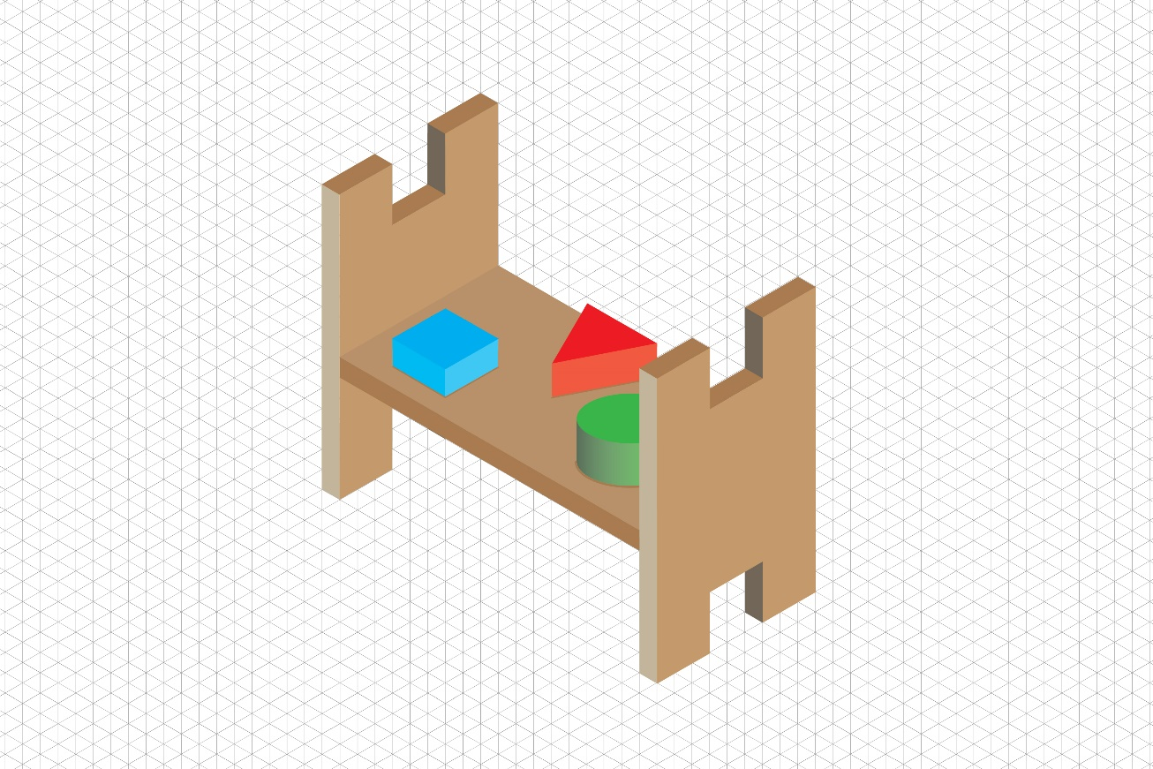

22.1 **Award 2 marks for achieving 10 components that are clearly distinguishable. Award 1 mark for either 8 or 9 components.** See grid for answer: [2 marks]



22.2 **Award 1 mark for working out and one mark for the answer in pence.**

a) £3.78 / 42 = 9p per square. 4 x 9p = 36 pence per component or £0.36. [2 marks]

b) Minimum 2cm2, allow for error carried forward.   
2 x 9p = 18 pence or £0.18. [2 marks]