Score screen design

- Enter design mode and select the score screen.  - Add a label and place it where you would like the score to appear.  - Change the id to userScoreLbl.  - Format the font, size, and position; change the text property to an example score, such as 10. | 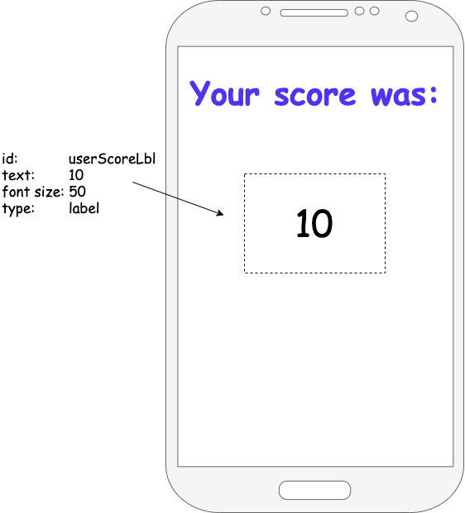

Resources are updated regularly — the latest version is available at: ncce.io/tcc.

This resource is licensed under the Open Government Licence, version 3. For more information on this licence, see ncce.io/ogl.

