Name: Class:

Task 1
1. Carbon fibre is a very strong composite material made from thermoset polymer and carbon fibres. It is used to make bike frames, car chassis and running blades.
A bike frame design has a mass of 1.75 kg. If the ratio of polymer to carbon fibre is
3 : 4, calculate the mass of polymer and carbon fibre are needed to manufacture 100
bike frames.
Polymer: | Carbon fibre:

2. Epoxy resin is a thermoset adhesive which is made by adding a resin to a hardener. Study the design of the epoxy resin dispenser below and estimate the ratio of resin to hardener being dispensed.
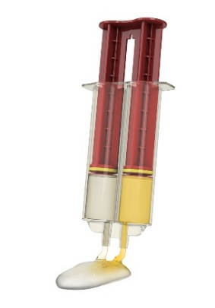

3. A particular type of stainless steel contains the metals iron, nickel and chromium in the ratio of 47 : 35 : 18 by mass.
How much iron, nickel and chromium are present in 20.0 kg of stainless steel?

Task 2
1. Calculate the following:
(a) A student makes a wooden chair in which $\frac{1}{4}$ of the total cost is teak and $\frac{1}{3}$ of the cost is pine. The remaining costs were made up of components and finishes.
If the total cost of the chair was £52.50, work out the cost of the teak and the cost of the pine to the nearest penny.

(b) The average car engine weighs 158 kg.
The ratio of the mass of the engine to the mass of the car is 1 : 11.
What is the mass of the car?

2. In a school, there are 40 students studying GCSE Design and Technology this year.
The number of students studying GCSE Design and Technology this year is an increase of $\frac{1}{4}$ on the numbers studying the course the previous year.
How many students studied the course the previous year?

