Name: Class:

Task 1

Look at the following statement.

Shade in the parts of the Venn diagram that show when you would go to the concert:

*“I will only go to the concert if Harminder is not going or if Manisha and Gemma are going”*

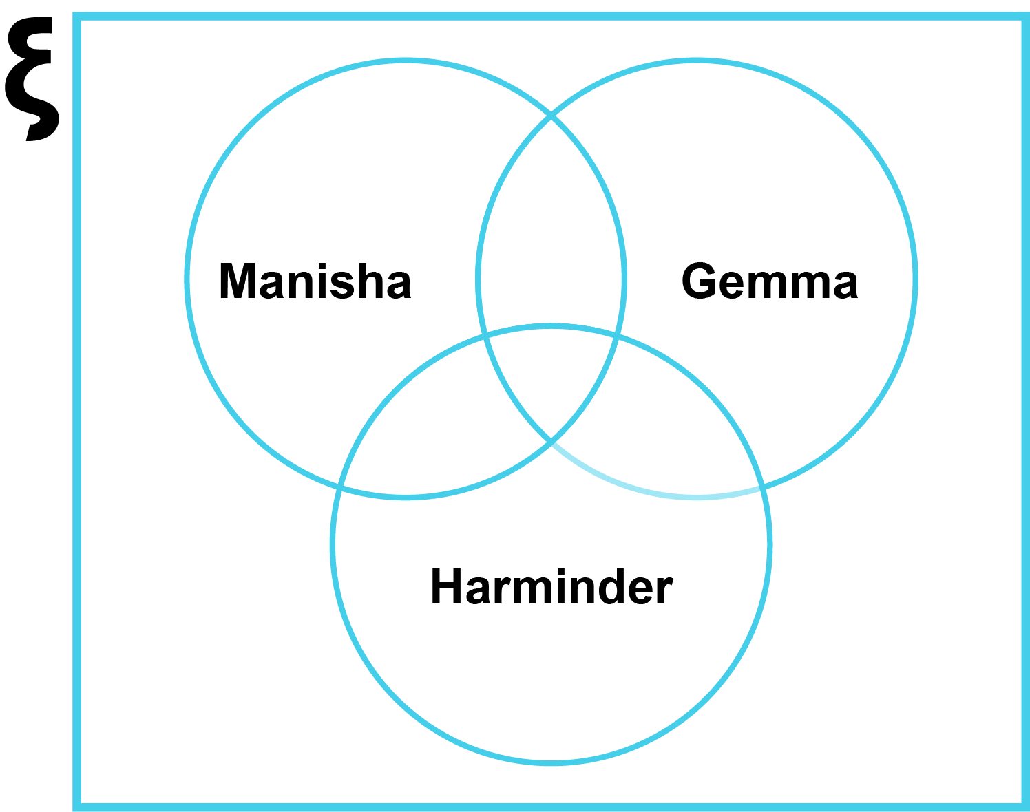

Task 2

Look at the below pipes.

(a) Complete the truth table for the “OR pipe” shown below.

|  |  |  |  |
| --- | --- | --- | --- |
|  | **A** | **B** | **Output** |
| OFF | OFF |  |
| ON | OFF |  |
| OFF | ON |  |
| ON | ON |  |
|  | | |

(b) How can the following handles be moved to make water flow? Write down the handles that need to be turned on and off. There are three different solutions to the problem.

Solution 1:

Solution 2:

Solution 3:

Task 3

(a) An OR gate takes two inputs, A and B.

Complete the truth table for this gate.

|  |  |  |  |
| --- | --- | --- | --- |
|  | **A** | **B** | **Output** |
| FALSE | FALSE |  |
| TRUE | FALSE |  |
| FALSE | TRUE |  |
| TRUE | TRUE |  |

(b) A NOT gate takes one input, A.

Complete the truth table for this gate.

|  |  |  |
| --- | --- | --- |
|  | A | Output |
| FALSE |  |
| TRUE |  |

(c) Complete the truth table for the following circuit:

|  |  |  |  |  |  |
| --- | --- | --- | --- | --- | --- |
| **A** | **B** | **C** | **D** | **E** | **Output** |
| True | True | True |  |  |  |
| True | True | False |  |  |  |
| True | False | True |  |  |  |
| True | False | False |  |  |  |
| False | True | True |  |  |  |
| False | True | False |  |  |  |
| False | False | True |  |  |  |
| False | False | False |  |  |  |

(d) If you **don’t have access** to a computer in class, ask a friend to check your truth tables

If you **have access** to a computer, go to <https://logic.ly/demo> and construct a logic gate circuit for each of the above circuits. Remember to connect the inputs as switches and the output should be a light bulb.