**HANDOUT 1**

**Your Likes & Dislikes**

Making Decisions

We all make decisions every day. Some can be life-changing while others, like deciding which clothes to wear, are less important.

This series of activities is designed to introduce you to your likes and dislikes and how they affect decisions about your future career choices.

|  |  |
| --- | --- |
| **Name:** |  |
| **Tutor Group / Class:** |  |
| **Year Group:** |  |

**Top Tip:** Ask a parent, guardian or sibling to work through the activities Handouts 1 and 2 with you. Discuss your responses together to help you consider the answers you have given today and why.

**Activity 1:**

**Q: What decisions have you already made today?** Type your answers in the table below: **Examples:**

|  |
| --- |
| **WHAT DECISIONS HAVE YOU MADE TODAY?** |
|  |
|  |
|  |
|  |
|  |

* What to eat for breakfast/ dinner? - What clothes to wear today?
* How much homework will I do? - Who will I talk to online?

**Q: How much time did you spend making decisions? Was it a lot, little or none?** Pick 2 of the decisions you listed above and write how much time you spent on each.

|  |
| --- |
|  |
|  |

|  |
| --- |
|  |
|  |

**Q: How much of an impact did those decisions have on the other decisions you’ve made today? Was it a lot, little or none?** Pick 2 of the decisions you listed in the table above and write down the impact those decisions have had on the other decisions you’ve made today.

|  |
| --- |
|  |
|  |

|  |
| --- |
|  |
|  |

**Activity 2:**

Complete the questions below by answering ‘yes’ or ‘no’.

**Q: Would you like to eat pasta at lunchtime?**

|  |
| --- |
|  |

**Q: Are you going to watch TV tomorrow?**

|  |
| --- |
|  |

**Q: Will you do your homework today?**

|  |
| --- |
|  |

**Q: Do you ask your best friend for advice?**

|  |
| --- |
|  |

**Q: Now think about your answers to the questions in Activity 2. Were the questions ‘easy’ or ‘hard’? How much thought was needed?**

Record your responses below:

|  |
| --- |
|  |
|  |
|  |
|  |

**HANDOUT 2**

**Your Likes & Dislikes**

Making Decisions

We all make decisions every day. Some can be life-changing while others, like deciding what clothes to wear, are less important.

Here are a few more activities designed to help you reflect on your links and dislikes.

**Activity 3:**

The following decisions are to do with choosing a career you might enter. Complete the questions below by answering ‘yes’ or ‘no’.

**Q: Would you want a job that involves designing new clothes?**

|  |
| --- |
|  |

**Q: Would you like to understand how to write software?**

|  |
| --- |
|  |

**Q: Would you like to prepare or use maps and charts?**

|  |
| --- |
|  |

**Q: Would you like to be responsible for controlling or adjusting equipment?**

|  |
| --- |
|  |

**Q: Would you like to work with plants?**

|  |
| --- |
|  |

**Q: Do you want a job where you’ll help other people?**

|  |
| --- |
|  |

**Q: Would you like a job that involves working with children?**

|  |
| --- |
|  |

**Q: Now think about your answers to the questions in Activity 3.**

* Was it easier to answer these questions compared to those in Handout 1? If it was easier, why was this?
* Was it difficult to choose between ‘yes’ and ‘no’?
* What about if you’re not sure?
* Could you answer ‘yes’ for each aspect? Why is this unlikely?

Record your responses below:

|  |
| --- |
|  |
|  |
|  |
|  |
|  |
|  |
|  |

**Activity 4:**

The Likes & Dislikes questions in Kudos are designed to give you a personalised list of career ideas that you might like.   
  
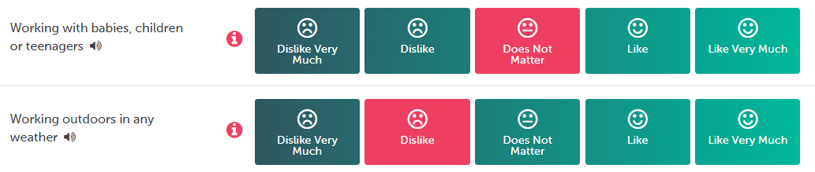

Repeat the questions already answered in Activity 3 but this time answer below with either:

* Dislike Very Much
* Dislike
* Does Not Matter
* Like
* Like Very Much

**Q: Would you want a job that involves designing new clothes?**

|  |
| --- |
|  |

**Q: Would you like to understand how to write software?**

|  |
| --- |
|  |

**Q: Would you like to prepare or use maps and charts?**

|  |
| --- |
|  |

**Q: Would you like to be responsible for controlling or adjusting equipment?**

|  |
| --- |
|  |

**Q: Would you like to work with plants?**

|  |
| --- |
|  |

**Q: Do you want a job where you’ll help other people?**

|  |
| --- |
|  |

**Q: Would you like a job that involves working with children?**

|  |
| --- |
|  |

**Q: Now think about how you answered the questions in Activity 4.**

* Was it easier or more difficult to answer the questions the second time around? Please provide your reasoning.
* Which set of answers gives you the most accurate response?
* What do you think your answers show you about what you need to do before making choices about your career?

Record your responses below:

|  |
| --- |
|  |
|  |
|  |
|  |
|  |
|  |
|  |
|  |
|  |

**What’s next?**

Log in to Kudos and complete the MyFuture Quiz to find out which careers suit you.