Name: Class:

Task 1

Below are three sets of training data.

Use the training data to determine **five** rules that can be used to classify each category. Only use the images to create your rules. Do not guess at features that you cannot see.

(a) Training data for the classification of ‘Insects’.

|  |  |  |  |
| --- | --- | --- | --- |
|  |  |  |  |
| ✓ | ✓ | ✓ | 🗶 |

Rules:

1.

2.

3.

4.

5.

(b) Training data for the classification of ‘Mammals’.

|  |  |  |  |
| --- | --- | --- | --- |
|  |  |  |  |
| ✓ | ✓ | 🗶 | ✓ |

Rules:

1.

2.

3.

4.

5.

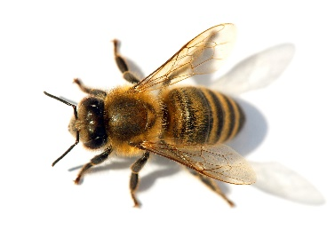(c) Now look at the following photo.

* How many of the rules for insects and mammals does it meet?
* How would you classify it?
* Work out a percentage of rules met to show how confident you are of this classification.

|  |  |  |
| --- | --- | --- |
| **How many rules met for ‘insect’** | **How many rules met for ‘mammals’** | **Is this a mammal or an insect? How certain are you?** |
|  |  | Classification:  Certainty:  % |

(d) Now look at the following photo.



* How many of the rules for insects and mammals does it meet?
* How would you classify it?
* Work out a percentage of rules met to show how confident you are of this classification.

|  |  |  |
| --- | --- | --- |
| **How many rules met for ‘insect’** | **How many rules met for ‘mammals’** | **Is this a mammal or an insect? How certain are you?** |
|  |  | Classification:  Certainty:  % |

Task 2

Imagine you are a machine and you are learning to tell the difference between spam, and real harmless messages.

You can do this task with a partner or in a small group.

(a) Find examples of at least five spam messages from any of the following:

* Spam in your email account
* Spam from one of the websites given below
* An Internet search for examples of spam

<https://as.exeter.ac.uk/media/level1/academicserviceswebsite/it/documents/Examples_of_spam_and_phishing_emails.pdf>

<https://www2.aston.ac.uk/ict/services/it-security/spam/sample-spam-emails>

<https://www.quostar.com/blog/four-scam-emails-to-watch-out-for/>

<https://us.norton.com/internetsecurity-online-scams-phishing-email-examples.html>

(b) Now write at least **five rules** which you could use to filter spam emails and divert them away from someone’s inbox. Give each rule a number.

1.

2.

3.

4.

5.

(c) Look at the two emails below.

i. Annotate each email to show which rules have been broken. Remember, the same rule may have been broken more than one time

ii. Calculate a ‘spam score’ for each email by adding up the total number of rules that are broken.

|  |  |  |
| --- | --- | --- |
|  | **Email 1** | **Email 2** |
| Email |  |  |
| Spam score  (How many times were your rules broken?) |  |  |

(d) Most email programs allow the user to classify an email as spam when they delete it.

Explain how email providers can use this information to improve their spam detection capabilities.