Task 4
Add a new function to the program

Type the following text:
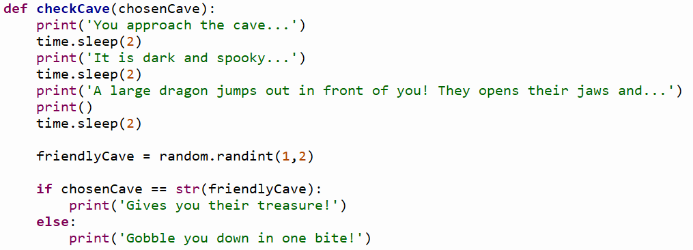

- Run the program
- In the shell, type the following and press enter:
- checkCave()
The program will generate an error, why?
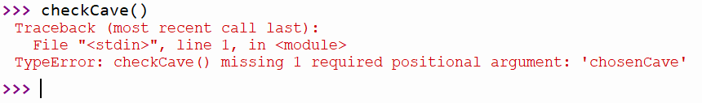
Reading the error message, on the 3rd line, the error states ‘missing 1 required positional argument’.
Arguments are values that must be inputted to some types of functions. If you look at the function definition (the 1st line), of CheckCave(), you can see that the function does indeed require an input – that is the bit between he bracket. We call these inputs to functions parameters.
So lets try this again, but this time we’ll pass the cave variable that we captured when we ran chooseCave() in the last task:
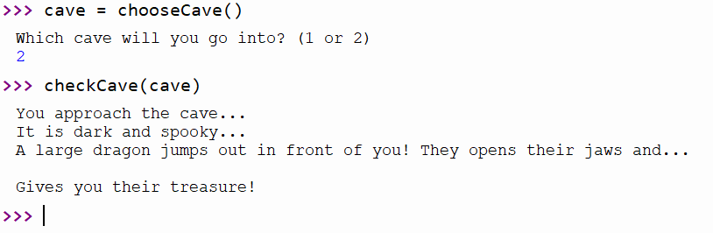

Explain what this function is doing.
Specifically mention:
- Parameters
- Passing values (arguments) to functions as parameters.

