Unfamiliar Listening Question

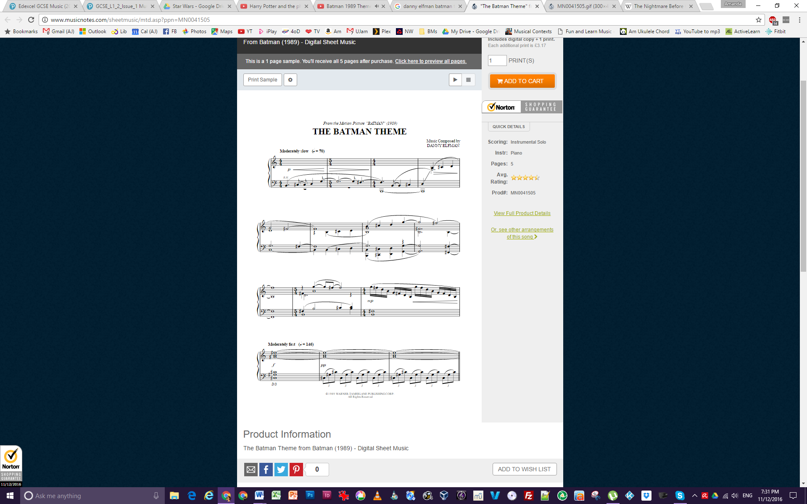1. You will hear this extract 4 times.

a) What is the tonality of bars 1 – 11? (1)

………………………………………………………………………………………………………………………………………………….

b) Which family of instruments play the opening leitmotif in bars 1-2? (1)

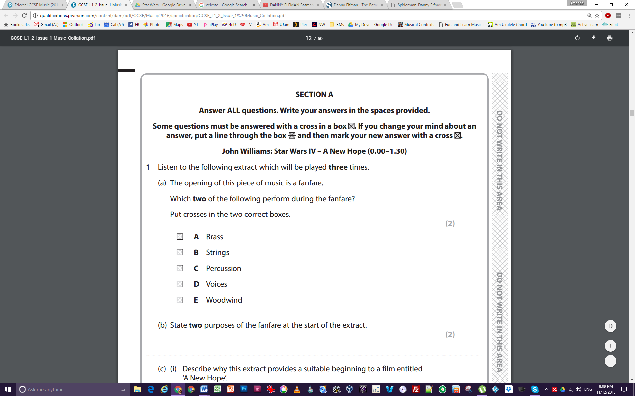

c) Give **two** differences between the music in bar 6 and bar 13. You should refer to (2)

any of the following; choice of instruments, key, tempo, rhythm.

………………………………………………………………………………………………………………………………………………….

………………………………………………………………………………………………………………………………………………….

………………………………………………………………………………………………………………………………………………….

d) Name the harmonic device used in bar 3 & 4. (1)

………………………………………………………………………………………………………………………………………………….

e) Which word best describes the texture in bars 4 – 10. (1)

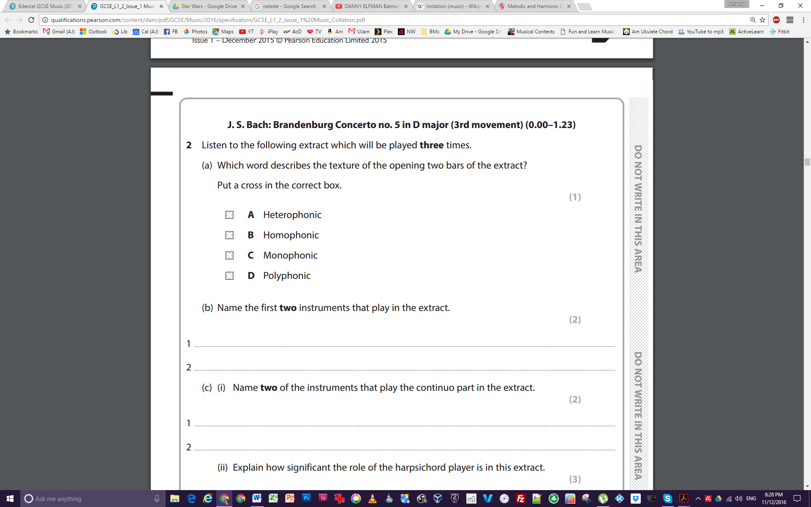

e) Give two musical ways Danny Elfman has achieved an exciting build-up in this (2)

extract of music.

………………………………………………………………………………………………………………………………………………….

………………………………………………………………………………………………………………………………………………….

………………………………………………………………………………………………………………………………………………….

**(TOTAL for Question 1 = 8 marks)**