Explorer task: Escape the maze

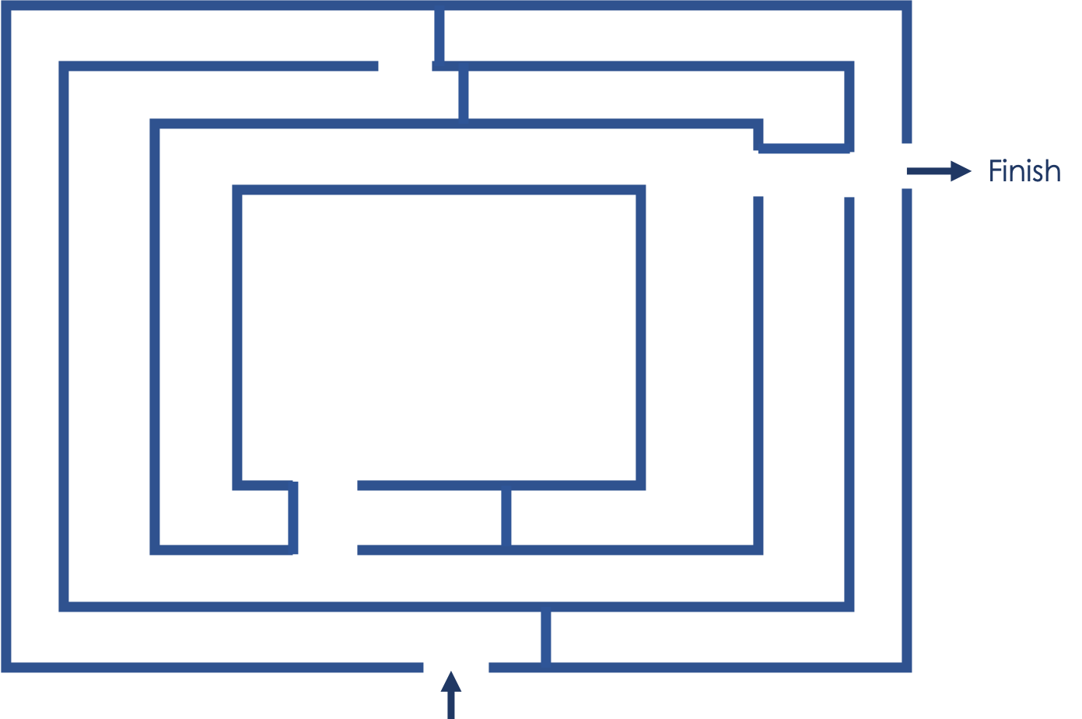

In a different lesson, learners were given the task of writing a subroutine to help Scratch cat escape the maze. They were allowed to use the following blocks:

|  |  |
| --- | --- |
|  | This will turn the cat 90 degrees to the **left** |
|  | This will turn the cat 90 degrees to the **right** |
|  | This informs Scratch cat to continue to walk forward until they are facing a wall |
|  | This is a count-controlled loop. The number placed after the word ‘repeat’ will instruct the computer how many times to execute the blocks of code placed within this **Repeat** block. |

Look at the subroutines below. When executed, two of the subroutines will help Scratch cat escape the maze.

|  |  |  |  |
| --- | --- | --- | --- |
| **Subroutines** |  |  |  |
| **Escaped? (Yes/No)** |  |  |  |

### 

|  |  |
| --- | --- |
| **Question** | **Your answer** ▿ |
| Of the two that you have selected, which one do you think your teacher would give you more marks for? Why? |  |

Resources are updated regularly — the latest version is available at: [ncce.io/tcc](http://ncce.io/tcc).

This resource is licensed under the Open Government Licence, version 3. For more information on this licence, see [ncce.io/ogl](http://ncce.io/ogl).