Name: Class:

Task 1

(a) Draw an 8x8 pixel art masterpiece using just black or white. Alternatively, if you have access to a computer, you can go to [www.pixilart.com](http://www.pixilart.com). Create a new image that has 8x8 pixels and then draw your image in black and white. Copy what you have drawn below.

(b) Convert the image into binary. 8 bits will represent each row. 1 represents white and 0 represents black.

(c) Check the binary that you have put with a friend to see that you haven’t made any mistakes.

Task 2

(a) Write a caption for the image that you created in Task 1.

Your caption should be between 9 and 16 characters. Use only capital letters, exclamation marks or spaces. Remember that the number of characters will include any spaces.

Caption:

Look at the ASCII table below.

|  |  |  |  |  |  |  |  |  |  |  |
| --- | --- | --- | --- | --- | --- | --- | --- | --- | --- | --- |
| **Letter** | **ASCII** |  | **Letter** | **ASCII** |  | **Letter** | **ASCII** |  | **Letter** | **ASCII** |
| A | 01000001 |  | H | 01001000 |  | O | 01001111 |  | V | 01010110 |
| B | 01000010 |  | I | 01001001 |  | P | 01010000 |  | W | 01010111 |
| C | 01000011 |  | J | 01001010 |  | Q | 01010001 |  | X | 01011000 |
| D | 01000100 |  | K | 01001011 |  | R | 01010010 |  | Y | 01011001 |
| E | 01000101 |  | L | 01001100 |  | S | 01010011 |  | Z | 01011010 |
| F | 01000110 |  | M | 01001101 |  | T | 01010100 |  | ! | 00100001 |
| G | 01000111 |  | N | 01001110 |  | U | 01010101 |  | <space> | 00100000 |

(b) Convert your caption into binary using the table. Put eight bits on each line.

|  |  |  |
| --- | --- | --- |
| Letters 1 – 8 |  | Letters 9 – 16 |
|  |  |  |
|  |  |  |
|  |  |  |
|  |  |  |
|  |  |  |
|  |  |  |
|  |  |  |
|  |  |  |

(c) Ask a friend to check your binary conversion is correct.

Task 3

Imagine that you need to pass a note inside a packet to a friend in your classroom without standing up. You would need to pass the packet to someone close to you. They would then pass the packet further until it reached your friend.

You have set up a packet-passing network!

Draw your network below using names or numbers for each of the nodes (circles) in the network.

If you have access to a computer then you can use <https://csacademy.com/app/graph_editor/> to build the network.

|  |
| --- |
|  |

Task 4

You are now going to send your image and caption to another person in the classroom.

(a) Your teacher will pair you with someone else in the class.

Write their name here: ___

(b) You will send three packets of information to your partner.

* Packet 1: Binary data for your image
* Packet 2: The binary data for the first half of your caption
* Packet 3: The binary data for the second half of your caption

If you are doing this on paper, you should send your packets via other students in the class.

If you have access to a computer and school email, your teacher may ask you to send a screenshot of each packet via email.

Copy the binary data that you created in Task 1 and Task 2 into the data packets below. Then send each packet to your partner. Remember, the packets don’t need to arrive in order.

✂

Destination student: _____________

Packet number: 1

Binary data for image:

✂

Destination student: _____________

Packet number: 1

Binary data for characters 1-8:

✂

Destination student: _____________

Packet number: 1

Binary data for characters 9-16:

Task 5

You will receive three packets of binary information from your partner in the class.

(a) Use these to reconstruct below the image and caption they have sent you.

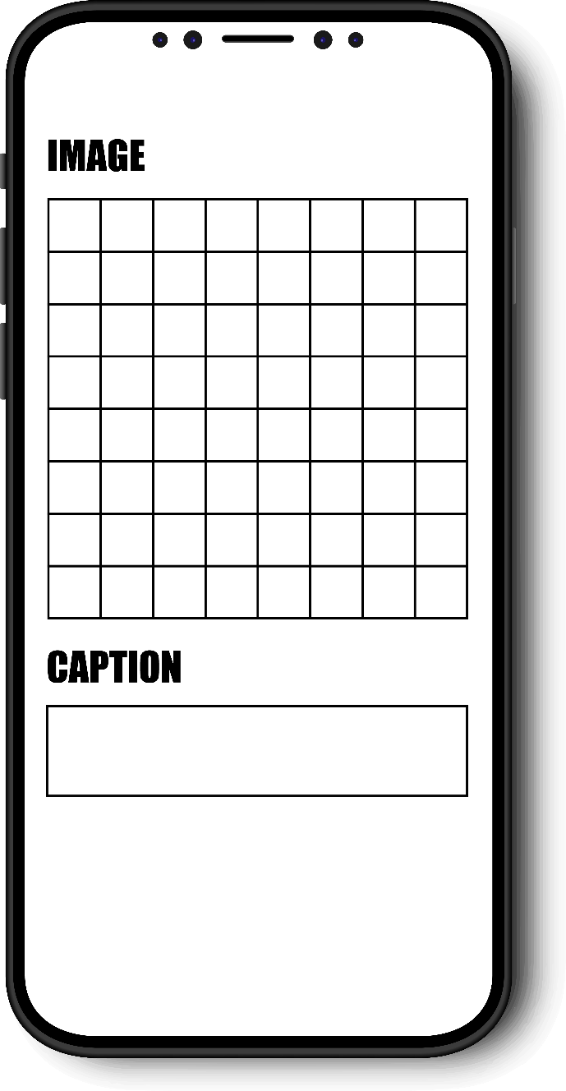

(b) Explain how decomposition helps in being able to carry out the task of getting images and text messages from one phone to another.