# Worksheet 2 Packet switching and routers

**Task 1**

Using the tool [www.monitis.com/traceroute](http://www.monitis.com/traceroute) you need to investigate how long packets of data take to travel around the Internet.

Simply type in the address of the website you are trying to reach and record the average latency from Europe. You can also see a visualisation of the hops across routers from start to finish.

|  |  |  |
| --- | --- | --- |
| **Continent** | **URL** | **Average response time** |
| Europe | www.bbc.co.uk |  |
| Europe |  |  |
| Africa | www.southafrica.net |  |
| Africa |  |  |
| Asia | www.tianya.cn |  |
| Asia |  |  |
| Australasia | www.smh.com.au |  |
| Australasia |  |  |
| North America | google.com |  |
| North America |  |  |
| South America | www.brasil.gov.br |  |
| South America |  |  |

1. Which website has the shortest latency?
2. Which has the longest latency?
3. Why do you think this website has the longest latency?

**Task 2**

1. The following network shows the latency in milliseconds (ms) between routers in a network. Routers estimate the latencies from the actual progress of packets during the previous millisecond.

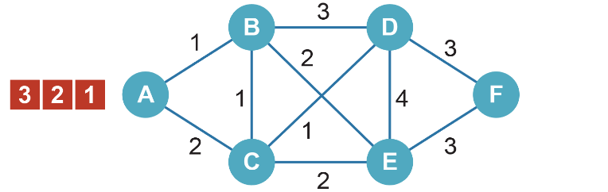

0 ms

Node A is sending data to node F as three packets in the order: 1, 2 and 3.

On the diagrams below, label where these packets will be after each millisecond if each travels by one of the quickest routes calculated from the estimated latencies. Current atencies and available routes vary each millisecond depending on congestion or cable failure.

|  |  |
| --- | --- |
| 1 ms | 2 ms |
| C:\Users\Rob\AppData\Roaming\PixelMetrics\CaptureWiz\Temp\114.png | C:\Users\Rob\AppData\Roaming\PixelMetrics\CaptureWiz\Temp\77.png |
| 3 ms | 4 ms |
| C:\Users\Rob\AppData\Roaming\PixelMetrics\CaptureWiz\Temp\125.png | C:\Users\Rob\AppData\Roaming\PixelMetrics\CaptureWiz\Temp\126.png |
| 5 ms | 6 ms |
| C:\Users\Rob\AppData\Roaming\PixelMetrics\CaptureWiz\Temp\127.png | C:\Users\Rob\AppData\Roaming\PixelMetrics\CaptureWiz\Temp\128.png |
| 7 ms | 8 ms |
| C:\Users\Rob\AppData\Roaming\PixelMetrics\CaptureWiz\Temp\129.png | C:\Users\Rob\AppData\Roaming\PixelMetrics\CaptureWiz\Temp\130.png |

In which order will the packets arrive?

1. Justify why packet payloads are usually kept to around 1500 bytes. Consider the effects of much larger payloads on transmission time, and the effects of very small payloads on the overheads within the headers and trailers.