**Homework 4: Conditional formatting and validation**

1. Here is a spreadsheet showing class marks for three tests.

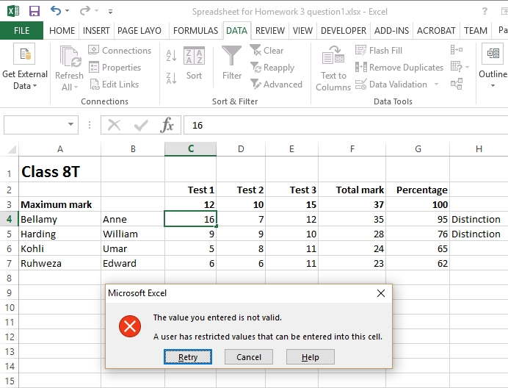

(a) Why has this error message been displayed? [2]

(b) The user can specify a customised message to be displayed if the user enters invalid data in any of the cells C4 to E7 using the dialiog box shown below.

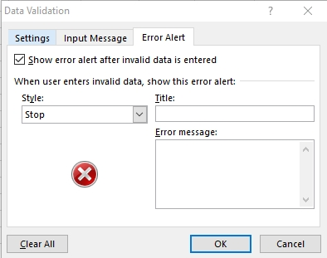

Suggest a title and a suitable message for the appropriate boxes. [2]

2. A COUNTIF function has been inserted in cell H9:

=COUNTIF(H4:H7,"Distinction")

(a) What does the COUNTIF function do? [1]

(b) What will be displayed in cell H9? [1]

3. The spreadsheet contains formatted cells, formulae to find totals and percentages,   
an IF function and validation.

Describe briefly three other features which you can apply to a spreadsheet to   
increase its usefulness. [6]

[Total 12 marks]