Lesson 2 How do you really know ANYTHING? Can we be really certain of the TRUTH of anything? An introduction to the thinking of Rene Descartes….

What can we be certain of?
Consider these word/phrases. Highlight each one in one of these categories:
- May have existed/exist
- Probably exists/existed
- Definitely exists/existed beyond all doubt.

Warminster School | Father Christmas | Jesus Christ
The Prime Minister | Australia | London
God | Mount Everest | wind
The Bible | Evil in the world | love
The furthest star in the galaxy | The Times Newspaper | friendship
Quarks | The White House | Shakespeare

Explain the reasons for your choices.
Taking your thinking further.
Consider now only those ideas that you know beyond all doubt. Write them down.
Instructions:
- Place a tick beside those you are SURE you have SEEN, whether in a book, television, or for yourself.
- Place a second tick beside those which you have SEEN FOR YOURSELF.
- Place a third tick beside those which you can see RIGHT NOW>
Reflection: what do you think about this process?

Can we be sure of anything?
Your list is very small now. There may not be any phrases or words left.
You are coming close to the thinking of the great philosopher Rene Descartes (1596-1650)
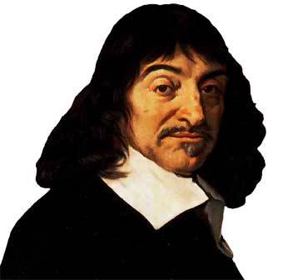
He wanted to know if we knew anything with any certainty.
He decided that…
First we need to remove from our minds everything about which we have the slightest doubt;
- our sense experience (even what we see is an illusion)
- our memories of the past (different people remember the same event differently)
- what we think we know now (was that a dream or an illusion?)
What are we left with? DOUBT!
We can be certain that we are DOUBTING!
This means that we are THINKING
The fact that we are THINKING is the reason that we know we exist!
Descartes put it this way:
Cogito ergo sum – ‘I think therefore I am’
As a result of THINKING, Descartes believed we could understand the natural world and the world of ideas.
Thinking is REASON. Reason is PHILOSOPHY. Philosophy means … (refer to lesson 1!)
Descartes believed reason could lead us to believe lots of things with certainty. For Descartes, REASON led him to believe in God.
How might REASON lead to belief in GOD?

What do YOU think about this argument? Why?

