**Task 3**

**Add a new function to the program**

Type the following text:

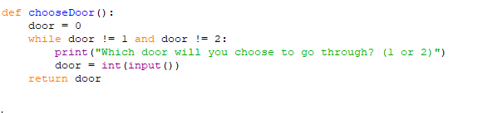

* Run the program
* In the shell, type the following and press enter:
* chooseDoor()

The program should ask you the question:



…and then output’s your answer

Explain what this function is doing.

Specifically mention:

* The input() function
* Storing a value in a variable
* The effect of using the return keyword