Name: Class:

Task 1

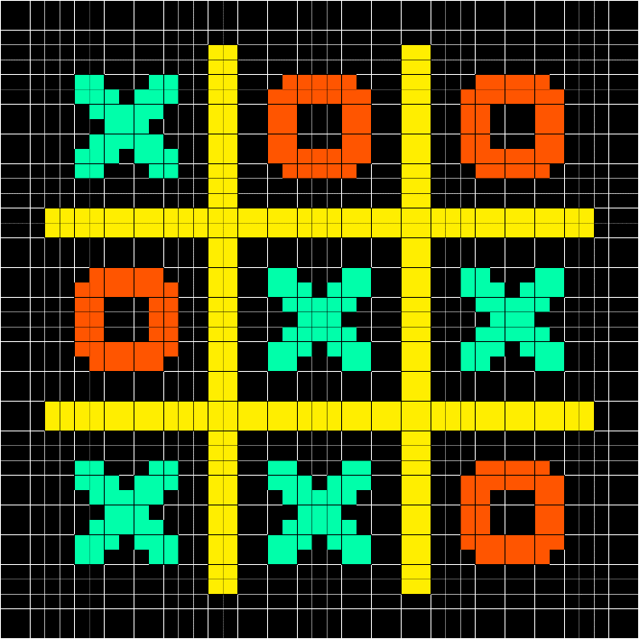

Processing an image starts with identifying shapes in very fine detail, so looking at just a few pixels.

A noughts and crosses board will contain a set of O and X symbols.

Remember that in pixel form, rounded shapes will be squared off (pixelated) when stored.

Create a set of at least **five** rules that can determine if a symbol is an O or an X.

Task 2

1. Open Scratch 3 or, if this isn’t on your computer, go to <https://scratch.mit.edu/> to use the online version of Scratch.

2. Open the file ShapeScanner1.sb3 that your teacher gives you.

3. Make sure you have the Detector sprite selected so that it shows the Code tab.

When the green flag is pressed the following code is run:

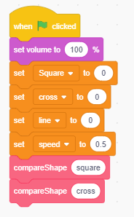

4. Run the program to see what it does.

5. Make changes to the variable named speed. What is the effect of changing this variable?

6. Add one block to the left program so that it also compares the left shape to the line shape.

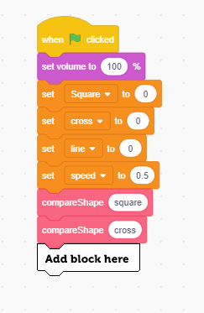

7. Adapt the left program so that it displays which shape has been identified.

The following blocks are likely to be helpful in your adaptation of the program:

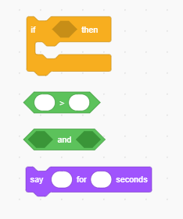

8. Explain how the compareShape algorithm works.

9. What does the following code in compareShape do?

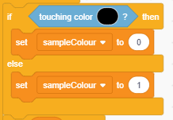

10.

* Select the square sprite then go into the costumes tab.
* Create the following costumes for the sprite, then run the AI program on them to see what shape it decides they are.
* Write the output in the table below.

|  |  |
| --- | --- |
| **New costumes** | **Output** |
|  |  |
|  |  |
|  |  |

Extension

Make changes to the program’s output to make it give more meaningful output.

Some suggested ways to improve the output:

* If the scores are the same, it could say that it can’t decide, and it might be one shape or another
* If the scores are all close by, it could say that it is finding it hard to tell which shape is being used