Name: Class: Mark:

1. A self-driving car is travelling towards a zebra crossing. There are three people on the crossing on the cars side, and one person on the crossing on the other side.
The car’s brakes fail. The computer must decide whether to continue on the left of the road, potentially injuring people, or turn right, potentially injuring one person.
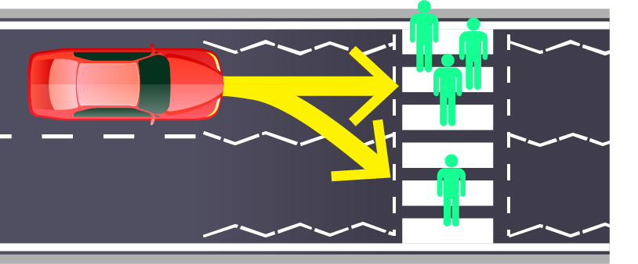
(a) Choose whether you would program the car to stay in the left lane or switch
to the right lane. Explain why you made this choice. [2]
Left lane or right lane:
Reason for choice:

(b) The car now encounters a situation where it has the following choice:
- Keep moving forward and risk running over a pigeon
- Turn to avoid the pigeon, mount the kerb and burst the car tyre.
Choose whether you would program the car to keep moving forward or turn to
avoid the pigeon. Explain why you made this choice. [2]
Keep moving forward, or turn and avoid the pigeon:
Reason for choice:

2. AI could be used to automatically fine people who cross a pelican crossing when
the lights for pedestrians are red.
Give two ethical issues such a system may create. [2]
Ethical issue 1:

Ethical issue 2:

3. Many jobs in the future are likely to be replaced by AI and automation.
Give one job that is likely to be replaced by automation. [1]

4. Give three reasons why AI and a robot would be likely to replace this job. [3]

[Total 10 marks]

