GCSE Music 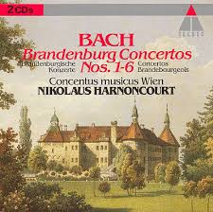

SET WORK INFORMATION

J.S. Bach

(1685-1750)

Brandenburg Concerto No. 5 in D Major, 3rd Movement

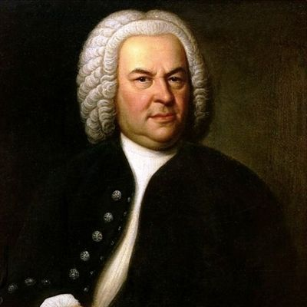

STUDENT NAME………………………………………

BASIC INFORMATION



*J.S. Bach was born in Germany in Eisenach. He came from a family of professional musicians and was the youngest of 8 children. Both of his parents had died by the time he was 10 and so he was brought up by an elder brother – who was an organist – and helped Bach develop his musical skills.*

* *He became a choirboy at the age of 15*
* *He became church organist and choirmaster in 1703 and 1707*
* *In 1717 he was appointed Kapellmeister (choirmaster) at the court of Prince Leopold in Cothen and it was at this time that the Brandenburg Concertos were written*
* *He wrote lots of vocal music (particularly sacred), organ music and other instrumental pieces*

Bach wrote during the **Baroque** period of music. Although there is not a technical start and end date – it is approximately 1600-1750.

KEY FEATURES OF THE BAROQUE PERIOD

1. Terraced dynamics (two stages – loud and soft)
2. Baroque orchestra – mainly strings with SOME woodwind and brass (depending on the availability)
3. Use of Harpsichord (Basso continuo)
4. Use of sequences, pedals and suspensions
5. Use of ornaments

Other well known Baroque composers

* Vivaldi
* Corelli
* Handel
* Purcell

**Consolidation activity**

Here is a selection of tasks that get progressively more challenging. You should spend an hour completing this. If you have not completed it after an hour, there is not an expectation to keep going until you have.

1. What are the dates and nationalities of the 4 composers named on the previous page (write these next to their names)?
2. Write definitions (that YOU understand) of all the key terms which have been printed in RED on the previous page. You should do this in the box below and indicate on the previous page that this information is here.
3. This piece is from a group of how many which form the whole concerto No. 5?
4. What is the difference between a concerto and a concerto grosso? Which is this piece?

____________________________________________________________________________________________________________________________________________________________________________________________________________________________________________________________________________________________________

1. Listen to another piece from this concerto and complete the statement below

I listened to_________________________________ and I thought that things which were similar were;

a)

b)

c)

And things which were different were;

a)

b)

c)

Keywords and their definitions

**Wider Listening (General)**

Each piece you listen to requires you to also know about other SIMILAR types of music. They could be similar because

* the same composer wrote them
* because they are written in the same musical period,
* many other reasons.

Here is a list of pieces of music which **could** be linked to this set work and the composer. The youtube links are also provided (should you wish to access this booklet online). In the boxes provided, make some comments about why you think this piece is included in the wider listening for this set work.

Piece 1 – ‘Autumn’ from the ‘Four Seasons’ by Vivaldi

Youtube link – <https://www.youtube.com/watch?v=H7hGiZ579cs>

Comments ;

Piece 2 – Vivaldi Trumpet concerto in Ab.

Youtube link – <https://www.youtube.com/watch?v=pWTr0MyITJ4>

Comments ;

Piece 3 – Bach Mass in B Minor - Gloria

Youtube link – <https://www.youtube.com/watch?v=izVzruuk1lc>

Comments ;

**Analysis of our Set work**

**Facts about the context of the piece**

*What style is it? What are the key features of this style? Are they in this piece? Is it part of a bigger piece? If so, where does this piece ‘sit’ in comparison?*

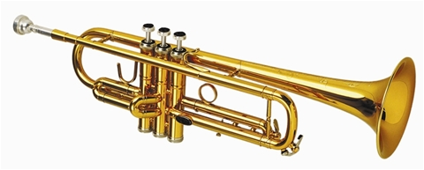 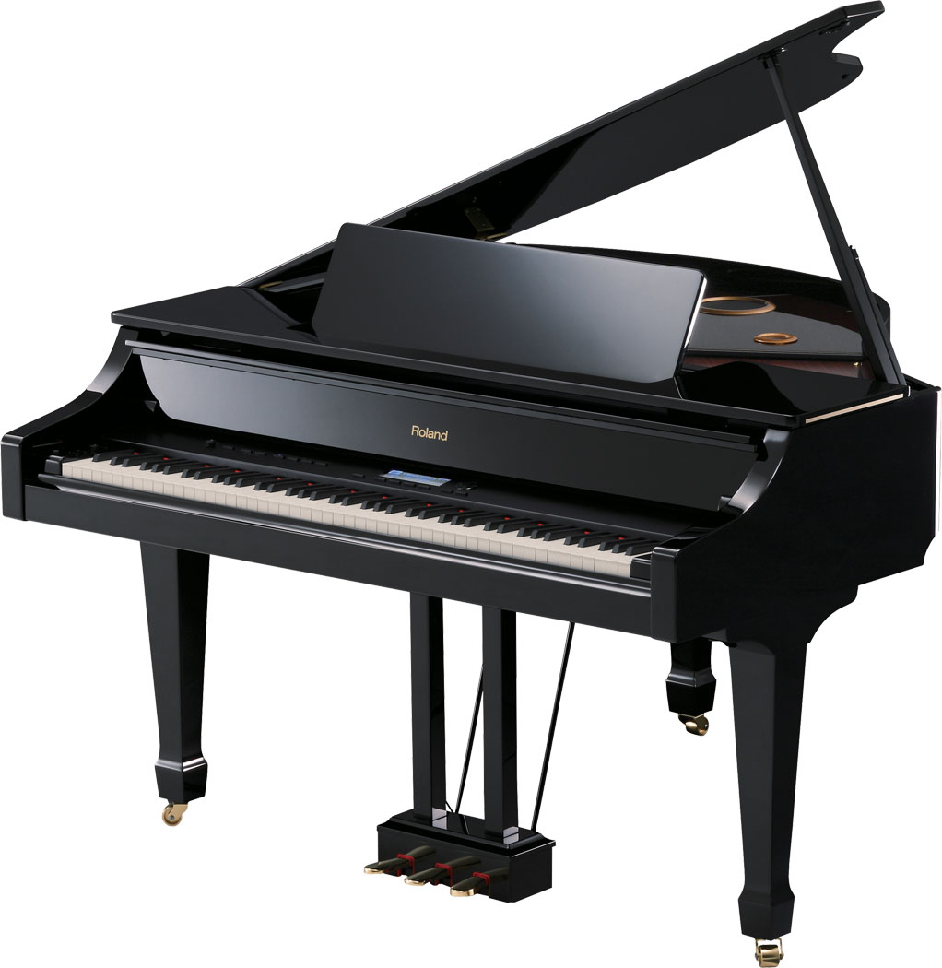

**Sonority**

*Think about; what instruments are playing in the piece? What role does each of them have? (don’t forget singers!). Is it tricky to play? Why? Does it use a large range for that instrument? Are there any specific techniques used (like mutes, effects etc). What are the dynamics like in the piece?*

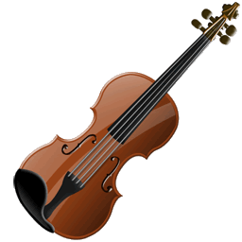 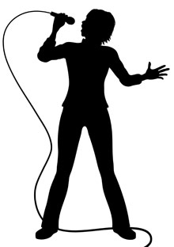 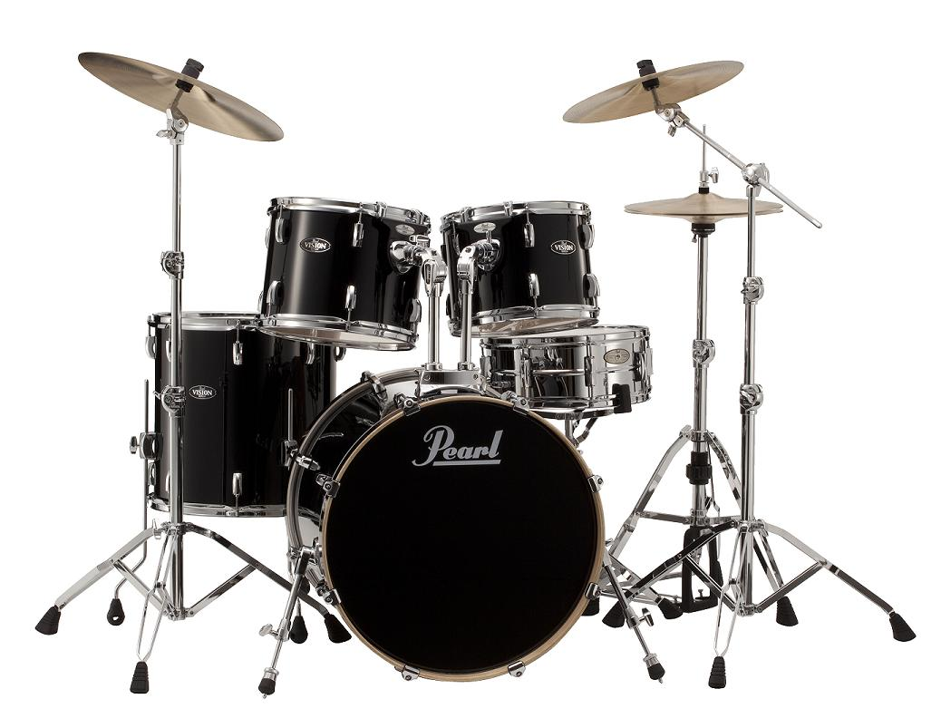 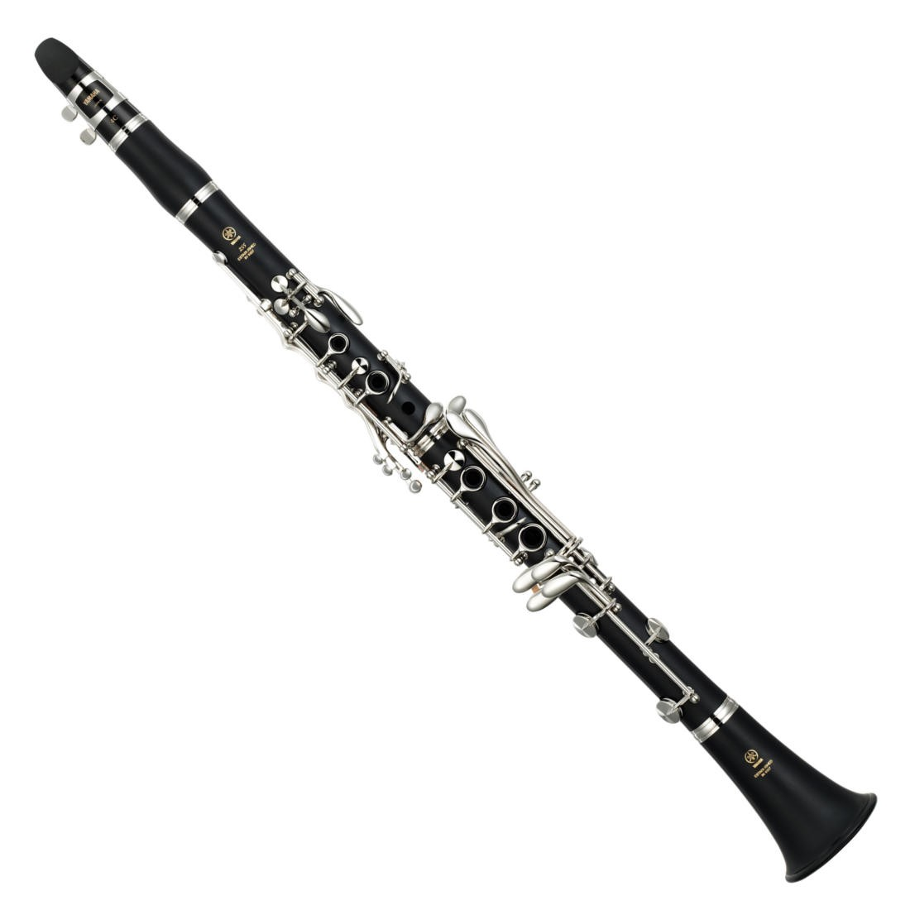

**Melody**

**Rhythm, Tempo & Metre**

Think about; *dotted notes? Triplets? Swung quavers? Syncopation? Hemiola? Anacrusis? Time signature(& and changes to it), strong beats of the bar, repeated patterns, key rhythms in the piece. What is the speed of the piece? Does it change? Can you use an Italian term to describe the tempo?*

*Think about; instruments, doubled melody? Octaves? 3rds? Unison? Regular phrases? Tessitura? Conjunct? Disjunct? Diatonic? Chromatic? Rising? Falling?*

**Harmony**

Think about; *Use of chords? Chord Progressions? Circle of 5ths? 12 Bar Blues? Important patterns at cadences? Diatonic or chromatic? Functional (I and V & Cadences)? Harmonic rhythm? Does it stay the same?*

**Structure**

Think about; *is it varied? Repeated? Contrasted? Ternary? Sonata Form?*

**Texture**

Think about; *Monophonic? Polyphonic? Homophonic? Antiphonal? Heterophonic? Pedal? Countermelody? Exchanging ideas in parts? (DIALOGUE)*

**Tonality**

Think about; *Major .Minor, Modal, Atonal. Does the key change?*

**Dynamics**

*How would you describe the volume of the piece? Does it change? Are all the instruments the same volume?*

**Listening Activities**

*Here are some listening questions linked to your set work.*

LISTENING 1 (0.00-0.30secs)

You will hear the piece 3 times.

1. Name the first instrument which plays?_____________________________________(1 mark)
2. Describe the role of the flute at the start of the extract?

______________________________________________________________________________________________________________________________________________________________________________(2 marks)

1. Which instrument is introduced after the flute?

‘cello organ harpsichord 2nd violin

(1 mark)

1. Describe the texture during the extract

____________________________________________________________________________________________________________________________________________________________________________________________________________________________________________________________________________________________________________________________________________________________________________________

(3 marks)

LISTENING 2 (2.43-3.12)

You will hear the piece 3 times

1. Name the solo instrument at the start of the extract? _______________________

(1 mark)

1. Name the ornament heard in this solo? _______________________

(1 mark)

1. Which statement best describes the accompaniment during the solo? (underline two statements)
2. The orchestra does not play
3. The orchestra plays in unison/octaves
4. The orchestra plays throughout the extract
5. The orchestra plays short ideas but is not always playing

(2 marks)

1. Name two typical Baroque features which are heard in this extract?
2. _______________________________________________________
3. _______________________________________________________

(2 marks)

***REINFORCING YOUR LEARNING****; In addition to these listening questions you should also be listening to this set work at times when we aren’t studying this piece. You should also be able to identify when particular sections change and also the keys and instruments.*

**Extended Response question**

For each set work, you MIGHT be asked to write in more detail about the piece. You will hear the piece played to you and you will also have a piece of music you’ve NOT studied as well.

They will be linked in some way (for example, if you are asked to write about a vocal piece, then the unknown piece is quite likely to be a vocal piece too).

Vivaldi – Four seasons – Winter. (0.00-2.10)

<https://www.youtube.com/watch?v=TZCfydWF48c>

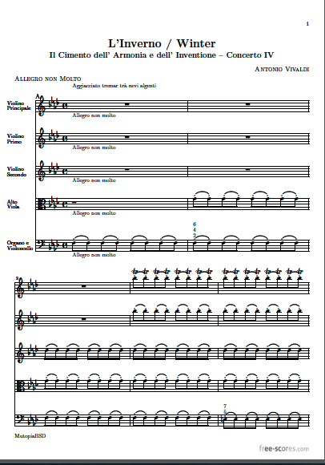

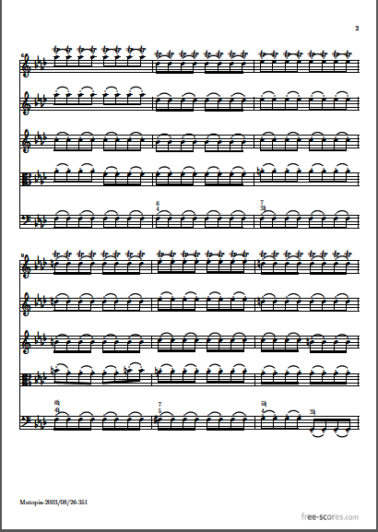

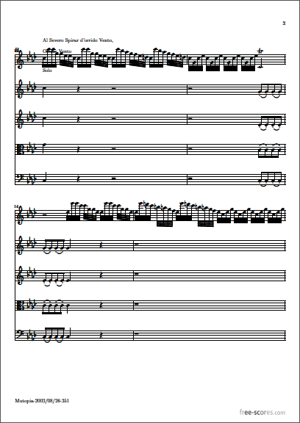

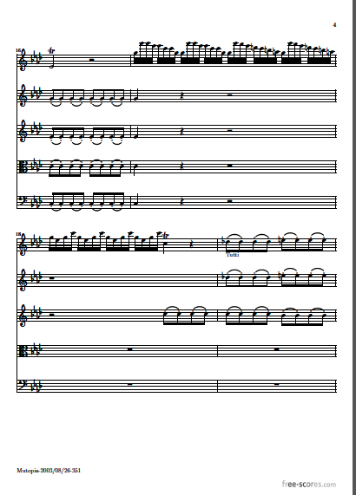

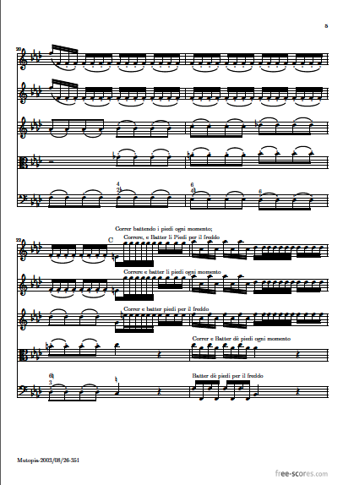

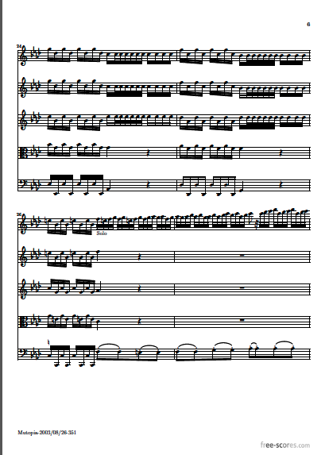

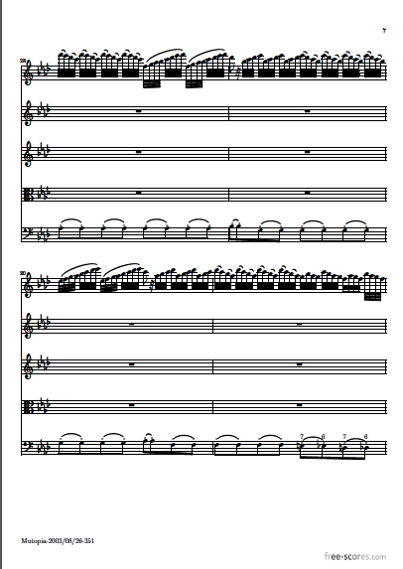

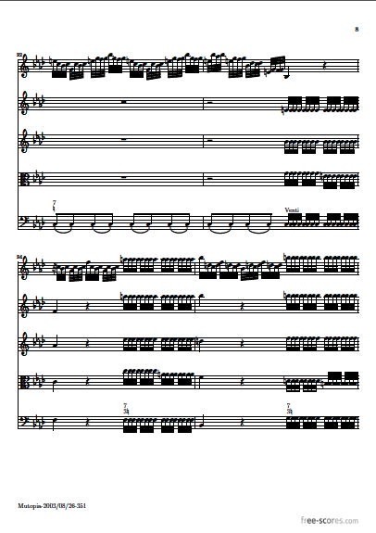

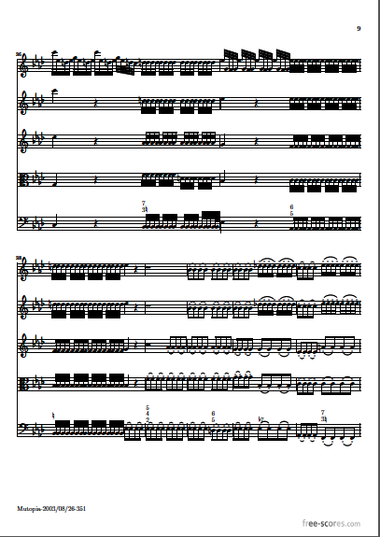

**NOTES ON ‘UNFAMILIAR’ PIECE OF MUSIC**

**Typical Question**

Using the notes you have made above and the notes earlier in this booklet about your set work, then answer the following question. You should spend no more than 25 minutes putting the answer together.

***Things to consider***

* You need to give facts EQUALLY about both pieces
* It will be marked out of 12 (see the next page for the marking guidance from the exam board)
* You should back up each point with a bar reference (or example) from the score
* Include a conclusion at the end

QUESTION

Compare and contrast the use of the orchestra in the excerpt from *Bach’s Brandenburg No5 in D Major* and in *Vivaldi’s ‘Winter’ from The Four Seasons*. You should ensure that you reference any valid points made.

(12 marks)

(12 marks)

**Mark Scheme for 12 mark responses**

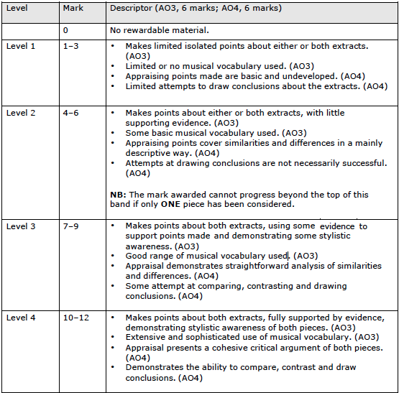

**Challenge and consolidation activities**

Here are a selection of different activities you could try in relation to this set work. Some are designed to help you check your understanding and others (marked with an *) are designed to challenge you.

Sometimes, these will be set as personalised homework, but other times, they should be used by you outside of your classroom learning to support your knowledge.

1. Can you write 2 sentences which describe the structure of this piece?
2. Can you create a wordsearch which includes at least 20 keywords related to this piece?
3. What key is this piece in? How do you know?
4. Can you list 4 facts about the composer of this piece?
5. Can you name 3 other Baroque composers?
6. *which features of Baroque music ARE NOT found in this set work?
7. *What features of Baroque music were developed as the music moved into the Classical period?
8. *Which features of Baroque music were no longer used as the music moved into the Classical period?
9. Name 3 famous Classiscal composers?
10. *What are the main chords and cadences used in this set work?

Cross off each of the questions when you have completed them. Lined paper is provided at the end of this booklet for these tasks.



