Name: Class:

Task 1

The computer scientist Alan Turing imagined a test of artificial intelligence, which aimed to answer the question: can machines think?

A judge texts questions to a human, and to a computer. He cannot see either – and because they communicate by text, he can’t analyse a voice to see if it is real or artificial.

The test is as follows: if the judge can’t tell from the answers which is from the human and which is from the computer, then the computer has shown that it is able to think.

(a) Devise at least **three** questions for the judge to use.

(b) Explain why you think that the questions you have chosen would be hard for a computer to answer.

(c) Try the online experiment at: <https://www.newscientist.com/article/visual-turing-test/>

Task 2

Look at the below captcha.

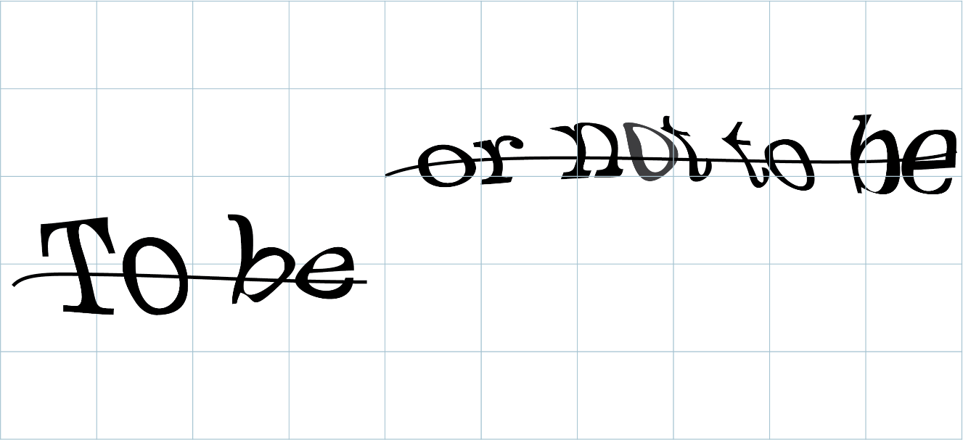

(a) What does the captcha say?

(b) Give **four** reasons that a computer with AI would find this hard to read.

1.

2.

3.

4.

(c) Give one other way that captchas can be carried out by websites.

Task 3

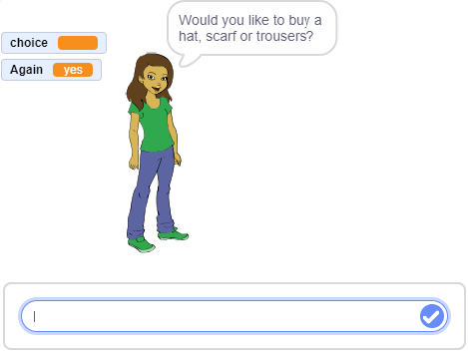Chatbots are computer programs that talk with people. They are often used on the Internet to help people solve problems.

You are going to develop a small chatbot to help in an online clothing shop.

1. Open the file Chatbot1

2. Press the green flag to run the file

3. When asked the question “Would you like to buy a hat, scarf or trousers?” make suitable replies to complete the table below.

|  |  |
| --- | --- |
| **Reply to question** | **Response from the chatbot** |
| hat |  |
| I’d like to buy a scarf please |  |
| trowsers |  |
| I definitely don’t want trousers |  |

4. How do you think the chatbot works?

5. Adapt the program so that once the item of clothing has been chosen, the chatbot will ask the user if they would like to pay by cash or card. If the user says “cash” then the chatbot will say “sorry we can’t accept cash on the Internet”, if they say “card” answer with “please enter your card number”.

6. Make the chatbot say or ask other things to make it more human. For instance, they may say things like please/thank you or even ask if the person is okay, needs any help, or how the weather is.

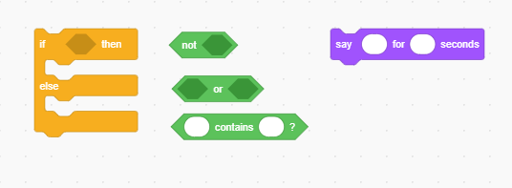7. If the user doesn’t enter hat, scarf or trousers, the chatbot makes no response. Instead, make the chatbot say “I don’t understand” if they haven’t picked one of these three items of clothing. You may find the blocks below are helpful in solving this question.