# Homework 5 Graphs

# 1. Draw the adjacency matrix for this graph. [5]

|  |  |  |  |  |  |
| --- | --- | --- | --- | --- | --- |
|  | **A** | **B** | **C** | **D** | **E** |
| **A** |  |  |  |  |  |
| **B** |  |  |  |  |  |
| **C** |  |  |  |  |  |
| **D** |  |  |  |  |  |
| **E** |  |  |  |  |  |

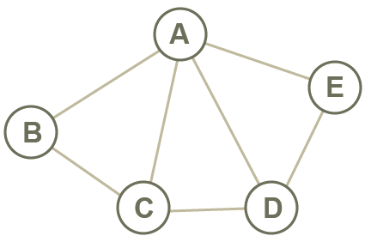

# 2. Draw the adjacency list for this graph. [5]

|  |  |  |  |
| --- | --- | --- | --- |
| **A** |  |  |  |
| **B** |  |  |  |
| **C** |  |  |  |
| **D** |  |  |  |
| **E** |  |  |  |

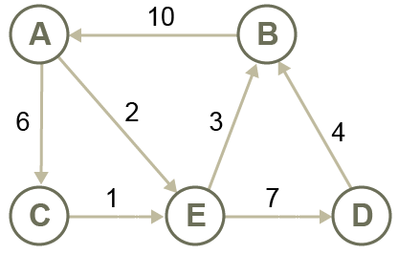

# 3. Contrast the use of an adjacency matrix with that of an adjacency list [5]

# 4. Draw the graph for this adjacency list. [5]

|  |  |  |  |
| --- | --- | --- | --- |
| **A** |  |  | [D, E] |
| **B** |  |  | [C, E] |
| **C** |  |  | [B, D] |
| **D** |  |  | [A, C] |
| **E** |  |  | [A, B] |

[Total 20 Marks]