# Worksheet 7 Vectors

**Task 1**

1. Describe **three** different ways in which a vector can be represented. [3]

2 ℕ is the set of all natural numbers (whole counting numbers including 0)

ℝ is the set of real numbers

(a) Give an example of a 3-vector over ℕ, defined as a function f: S ↦ ℝ,

where S is the set {0, 1, 2} and ℝ is the set of Real numbers [1]

(b) Show how this function could be represented as a dictionary. [1]

(c) How is the vector notation ℝ2 spoken? [1]

(d) Give an example of a ℝ2 as an arrow [1]

(e) Give an example of a ℕ4 vector defined as a list. [1]

3. (a) Add the two vectors shown in the diagram and draw the resultant vector. [1]

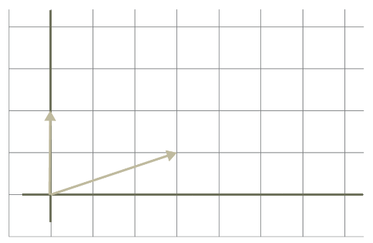

(b) Give the resultant vector as a Cartesian coordinate. [1]

(c) Show that the arithmetic method of adding vectors produces the same result. [1]

4. Point A is defined as (-2, -1).

(a) Draw the vector which corresponds to this point on the diagram. [1]

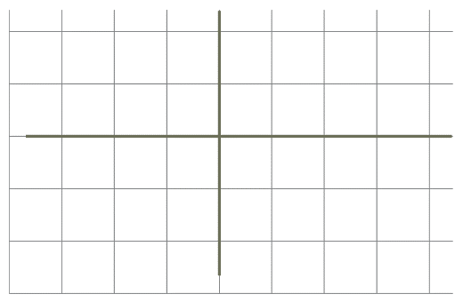

(b) Use scalar vector multiplication to multiply the vector by1/2. [1]

(c) Draw the resultant vector on the diagram below. [1]



(d) Give the name for the effect of scalar vector multiplication on the vector. [1]

Total marks for Task 1: [15]

**Task 2**

5. The convex combination method of combining two vectors is given by *w* = *αu + βv*.

(a) What constraint is applied to the values of *α* and *β*? [2]

(b) Show the convex combination of the following vectors. Show your working. [2]

*u = [4, 8, 12] v = [16, 16, 16]*

*α = ¾ β = ¼*

6. The dot product (*u* •  *v*) is a way to multiply 2 vectors.

(a) Given the two vectors below, find *u* •  *v.* Show your working. [2]

*u* = [7, 2] *v* = [4, 3]

(b) Using the formula given below for cos Ɵ, where Ɵ is the angle between the two vectors:

cos Ɵ = (u • v )

(ǁuǁ • ǁvǁ)

find cos Ɵ for the two vectors *u* and *v* given above. [2]

(c) Given that cos 90° = 0, use the dot product of two vectors [7, 2] and [6, -21] to determine whether they are at right angles to each other. [1]

(d) (i) Draw the vectors *u* = [2, 1] and *v* = [-3, -1.5] [2]

(ii) Use the diagram to find the angle Ɵ between the vectors. [1]



(iii) Find the value of cos Ɵ using the formula given in part (b) [3]

Total marks for Task 2: [15]