**Passing the score into userScoreLbl**

Add the following block of code at the correct position:

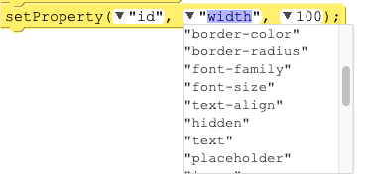

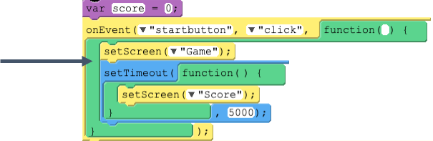

Customise the properties so that it changes the text to the value of the score variable.

### **Explorer activity**

* Add and code a **Play again** button

Resources are updated regularly — the latest version is available at: [ncce.io/tcc](http://ncce.io/tcc).

This resource is licensed under the Open Government Licence, version 3. For more information on this licence, see [ncce.io/ogl](http://ncce.io/ogl).