# The canyons of Arizona

The Grand Canyon in Arizona is a natural wonder that you simply have to see to believe. Stretching 277 miles from end to end, the steep, rocky walls plunge more than a mile down to the floor of the canyon, where the Colorado river snakes its way towards the Southwest.

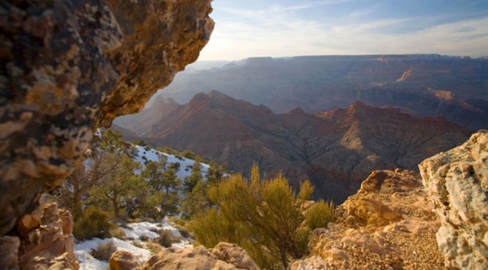

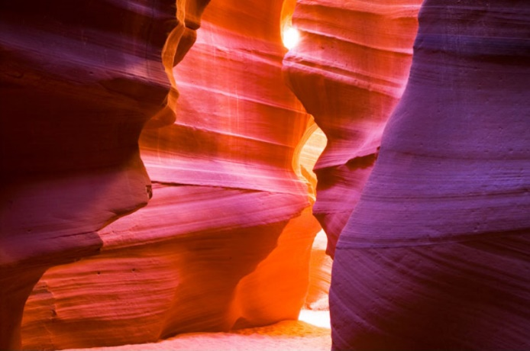

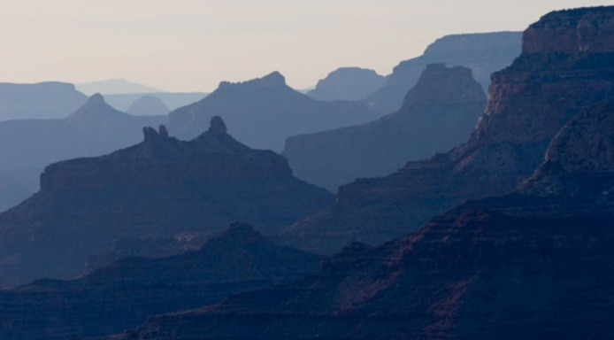

Around 5.5 million people visit the Grand Canyon each year. The South Rim can be accessed by free shuttle buses or by personal transport.

Antelope Canyon is a **slot canyon** on Navajo land east of Page, Arizona.