**Homework 5: Macros and charts**

1. (a) What is a spreadsheet macro? [2]

(b) Give an example of when a macro might be useful in a spreadsheet. [2]

2. Here is a spreadsheet showing statistics about users on the top five social media sites in 2017.

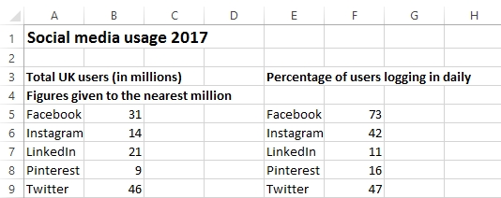

Suggest two ways in which this data can be made more easily understandable [2]

3. Given the choice of a bar chart, pie chart or line graph, which would be the most suitable type of chart/graph to display these figures in graphical form?

Give a reason for your answer. [4]

[Total 10 marks]