Answers
Starter
1. An engineer requires 100 m of steel cable.
(a) How could this be represented in:
i) millimetres? 100 × 1000 = 100,000 mm
ii) centimetres? 100 × 100 = 10,000 cm
(b) Explain what happens to the place value of each digit in your answers above in order to convert from metres to cm and mm.
The decimal place is moving to the left as the units get smaller.
2. The average weight of a member of a user group is 68.54 kg.
(a) Round this figure to the nearest whole number. 69 kg
(b) Explain how you rounded the number.
To round to the nearest whole number, you refer to the first number after the decimal point. If this number is 5 or more, the number should be rounded up.
Task 1
1. Calculate the following:
(a) A student has turned an aluminium tube to an external diameter of 8.45 mm.
Write this figure to 1 d.p.
8.5 mm
(b) A teak garden bench has a mass of 30.78 kg.
Write the mass to 1 d.p.
30.8 kg
(c) A bag of 500 buttons have a total mass of 235.78 g.
Work out the average mass of a button to 2 s.f.
Average mass of a button = $\frac{235.78}{500}$ = 0.47156 g = 0.47 g (2 s.f.)
2. A blow moulding machine produces 1200 biodegradable plastic bottles per hour.
The costs and materials for each hour of manufacture are listed below:
- Running costs: £31
- Mass of polymer needed: 21.45 kg
- Volume of polymer needed: 45.47 litres
Based on these figures:
(a) Calculate the running costs per bottle. Give your answer to 2 d.p.
$\frac{31}{1200}$ = 0.025833… = £0.03 (2 d.p.)

(b) Calculate the mass of polymer per bottle in grams. Give your answer to 2 d.p.
$\frac{21.45}{2100}$ × 1000 = 17.875 = 17.88 g (2 d.p.)
(c) Calculate the volume of polymer per bottle in millilitres. Give your answer to 2 s.f.
$\frac{45.47}{2100}$ × 1000 = 37.89166… = 38 ml (to 2 s.f.)
3. A family car produces 250 g of CO₂ per km. The car travels 150 km per week on average.
Calculate the total mass of CO₂ produced per year (365 days in a year) by the car.
Give your answer in kilograms to 3 s.f.
CO₂ produced per week = 250 × 150 = 37,500 g = 37.5 kg
CO₂ produced per year = $\frac{37.5}{7}$ × 365 = 1955.357... = 1,960 kg
Task 2
1. Express the following numbers in standard form.
(a) A steel bar with a mass of 156,700 g
1.567 × 10⁵ g
(b) A volume of epoxy resin of 0.0045 m³
4.5 × 10⁻³ m³
2. Express the following standard form numbers as ordinary numbers.
(a) An aircraft has wings with a span of 3.58 × 10⁴ mm
35,800 mm
(b) The aircraft travels at 9.6 × 10² km/hour
960 km/hour

3. The diagram shows a flexible solar cell.
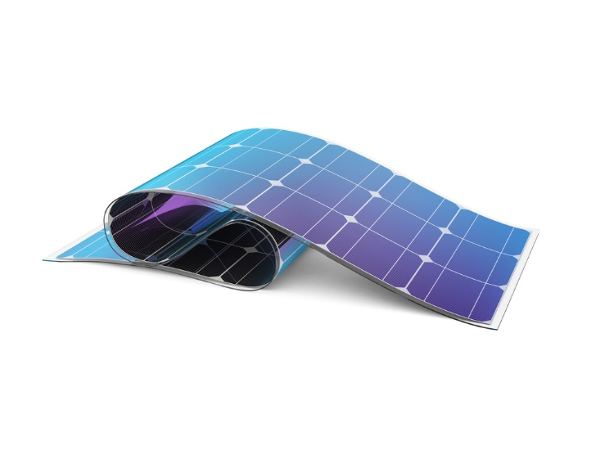
In each square cell, there is a thin wafer of silicon semi-conductor.
The squares have a length of 15 cm and a thickness of 0.25 mm.
Convert both dimensions into metres. Express both dimensions in standard form.
$\frac{15}{100}$ = 0.15 m = 1.5 × 10⁻¹ m

$\frac{0.25}{1000}$ = 0.00025 m = 2.5 × 10⁻⁴ m

