# Worksheet 6 Finite state machines

**Task 1**

1. The following FSM will accept only certain sequences of the symbols a and b.

Which of the following sequences will it accept?

(i) a (ii) abba (iii) bbaa (iv) bababaa (v )baaa

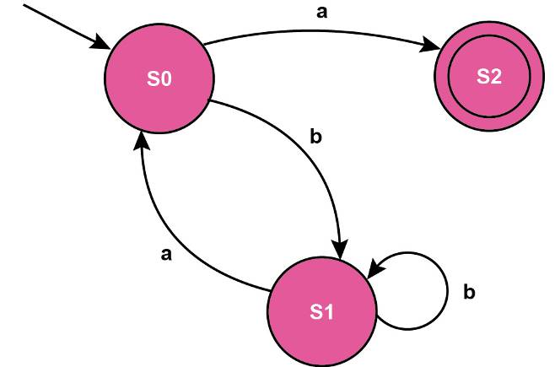

2. Which of these inputs are valid for the FSM below?

(i) 999 (ii) 9-3+77 (iii) 000999+ (iv) +67-4 (v) 0 + 9 + 6 + 54321 -1

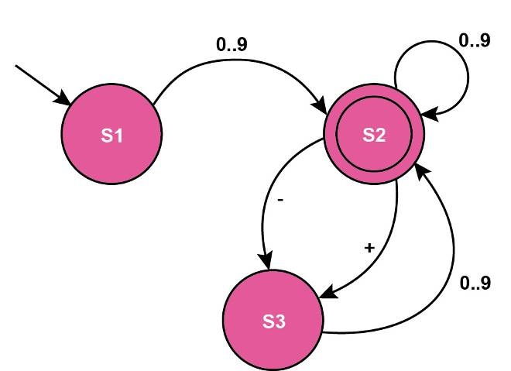

3. Draw a finite state machine which will accept the strings Ban Bran Brrr

**Task 2**

4. The FSM below determines whether a string is valid. Inputs are represented by 1 and

(a) Which of the following strings are valid?

10000 11011 100011

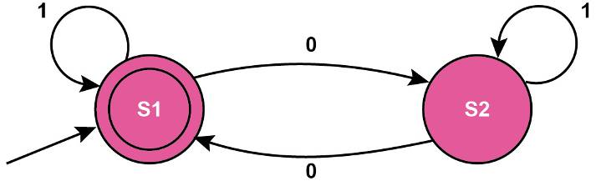

(b) What is the rule for a string which will be accepted?

(c) Complete the state transition table representing the FSM

|  |  |  |
| --- | --- | --- |
| **Original state** | **Input** | **New state** |
| S1 | 0 |  |
| S1 | 1 |  |
| S2 |  |  |
| S2 |  |  |

5. Draw the finite state machine corresponding to the state transition table below.

|  |  |  |
| --- | --- | --- |
| **Original state** | **Input** | **New state** |
| S1 | a | S2 |
| S1 | b | S1 |
| S2 | a | S2 |
| S2 | b | S1 |
| S2 | c | S3 |

6. A turnstile opens when 20p is inserted. It will accept one 20p coin or two 10p coins. If a customer inserts 10p and then realises they have no more 10p coins, they can press Cancel and their 10p coin is returned. If they insert 20p after already inserting 10p, the turnstile will not open and they must press Cancel and start again.

The Finite State Machine below shows this process.

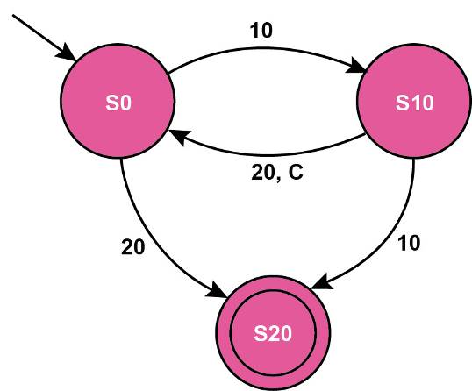

Complete the transition table below for this FSM.

|  |  |  |
| --- | --- | --- |
| **Original state** | **Input** | **New state** |
| S0 | 10 |  |
| S0 | 20 |  |
| S10 |  |  |
| S10 |  |  |
| S10 |  |  |

7. Draw the state transition diagram and the equivalent state transition table for a language in which an identifier must start with a letter and be followed by one or more letters or numbers.

If the first character input is a number, it reaches a “dead state” from which it can never reach the Accept state. Mark this state with the letter D.

|  |  |  |
| --- | --- | --- |
| **Current state** | **Input** | **Next state** |
|  |  |  |
|  |  |  |
|  |  |  |
|  |  |  |
|  |  |  |
|  |  |  |