Name: Class: Mark:

The following sample data shows three castles in Germany and three castles in England.

|  |  |  |
| --- | --- | --- |
|  |  |  |
| **Neuschwanstein Castle, Germany** | **Burg Eltz, Germany** | **Hohenzollern Castle, Germany** |
|  |  |  |
| **Windsor Castle, England** | **Lowther Castle, England** | **Arundel Castle, England** |

(a) Write **five** rules that identify a German castle. [5]

1.

2.

3.

4.

5.

(b) Write **five** rules that identify an English castle. [5]

1.

2.

3.

4.

5.

The final image is the Sleeping Beauty Castle in Disneyland Paris.

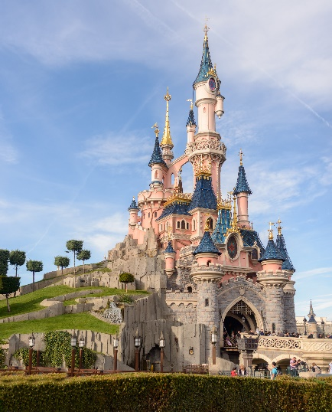

(c) Complete the table below to show the probability that the Castle is of an English   
or German design. [4]

|  |  |  |
| --- | --- | --- |
| **Country** | **Germany** | **England** |
| Number of rules met |  |  |
| Probability that this castle is German / English  (To get a percentage, multiply the number of rules met by 20) |  |  |

(d) According to your rules, is the Sleeping Beauty Castle based on a German Castle   
design or an English Castle design? [1]

[Total 15 marks]