**Homework 5: Sound**

# The first sound pattern below has been recorded three times using different digital sampling settings.

**Recording A**

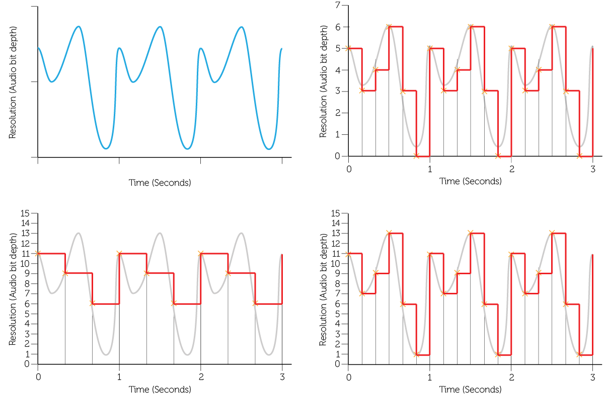

**Recording B**

**Recording C**

Calculate the file size of the each of the recordings A to C: (Show your workings) [6]

A:

B:

C:

# Which of the recordings above will be of the highest quality? [1]

# State a device that is used to capture an analogue sound signal. [1]

# The length of a recording will heavily influence the size of the sound file. State two factors other than recording length that determine the file size of a recording. [2]

5. Draw a line to match each file type to its appropriate technical term. [5]

|  |  |  |
| --- | --- | --- |
| MP3 file |  | A commonly used image format used by digital cameras |
| MP4 file |  | An audio coding format which uses a form of lossy data compression |
| WAV file |  | A set of instructions for digital instruments to play synthesised sounds, commonly used for phone ring tones |
| MIDI file |  | A digital multimedia format most commonly used to store video and audio |
| JPEG file |  | An audio file format used for raw and typically uncompressed audio |

[Total 15 marks]