Name: Class: Mark:

1. A sequence of steps that solve a computational problem is known as what?
Tick the correct answer. [1]
- A A recipe
- B An algorithm
- C A menu
- D A loop

2. When a REPEAT statement is inside another REPEAT statement, what is this called?
Tick the correct answer. [1]
- A A bird loop
- B A worm
- C A nested loop
- D An algorithm

3. Rewrite the following algorithm using one REPEAT statement. [2]
Down
Up
Down
Up
Down
Up

4. Look at the maze shown below.
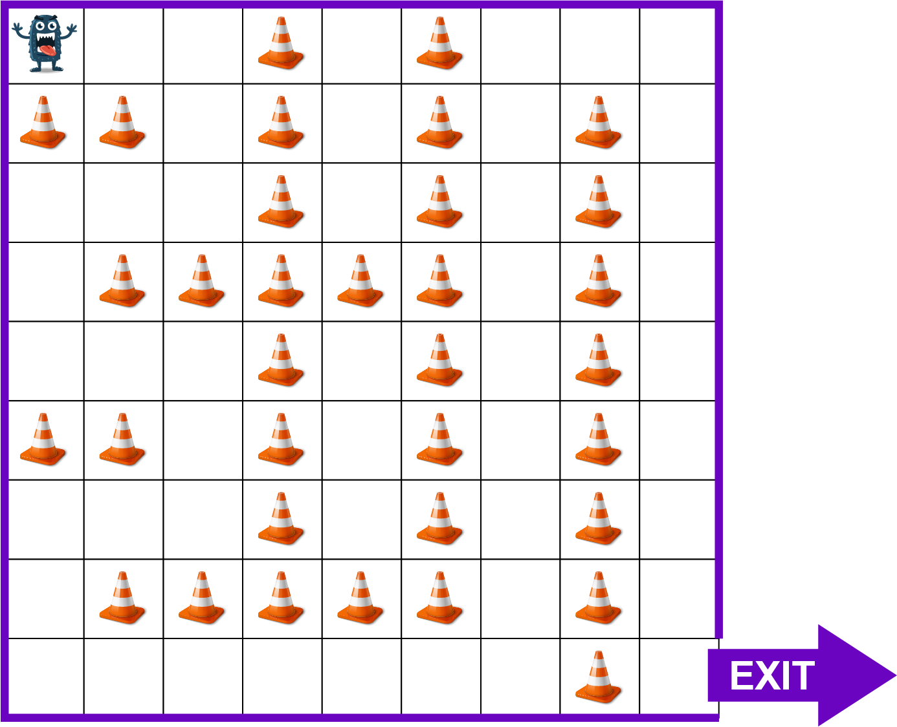 | Available instructions:  Right  Left  Up  Down  REPEAT number
Using only the instructions above, create a program to navigate through the maze to
the exit. Make use of as many REPEAT statements or nested loops that are required
to make the program as short as possible. [6]
[Total 10 marks]

