Name: Class: Mark:

1. A large electronics company recently conducted a life cycle analysis (LCA).   
The results highlighted that a number of harmful waste gases are being released as part of their manufacturing process.   
The company aims to trap the waste gasses during the manufacturing process.

The bar chart below shows the volume (per week) of 5 different gases that were highlighted in LCA.

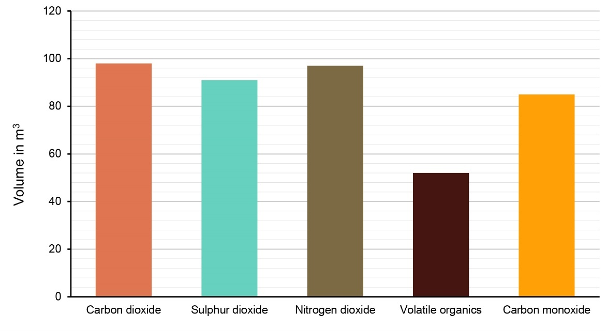

(a) Using the bar chart, give approximate values for each of the gases produced   
per week by the company. [5]

|  |  |
| --- | --- |
| Carbon dioxide |  |
| Sulphur dioxide |  |
| Nitrogen dioxide |  |
| Volatile organics |  |
| Carbon monoxide |  |

(b) What is the total volume of gases produced per week? [2]

(c) A special chemical filter is fitted to remove the carbon dioxide, sulphur dioxide and nitrogen dioxide gases.  
When this happens, what volume of gas still needs to be removed? [2]

(d) What is the percentage decrease in the volume of gases when the special chemical filter is being used. Give your answer to 1 d.p. [2]

2. A design business wishes to save money by changing 800 of its incandescent light bulbs to a more energy efficient variety.

The table below shows the three main types of bulb being considered. The figures give the power usage of a bulb, in Watts, measured at 1,600 Lumens (how bright they are).

|  |  |  |
| --- | --- | --- |
| Incandescent  100 W | Compact fluorescent  25 W | LED  18 W |
|  |  |  |

|  |  |  |  |  |
| --- | --- | --- | --- | --- |
|  | Watts  per bulb | Watts per 800 bulbs | Cost in  £ per hour | Cost in  £ per week |
| (a) | (a) | (b) | (c) |
| Incandescent |  |  |  |  |
| Compact fluorescent |  |  |  |  |
| LED |  |  |  |  |

Using the table overleaf:

(a) Work out how much energy is used by 800 of each bulb type and put the data clearly   
in the table overleaf. [4]

(b) It costs 10p to use 1,000 W for 1 hour. Work out how much it costs to   
power 800 of each bulb type for 1 hour. Give your answer in £. [3]

(c) Given that 800 bulbs are being used 10 hours each day, and for 5 days a week, work out the cost saving of moving from incandescent bulbs to LED bulbs each week. [3]

(d) Work out the annual cost saving for the design business. Assume that the   
business operates 45 weeks of the year. [2]

[Total marks 23]