**Worksheet 2: Creating a financial model**

Task 1

1. Suggest three products that you think would be good sellers. Find out approximate selling prices. (Check official websites for popular artists or groups.) Enter the products into Table 1 below.

Table 1

|  |  |  |
| --- | --- | --- |
| **Product** | **Website** | **Selling Price** |
|  |  |  |
|  |  |  |
|  |  |  |

1. Use the Internet to find out what would be a reasonable range of prices to charge for a good quality baseball cap, T shirt, hoodie and poster.

Make a note of the prices in the table below:

|  |  |
| --- | --- |
| **Baseball Cap** |  |
| **T-Shirt** |  |
| **Hoodie** |  |
| **Poster** |  |

Task 2

Save the spreadsheet Merchandising TBNT UK in your area and open it. This is the beginnings of the spreadsheet model that you will create to help StarCo estimate how much profit they can make from selling merchandise to TBNT fans.

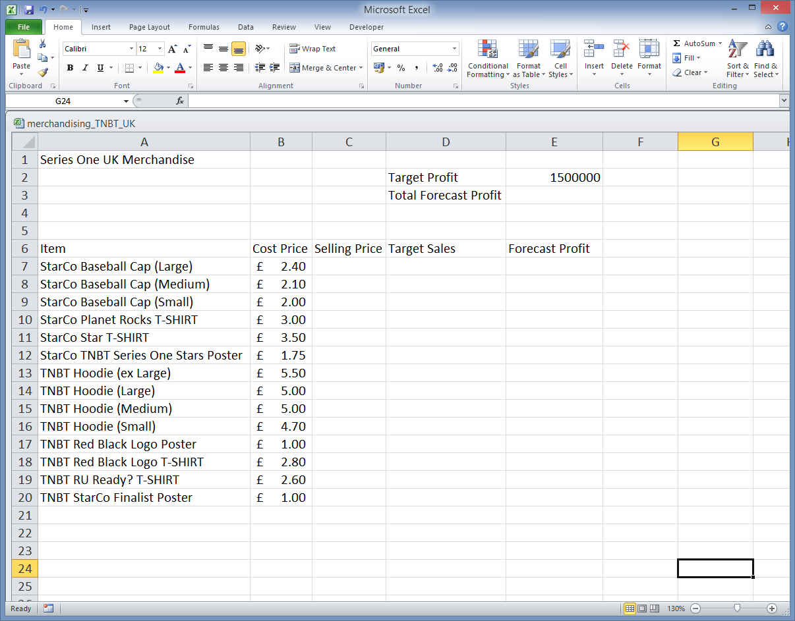

The cost prices of products that StarCo plan to sell have already been researched and entered into the spreadsheet. StarCo are going to base their projected sales on the sales figures from Series 1 (USA). Save and load this spreadsheet, named Merchandising TNBT USA, shown below.

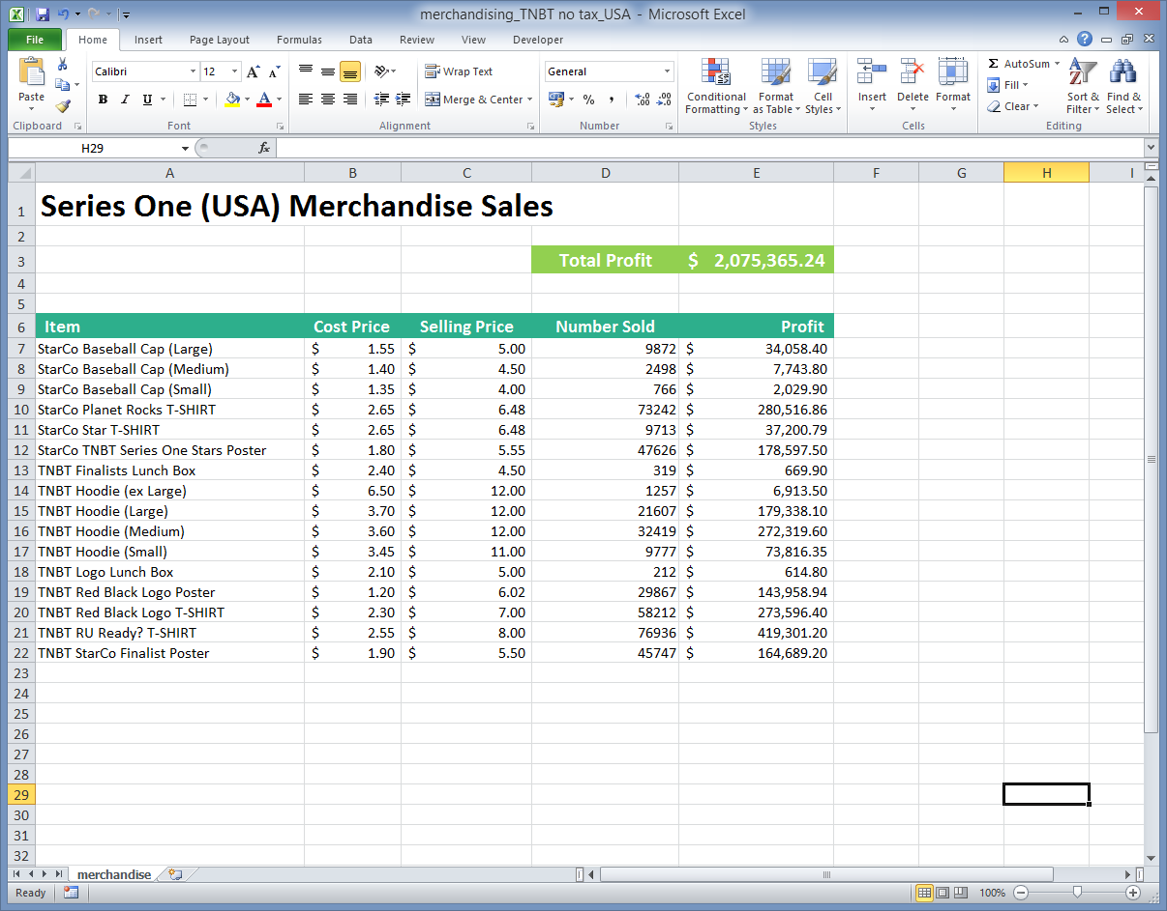

1. StarCo have decided not to include lunchboxes in their stock of merchandise. Why do you think this is?

Answer: ________________________________________________________­­______  
  
­­­­­­­­­­­­­­­­­­­­_____________________________________________________________________

The population of the US is approximately 5 times that of the UK. Use this fact, and anything else you consider relevant, to estimate and enter on your spreadsheet, Target Sales quantities of each product in the UK.

What factors apart from population, if any, did you consider? ____________________  
  
_____________________________________________________________________  
  
_____________________________________________________________________

1. Using the pricing information you researched in Task 1, enter values in your spreadsheet in Column C, Selling Price.
2. Enter a formula for Forecast Profit in cell E7. It will be   
   (Selling Price-Cost Price) * Target Sales  
   Copy the fomula to the other cells in the column.
3. In Cell E3 use the SUM function to find the Total Forecast Profit. Write the figure below:  
     
   Total Forecast Profit: __________________
4. Save your spreadsheet.

Task 3

1. Format your spreadsheet so that it is attractive and easy to read.

Extension

1. Open the Extension worksheet by clicking the tab at the bottom of the current worksheet, and complete the sales data to cater for VAT at 20%.