Name: Class:

Task 1
(a) Choose one of the famous phrases below.
“Success is only meaningful and enjoyable if it feels like your own.” Michelle Obama
"The greatest glory in living lies not in never falling, but in rising every time we fall.”
Nelson Mandela
"The way to get started is to quit talking and begin doing." Walt Disney
“Your best and wisest refuge from all troubles is in your science.” Ada Lovelace
(b) How many characters does your chosen phrase have? (Remember to include letters, spaces and punctuation)
Michelle Obama
Nelson Mandela
Walt Disney
Ada Lovelace

(c) Compress the phrase so that it is shorter but keeps the same meaning. You may use numbers or emoji if you wish.

(d) How many characters does your compressed phrase have?

(e) Explain why this is an example of lossy compression.

(f) Think about the logical thoughts that you had when you were compressing the phrase above. Write an algorithm below that could be used to compress other phrases.

Task 2
Work with a partner for this task.
(a) Partner 1: Think of a short, 5-7 letter word
Partner 2: Point in order (A, B, C…) to each of the letters on the grid below whilst showing your partner.
Partner 1: Blink if your partner points to the next letter in your word. Continue this process for the remaining letters in your word.
Write down the word you found:

A | B | C | D | E | F | G | H | I | J
K | L | M | N | O | P | Q | R | S | T
U | V | W | X | Y | Z

(b) Now swap with your partner. Repeat part (a) with a new word. This time count the number of letters that must be considered to find the word. For instance, if the word is “BE” you will consider two letters for B + five letters for E. In total you will have considered seven letters to find the word.
Write down the word you found:

How many letters needed to be considered to find the word?

(c) Now use the following grid with the word you used in part (b).
E | T | A | O | I | N | S | H | R | D
L | C | U | M | W | F | G | Y | P | B
V | K | X | J | Q | Z
How many letters need to be considered to find the word?

Task 3
Work with the same partner for this task as you did in Task 2.
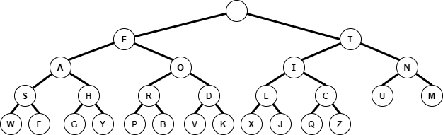
(a) Partner 1: Think of a new word
Partner 1: Wink with your left eye or right eye to indicate the direction on the binary tree that each letter is. If you cannot wink, then just say LEFT or RIGHT.
Partner 2: Work out what the word is that your partner is thinking.
For example – if your word is DOG, then you would wink the following:
LEFT, RIGHT, RIGHT; LEFT, RIGHT; LEFT, LEFT, RIGHT, LEFT.
The word chosen is:

(b) Now change over roles with your partner.
This time, use the same word that you used in Task 2, part (b) and (c).
Write down each wink/direction that is used in finding the letters.

Task 4
(a) Write down again the word that you chose for Task 2, part (b) and (c).
Chosen word:

(b) Each letter will require 8 bits to store it in ASCII on a computer.
How many bits does your word need to store it?

(c) One bit can store either a 0 or a 1. This can be used to represent LEFT or RIGHT.
How many bits are required to store the word?

