# Homework 5 IP addresses

1. A small business has an office with three employees. The network is designed as follows:

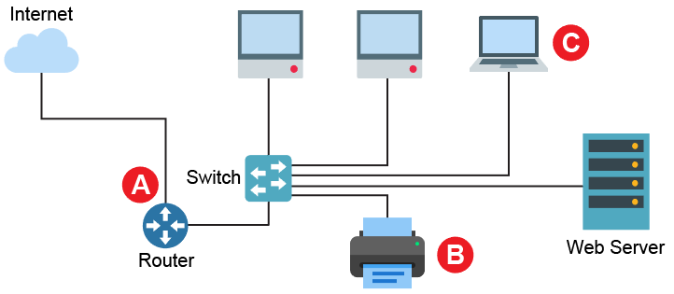

* 1. The network uses private IP addresses in the format 192.168.104.x.   
     Explain what sort of addresses these are. [2]
  2. The network has been given the external IP address: 83.48.154.43. Suggest suitable IP addresses to be used at points A, B and C as shown above. [3]

|  |  |
| --- | --- |
| **A** – The external port of the router |  |
| **B** – The network printer |  |
| **C** – The laptop |  |

* 1. The internal subnet mask on the network is 255.255.255.0. The server has an IP address of 192.168.104.8. Identify the network ID and the host ID of the server. [2]
  2. The company is expected to grow very quickly and could require IP addresses for almost 500 devices.

With reference to the maximum hosts available, explain why the current   
network will not be suitable. [1]

* 1. The external router has NAT and port forwarding facilities.

Explain how these features will be useful on the network as it is designed now. [4]

1. Dynamic Host Configuration Protocol (DHCP) is often used on a network to configure network hosts automatically.  
   1. Explain why a DHCP server can operate with a pool of IP addresses that has fewer addresses than the number of devices that may wish to access it. [2]
   2. Describe in detail the process that clients and a DHCP server use in order to   
      assign an IP address. [4]

[Total 18 Marks]