**Religious Studies A level**

**SIXTH FORM TRANSITION PROGRAMME**

**lesson 1**

INTRODUCTION;

Studying R.S A level opens doors.

It will challenge your thinking, the way you think, and how you think.

It will change your very vocabulary of thinking.

The way it does this is by opening doors to thinkers of past and present who have in their time and for their purpose challenged the status quo, looked at the world differently and tried to articulate this thinking in a readily accessible way for you and I.

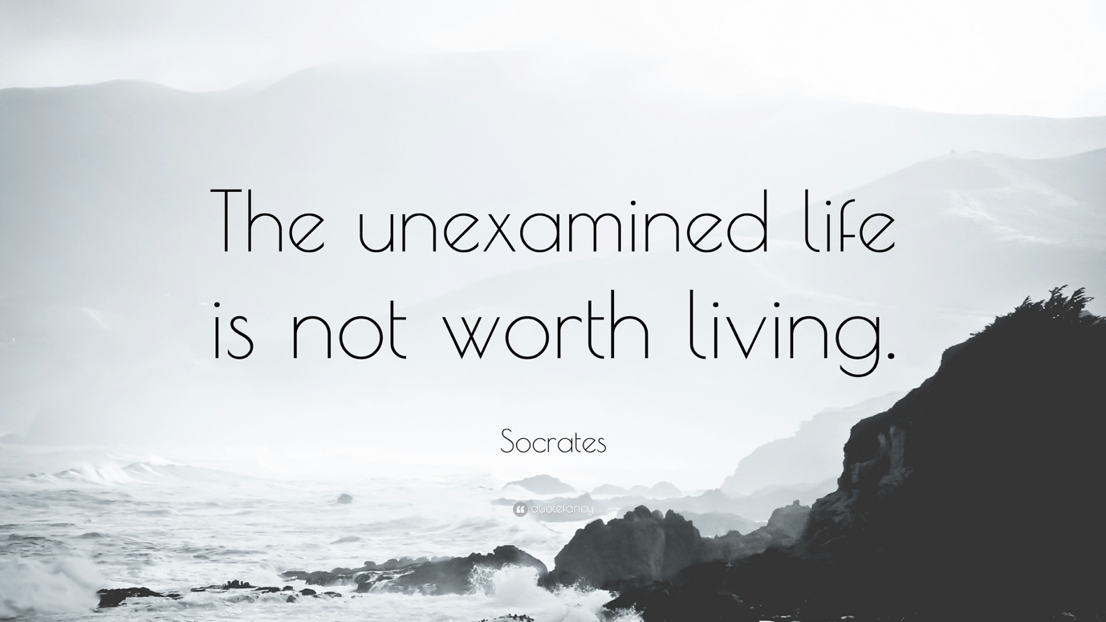

Sometimes we do reflect on life, on the world around us, on other people and what they do or don’t do, and wonder… what is the point of life, what is the meaning of life, what is the purpose of life….

Religious and philosophical reflection on these questions is what we look at in Religious Studies.

To these questions we will bring our own views and those of other key philosophers and thinkers.

In A level this is under three distinct sections: Philosophy, Ethics and Religious Thought.

You will find there is a lot of cross over between these three sections – and this is important for you to reflect on. However, for our transition programme, you will be reading, researching and reflecting on these three areas of thought.

You will need a paper and pen ready – or an open word doc to write your reflections and answers on as you move through these lessons. All tasks that you have to answer are highlighted yellow.

These questions are not new – we start thousands of years ago with the ancient Greek philosophers:

The School of Athens by Raphael 1514

This painting shows the two great Greek Philosophers Plato (c428-347BC) and Aristotle (384-322BC). Philosophy means ‘the love of wisdom’ from the Greek terms ‘philia’ for love and ‘sophia’ for wisdom.

The two key ancient thinkers of Classical Philosophy are in the centre.

Plato is on the left. His hand points to the heavens. He thought *real* truth was found outside of this world in the world of ideas.

Aristotle is on the right. His hand points to the earth, where we live and experience life. What does this say about his theories about the meaning and purpose of life?

Refection question: Who would you agree with more? Plato or Aristotle? Why?

**Basic Philosophy of Religion**

One of the big philosophical questions is … how do we know anything anyway? And if we do – how can we evaluate it?

Task: Complete this statement:

I know that my best friend is good because………………

What did we mean when we said they were *good*? Could we all agree on that?

When we start investigating philosophical questions we end up asking, how we can know anything with any *certainty*?

What are the different ways that the following pictures could be understood?

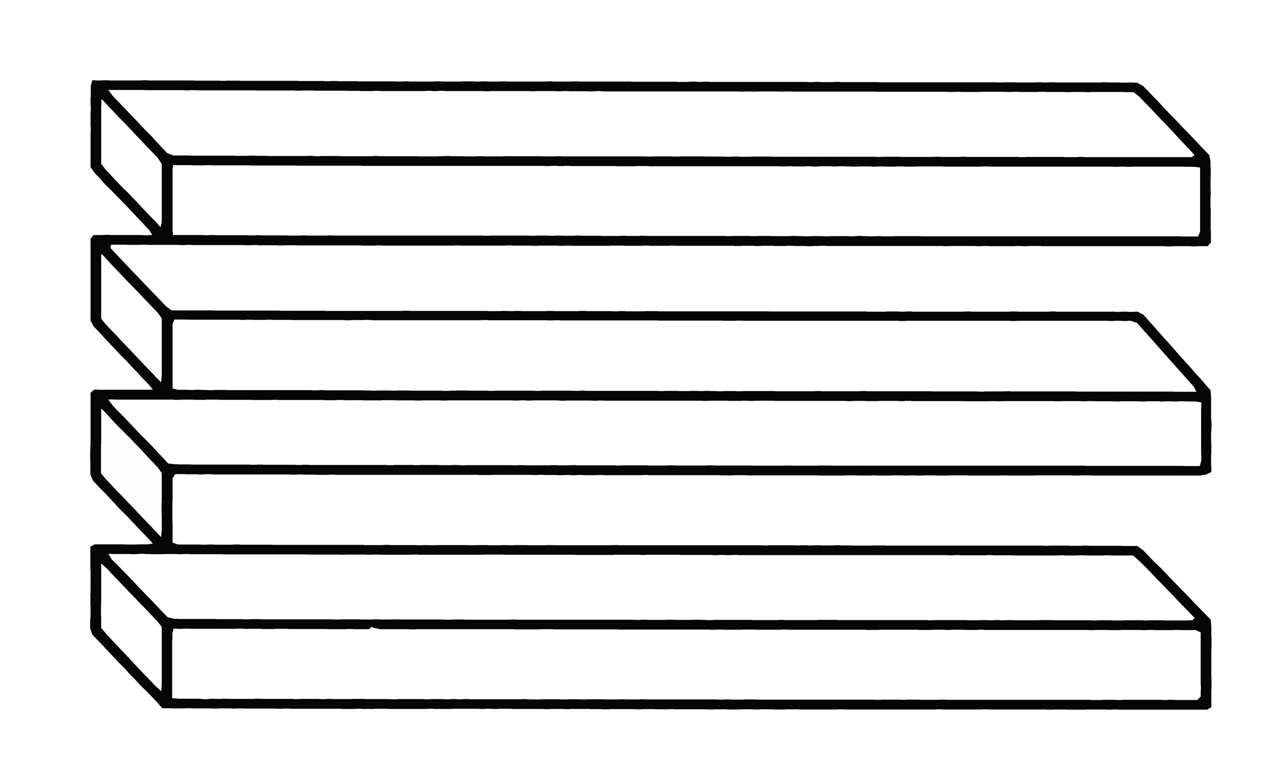

Square A and B are the same colour. Yes really they ARE the same colour. Prove it….

Other images are less difficult to see but they still hold important meaning or beliefs. What do you see in them?

Do these images reflect a pre-existing belief? Where might that belief come from?What beliefs are they?

Please write your comments and answers to the tasks on a word document and e mail it to me,