Name: Class: Mark:

1. The diagram shows a design for a recyclable coffee cup engineered from a   
biodegradable polymer.

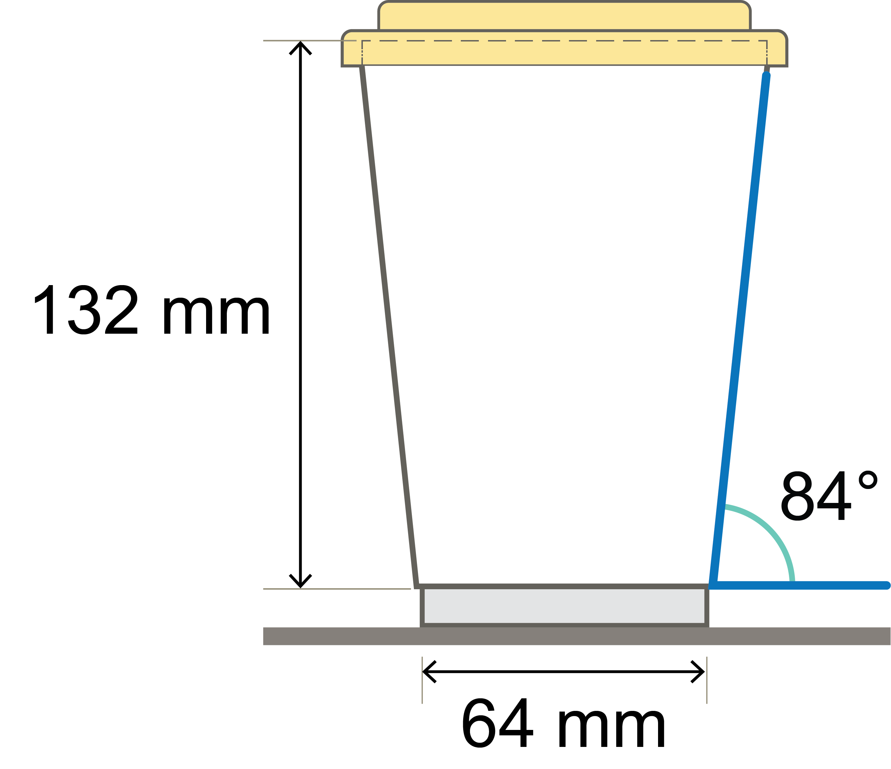

(a) Calculate the diameter of the top of the cup.

Give your answer to 1 decimal place.

Show your working. [3]

(b) A manufacturer wishes to engineer two sizes of coffee cup of exactly the same shape design, but one coffee cup is twice the height of the other.

They state that the taller coffee cup will hold twice the volume of coffee as the smaller variety.

State whether the manufacturer is correct. Give your reasons. [3]

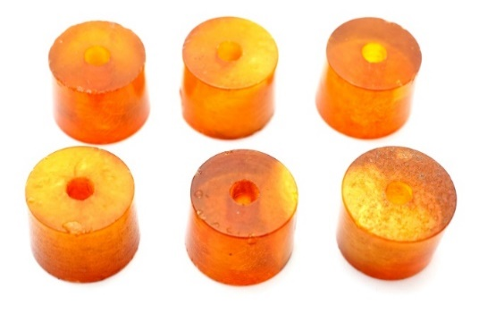2. These beads are made of pressed amber,   
a natural resin.

* The internal radius of the bead is 0.55 mm
* The external radius is 0.90 mm
* The height of the cylindrical bead, as shown,   
  is 12.5 mm

Calculate the **total** surface area of a bead, including the interior area provided by the central hole. Give your answer to 1 d.p. [4]

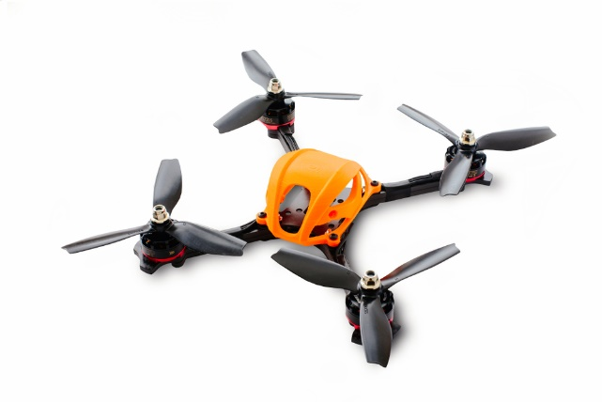3. This cabin for drone pictured has been 3D printed.

* The mass of the cabin shape is 12.8 g.
* The density of the polymer used for 3D printing it  
  is 1.19 g cm-3.
* The diameter of the 3D filament used is 3 mm.

(a) Calculate the volume of the polymer used to make the cabin.

Give your answer to 2 d.p. [2]

(b) Calculate the length of the 3D printer filament needed to print this design.

Give your answer to the nearest mm. Show your working. [3]

[Total marks 15]