**Purcell: Music for a While**

**Research prep**

Answer the following questions in full sentences.

1. What was the Restoration?
2. What nationality was Purcell, what are his dates and what musical period was he composing in?
3. What important development happened in 1672?
4. How was church music improved?
5. Why might Purcell never have achieved his true potential?
6. Which genre of music was lacking and neglected in London during the 17th century?
7. What was significant about the Theatre Royal?
8. What is a countertenor and what sort of range does it have?
9. Which voice range was favoured more by Handel (a later composer of the Baroque era)?
10. What year was ‘Music for a While’ composed in?
11. 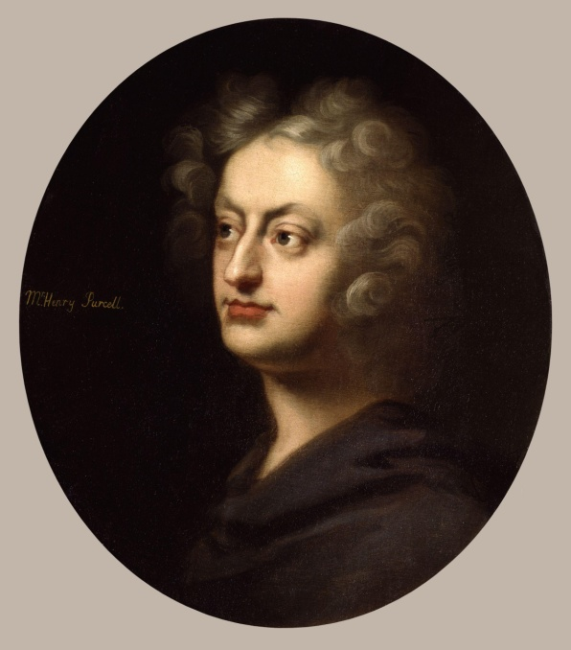Summarise the background to the song and the purpose of the song.

**Purcell: Music for a While**

Music for a while

Shall all your cares beguile.

Wond’ring how your pains were eas’d

And disdaining to be pleas’d

Till Alecto free the dead

From their eternal bands,

Till the snakes drop from her head,

And the whip from out her hands.

Music for a while

Shall all your cares beguile

**Listen to the piece and follow your score. What do you think the structure of this music is? Choose from one of the below:**

|  |  |  |
| --- | --- | --- |
| **Binary Form (AB)** | **Verse-Chorus** | **Ternary Form (ABA)** |

The piece is structured as a ............................................ in ....................................................................... form.

**Fill in the table below with the structure (in letters) and the bar numbers for each section of the piece.** Listen to the music and look at the lyrics for clues!

|  |  |
| --- | --- |
|  |  |
|  |  |
|  |  |
|  |  |

This form can also be considered ......................................................... due to the short repeat of

................................................. at the end.

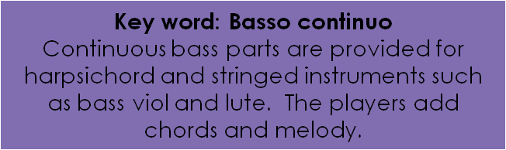**Purcell: Music for a While**

**Basso Continuo**

The accompaniment is known as the basso continuo, or continuo.

Task: Listen to Purcell’s *Music for a While*. Which instruments play the basso continuo part?

.................................................... , .......................................................... and ..................................................... .

* Ground bass, also known as basso ostinato, was used widely in both instrumental and vocal music in the Baroque era. It is a style in which the music is written above a repeating pattern of bass notes. In instrumental music, this often features a set of variations over this bass ‘ground’.
* In vocal music of the Baroque period the use of a ground bass was common.
* Purcell wrote several fine examples in Dido and Aeneas (1689) e.g. ‘Ah Belinda’ and ‘When I am laid in earth’.

Listen to Purcell’s grounds and list the musical features:

(Think about the musical elements whilst you are listening: Tempo, Harmony, Rhythm, Mood etc.)

* .............................................................................................................................................................................
* .............................................................................................................................................................................
* .............................................................................................................................................................................
* .............................................................................................................................................................................
* .............................................................................................................................................................................
* .............................................................................................................................................................................

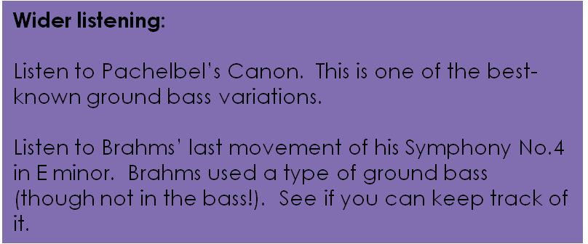

**Purcell: Music for a While**

**Analysis**

*Introduction (bars 1-3)*

1. Which instrument is playing the ground bass? What is doubling the same part?
2. Name the first chord.
3. Name the cadence at bar 34 to bar 41.
4. Name three characteristics of the **ground bass** in this section:
   * ........................................................................................
   * ........................................................................................
   * ........................................................................................
5. Overall is the ground bass **ascending** or **descending** in pitch?
6. Is the ground bass completely **diatonic**?
7. Name two **ornaments** in the RH part of the harpsichord.
8. Would the RH part of the harpsichord always have been played in exactly the same way?
9. Do you notice any **similarities** in the RH part of the harpsichord with that of the vocal melody?

**Purcell: Music for a While**

Analysis

Section A (bars 4-21)

1. What do you notice about the harpsichord part when the voice enters (compared with its part in the introduction)?
2. When the vocalist sings the word ‘music’, which note is used? To reinforce the word what then happens in bar 5?
3. Is the setting of the word music syllabic or melismatic?
4. Describe the dynamics used by the singer in the second statement of ‘music’.
5. Is the setting of the word ‘eternal’ syllabic or melismatic? Why do you think Purcell set this particular word in this way?
6. Can you spot any examples of imitation by the harpsichord of the vocal line?
7. The ground bass is 3 bars long, but the vocal phrases are not and stretch mostly over even bar lengths. Find an example on the first page of the score of the ground bass beginning in the middle of a vocal phrase.
8. Do the ground bass and vocal phrase finish at the same time at the very end of the piece?
9. Describe the word setting of “shall all” (bars 7-8).
10. Name the cadence at bar 94 – 101.

**Purcell: Music for a While**

Word - Painting

What do you think is meant by the term “word-painting” in relation to music?

How are the meanings of the following words emphasised through music?

1. ‘Wond’ring’ (bars 10-11)
2. ‘Pains’ (bar 123)
3. ‘Eas’d’ (bar 13-14)
4. ‘Pleas’d’ (bar 15)
5. ‘Eternity’ (bars 19-21)

Purcell: Music for a While

Analysis

Section B (bars 22-28)

1. What is the purpose of the short one bar break at bar 22-23?
   * ........................................................................................
   * ........................................................................................
2. Name the chord at bar 233. What is unusual about this? (think about the overall key of the piece)
3. On what beat of bar 23 does the ground bass start? Does it start at the same time as the vocal line?
4. The music and lyrics in the B section are persuading Alecto to drop the snakes from her head and the whip from her hand. How is the word ‘drops’ portrayed in the music?
5. Describe the device used at the cadence point at bars 27-28.

**Purcell: Music for a While**

Analysis

Section A1 (bars 29-38)

The shortened repeat uses the first two lines of text, “*Music for a while shall all your cares beguile*”. This forms a conclusion to and summary of the whole song.

1. How many statements of the ground bass can you hear in this section?
2. Is the vocal line the same as the first A section? Give some specific differences.
3. What does the symbol next to the harpsichord’s final chord mean? Why might the harpsichord play the chord in this way?
4. Name the final cadence and key.

**Purcell: Music for a While**

**Harmony & Tonality**

|  |  |
| --- | --- |
| **Introduction (1-3)** | A-minor |
| **Section A** | A-minor  E-minor  G-major  C-major |
| **Section B** | C-major  A-minor  E-minor  A-minor |
| **Section A1** | A-minor |

**Dynamics and tempo markings**

As was traditional practice in the Baroque era, these markings are not given in the score.

Clearly, however, the tempo is fairly slow and the music must start softly.

**Instrumentation**

Solo voice accompanied by harpsichord, lute and bass viol.

Our recording sounds a semitone lower than the written pitch of A minor, as it was made using Baroque instruments tuned to Baroque pitch.

**Purcell: Music for a While**

*Summary*

Music for a While is a song which first accompanies a priest trying to raise the ghost of King Laius. Later the song attempts to ‘beguile’ the Fury Alecto into forgetting her mission.

The song is a **lament** and is influenced by the Italian **da capo aria** style.

It is written for **solo voice** (soprano in this recording) and **basso continuo** which consists of a **harpsichord**, **lute** and **bass viol**. Purcell would not have written out the keyboard part in its entirety. The copy you are using is a **transcription**. Instead he would have written **figured bass** to tell the keyboard player which chords to use.

The structure uses a **ground bass** (basso ostinato) which is **3**-bars long. It is in **ternary form (ABA)** with the third section shortened. The main keys are **A minor** for both A sections and **C major** for Section B.

Common harmonic progressions such as **Ic-V-I** are used frequently at cadence points. There are a few **modulations** away from A minor and C major. There is use of **dissonance**, **suspensions** and **tierce de Picardie**.

Purcell uses many examples of **word-painting** such as dissonance, along with **melismatic** and **syllabic** word-setting.

**Ornamentation**, common in the Baroque era, is used frequently. For example, **mordents**, **appoggiaturas**, **grace notes** and **arpeggiation** are all used.

**Purcell: Music for a While**

*Summary*

Music for a While is a song which first accompanies a priest trying to raise the ghost of King Laius. Later the song attempts to ‘beguile’ the Fury Alecto into forgetting her mission.

The song is a ..................................... and is influenced by the Italian ..................................... style.

It is written for ..................................... (soprano in this recording) and ..................................................................... which

consists of a ....................................., ..................................... and ...................................... Purcell would not have written

out the keyboard part in its entirety. The copy you are using is a ...................................... Instead he would have written

................................................................... to tell the keyboard player which chords to use.

The structure uses a ..................................... (basso ostinato) which is **3**-bars long. It is in .................................................

with the third section shortened. The main keys are ..................................... for both A sections and

..................................... for Section B.

Common harmonic progressions such as ..................................... are used frequently at cadence points. There are a few

.............................................. away from A minor and C major. There is use of .....................................,

......................................................... and ....................................................................................... .

Purcell uses many examples of ........................................................................ such as dissonance, along with

..................................... and ..................................... word-setting.

........................................................................, common in the Baroque era, is used frequently. For example

...................................................., ............................................................... and .................................................... are all

used.

|  |  |  |  |
| --- | --- | --- | --- |
| **basso continuo** | **da capo aria** | **lute** | **Harpsichord** |
| **ground bass** | **A minor** | **transcription** | **C major** |
| **appoggiaturas** | **word-painting** | **grace notes** | **Syllabic** |
| **suspensions** | **tierce de Picardie** | **mordents** | **Ornamentation** |
| **Ic-V-I** | **lament** | **ternary form (ABA)** | **Dissonance** |
| **figured bass** | **modulations** | **solo voice** | **bass viol** |
| **melismatic** | **arpeggiation** |  | |