# Worksheet 1 Internal computer architecture

# Task 1 Input – process - output

Complete the diagrams below outlining the basic operations of various computer systems

1. Writing a story using a word processing package [2]

Input

Process

Output

Process

Input

Process

Input

Process

Input

Keyboard presses

1. Showing the position of a car on a Sat Nav [2]

Output

Coordinates matched to place on map

1. Taking a photo on a Smartphone [2]

Output

Image displayed

1. Paying for a car park ticket in an automated machine [3]

Output

**Task 2 System buses**

Data within a computer is moved around its various components using a series of interconnections known as system buses.

Complete the diagram below to label the following parts showing the direction in which addresses travel: [3]

**Processor, Data bus, Address bus, Main memory, I/O controller**

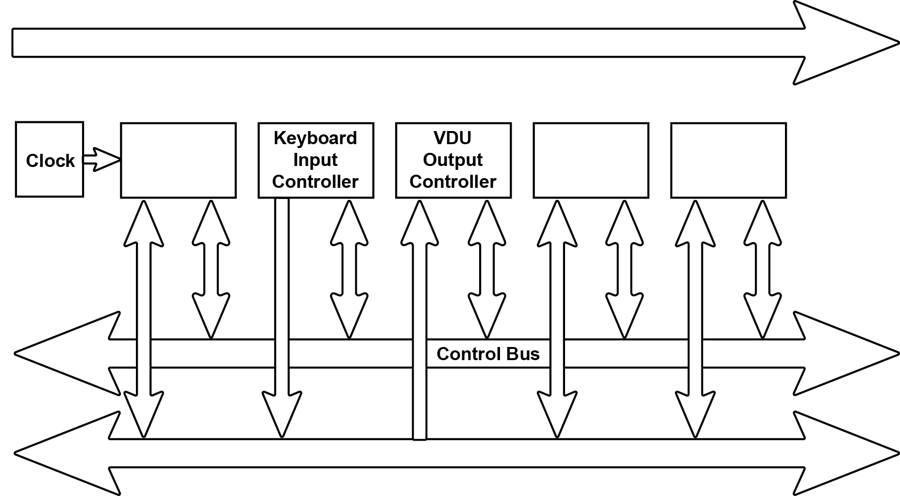

**Task 3 Word length**

Memory is divided into equal units called **words**. Each word has a separate memory address.

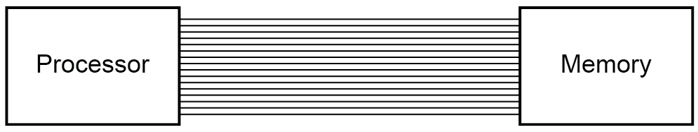

A processor uses a word length of 16 bits and has an address bus of 16 lines.

a) What is the maximum number of addressable words in memory? [1]

b) What is the overall memory capacity KiB? [1]

c) How does the width of the address bus affect system performance? [2]

d) How does the width of the data bus affect system performance? [2]

**Task 4 Memory and the stored program concept**

Using standard von Neumann architecture, instructions and data both share the same memory space.

|  |  |
| --- | --- |
| **Memory** | |
| **Address** | **Instruction / Data** |
| 0 | 10010111 00101111 |
| 1 |  |
| 2 | 00000000 11010100 |
| … | … |
| 255 | 00000000 01001010 |

One problem with this model is that the CPU can either be reading an instruction or reading/writing data to or from memory, but not both at the same time since instructions and data use the same bus system, which is a performance limitation.

1. Name another architecture that resolves this issue. How does it differ from von Neumann architecture? [2]
2. What other advantages are there of using this architecture? [2]