**Homework 2: Sequencing**

1. (a) A set of Christmas tree lights consists of three separate strings of lights wound together.

The lights on each string turn on for one second and then off for two seconds.   
Only one set of lights is lit at a time.

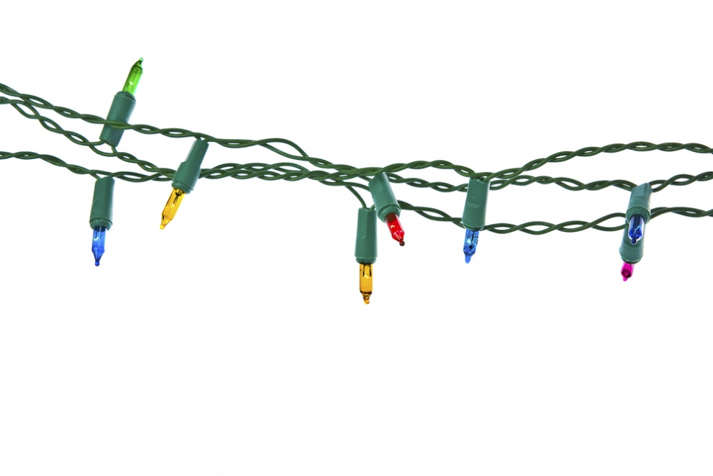

Complete the table below.

**Table 1: Christmas light sequence with delays**

|  |
| --- |
| **Set 1 ON** |
| **DELAY** for **1 second** |
|  |
|  |
|  |
|  |
|  |

[5 marks]

(b) Draw a flowchart representing this sequence. [5 marks]

[Total 10 marks]