Activity: Moves like Jim

Introduction
Open the Moves like Jim Scratch program (ncce.io/moveJim) and complete the tasks below.

You are to work through the tasks independently, but use your problem-solving skills to help you if you are struggling:

- Carefully read over the instructions again. Stop and think through the problem.
- Read the support tips and look at your work from previous lessons/tasks
- Ask your classmate to prompt you (not to do it for you)

Tasks | Your solution (take a screenshot of the block of code you have created or modified)▿
Task 1:
Complete the subroutine ‘move1’ so that you tell Jim what dance move to do if the user presses the correct key in time.

Support: Look at the available costumes to pick a dance move.



Task 2:

The ‘move2’ subroutine needs to be completed. Most (but not all) of the blocks to make this subroutine have been provided for you.

- ‘Move2’ requires both the q and w keys to be pressed for a successful move
- You must decide upon what the successful move is
- You must switch to costume ‘Jim-c’ if the user fails to press q and w in time
- The costume should be switched to ‘Jim-b’ at the end of the subroutine

Support: Look at the structure of the ‘move1’ subroutine to help you.

Task 3:
The subroutine gives a five second countdown before saying “dance” and the game starts.
Modify this subroutine to include count-controlled iteration.
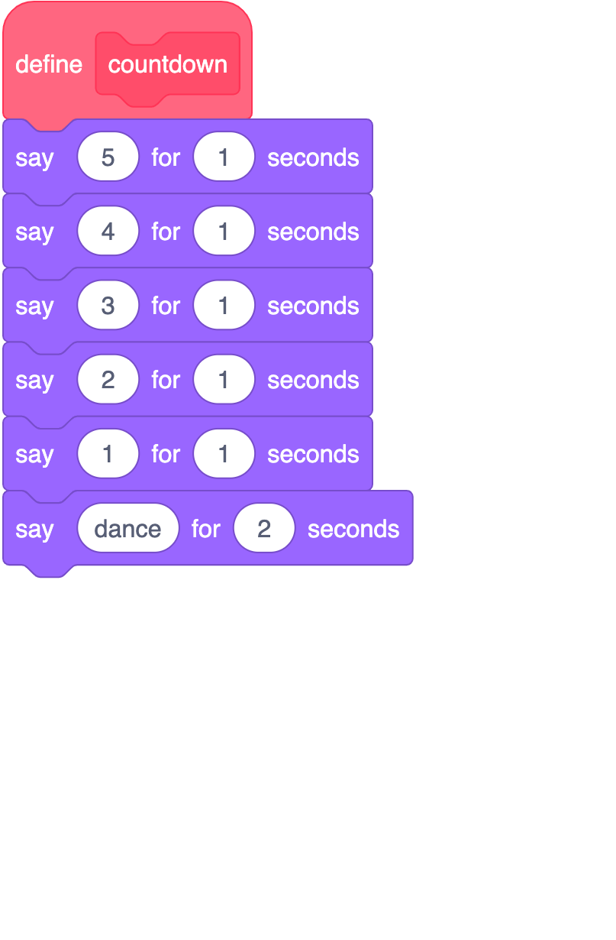
Support: ‘Counting cat’ or ‘Ten green bottles’ from lesson five.
Task 4:

The ‘move3’ subroutine needs to be built by you. It must meet the following criteria:

- Keys 1 or 9 must be pressed for a successful dance move to be executed
- This time, a successful dance move will be Jim switching between costumes ‘Jim-d’ and ‘Jim-e’ five times, waiting 0.3 seconds before swapping costumes
- You must switch to costume ‘Jim-c’ if the user fails to press 1 or 9 in time
- The costume should be switched to ‘Jim-b’ at the end of the subroutine

Explorer tasks

Task 5:

Use the score variable to add 1 to the score if the user has successfully completed each subroutine.

Take a screenshot of where you have increased the score for the ‘move3’ subroutine.

Task 6:

Complete the ‘feedback’ subroutine. It must meet the following criteria:

- If the score is greater than two, a well done message should be displayed for two seconds
- If the score isn’t greater than two, the following message should be displayed for two seconds: “Better luck next time”
- You can pick a costume to change, depending on the message

You should make sure that the subroutine is called after all the ‘move’ subroutines.

Task 7:

Use the space below to design your own dance-move subroutine algorithm.

Resources are updated regularly — the latest version is available at: ncce.io/tcc. This resource is licensed under the Open Government Licence, version 3. For more information on this licence, see ncce.io/ogl.

