# Representing sound

**Task 1 Classifying signals**

Below are examples of where signals are used. Identify how the signal would be transmitted/realised and whether it would be as an analogue or digital signal (Some boxes will be left blank):

|  |  |  |
| --- | --- | --- |
| Signal | Analogue | Digital |
| A radio station broadcasting on the AM frequency |  |  |
| A laptop connecting to the Internet through a fibre-optic connection |  |  |
| The speed a car is travelling for display on a speedometer with a needle |  |  |
| The temperature of an oven to be displayed on an LED display |  |  |
| The HDMI output of a computer’s graphics card |  |  |
| Pictures from a video camera transmitted to a studio via a microwave transmitter |  |  |
| A WiFi router sending a print job to a wireless printer |  |  |

# Task 2 Sampling sound

1. The following two sound samples have been recorded using different resolutions. The first was recorded at a resolution of 2 bits giving four possible wave heights. The second sample was recorded at 4 bits per sample giving 16 possible combinations.

Plot the sample points on each chart that were recorded for the samples and join them up using only horizontal and vertical lines to create a digital representation of the recording. The first three have been done for you.

**Recording A Recording B**

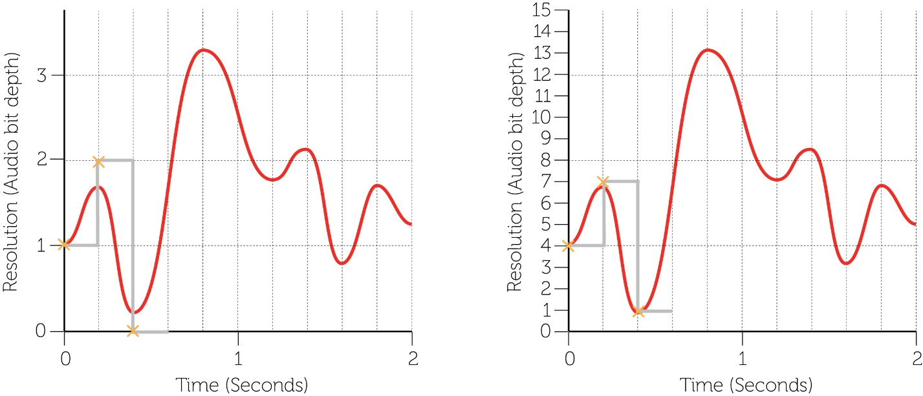

1. How do the two ‘digitised’ recordings compare? Which has greater accuracy and why?
2. What is the file size of recording A in bits?
3. What is the file size of recording B in bits?
4. Each sample point in Recoding A could be recorded as 0, 1, 2 or 3. To be represented on a disk, the sample points need to be translated into binary. Translate each of the points into their binary representation that would be stored in an audio file.

|  |  |  |  |  |  |  |  |  |  |  |
| --- | --- | --- | --- | --- | --- | --- | --- | --- | --- | --- |
| **Sample** | **0** | **1** | **2** | **3** | **4** | **5** | **6** | **7** | **8** | **9** |
| **Value** | 1 | 2 | 0 | 2 | 3 | 3 | 2 | 2 | 1 | 2 |
| **Binary data value** | 01 | 10 |  |  |  |  |  |  |  |  |

# Task 3 Nyquist sampling

1. A sound recording of frequency f is being sampled at different rates. Show the waveform of the sound that will be reproduced from the following sampling rates and explain how close the sound will be to the original, identifying any issue with the digital pattern produced:

The first example has been done for you.

|  |  |  |  |
| --- | --- | --- | --- |
| **Sampling frequency** | **Waveform after sampling** | **How close is it to the original?** | **Issues with digital pattern** |
| ***f*** | C:\Users\Rob\Dropbox\PG Online\A Level Series\AQA A Level series\AS AQA Units Incomplete\Unit 3 Data representation - Davison\NyquistWorksheet5.jpg | Not at all similar. | No sound will be reproduced as the cone of the speaker will not move. |
| **3*f*/2** | C:\Users\Rob\Dropbox\PG Online\A Level Series\AQA A Level series\AS AQA Units Incomplete\Unit 3 Data representation - Davison\NyquistWorksheet5.jpg |  |  |
| **5*f*/2** | C:\Users\Rob\Dropbox\PG Online\A Level Series\AQA A Level series\AS AQA Units Incomplete\Unit 3 Data representation - Davison\NyquistWorksheet5.jpg |  |  |
| **5*f*** | C:\Users\Rob\Dropbox\PG Online\A Level Series\AQA A Level series\AS AQA Units Incomplete\Unit 3 Data representation - Davison\NyquistWorksheet5.jpg |  |  |

1. State the principle of Nyquist’s theorem: