Name: Class:

Task 1

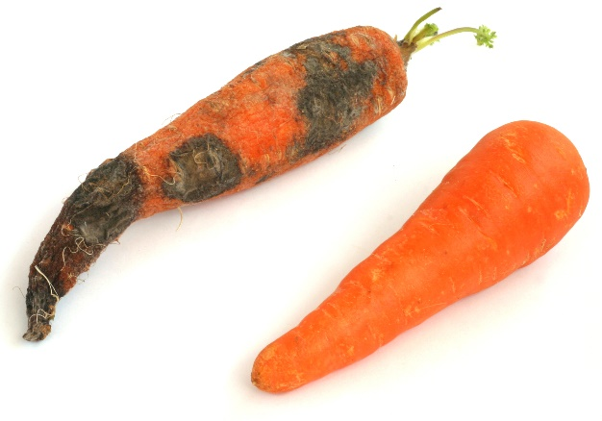**Safe vegetables**

An AI program is being developed which will classify unwrapped vegetables in a fridge as safe to eat, or not safe.

The following sensors will be available in the fridge:

* Camera
* Thermometer
* Pressure probe
* Electronic nose

Write down at least five rules to determine if each vegetable is safe to eat or not safe. The first rules has been completed for you.

|  |  |  |
| --- | --- | --- |
| **It uses these rules:** | | **Sensor** |
| 1 | Should be firm to the touch and not squashy | Pressure probe |
| 2 |  |  |
| 3 |  |  |
| 4 |  |  |
| 5 |  |  |
| 6 |  |  |
| 7 |  |  |
| 8 |  |  |

Task 2

You have built a robot which can move forward, backwards, and make turns. It has three sensors, which can detect the following:

* Is there a wall in front of the robot?
* Is there a wall to the left of the robot?
* Is there a wall to the right of the robot?

(a) Draw a line on the maze below to solve it.

(b) Write some rules which will help the robot navigate from the entrance of the maze on the top left to the exit on the bottom right.

|  |  |
| --- | --- |
| Rules for solving a maze | |
| 1 |  |
| 2 |  |
| 3 |  |
| 4 |  |

(c) Label the maze to show where your rules have been used.

(d) Swap your rules with a partner and see if they can solve your maze using the rules.

Task 3

Look at the two images below. The image on the left is taken from a camera in a self-driving car. The image on the right shows that the AI in the car has classified an object crossing the road as a person. The AI is 95% certain that this is a pedestrian. It gives a 5% chance that it is something else, such as a bin liner.

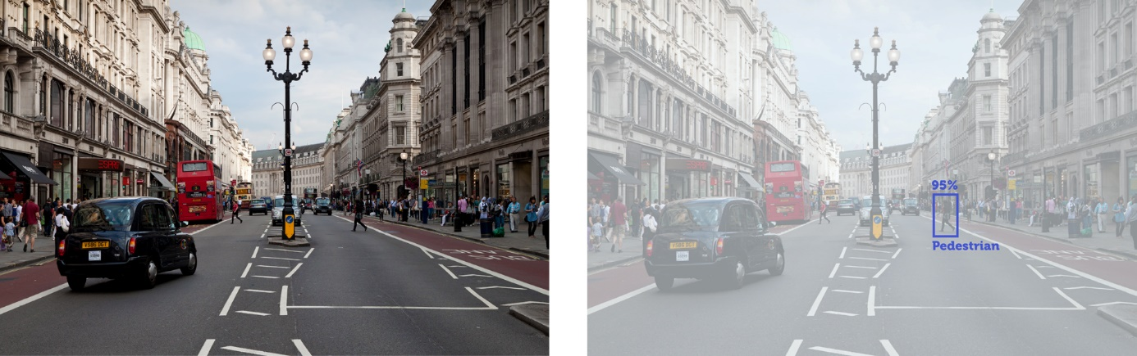

|  |  |  |
| --- | --- | --- |
| **View from camera** |  | **Classify objects** |

(a) Draw a box around at least another five hazards in the photo.

(b) Classify each of the hazards.

(c) Write a percentage for how certain you are that your classification is correct.