Name: Class:

Task 1

Look at the maze below. Work with a partner to do this activity.

|  |  |
| --- | --- |
|  | **Available instructions:**  **Right Left Up Down  REPEAT *number*** |

(a) Write the instructions that will move the monster to the maze’s exit. Use only the instructions given above. One person in your pair should write the instructions, whilst the other person checks what you have written. The first three instructions have been written for you.

Do **not use** REPEAT at this stage.

|  |  |  |  |
| --- | --- | --- | --- |
| Down Down Right |  |  |  |

(b) How many instructions did you use in part (a)?

(c) Now rewrite your instructions using REPEAT *number*. Your target is to use fewer than 25 instructions (this includes REPEAT as 1 instruction). Work in pairs for this task.

|  |  |  |  |
| --- | --- | --- | --- |
|  |  |  |  |

(d) How many instructions did you use?

Task 2

|  |  |
| --- | --- |
|  | **Available instructions:**  **Right Left Up Down  REPEAT *number*** |

(a) Write the instructions that will move the monster to the maze’s exit. Use only the instructions given above. One person in your pair should write the instructions, whilst the other person checks what you have written. Make use of REPEAT statements and nested loops. Your target is to use fewer than 15 instructions.

|  |  |  |
| --- | --- | --- |
|  |  |  |

(b) How many instructions did you use?

Task 3 – Computer version

Look at the table layout.

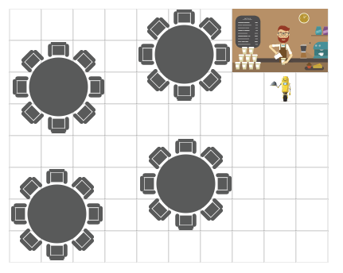

(a) Open Scratch 3, or go to: <https://scratch.mit.edu/projects/editor/>

(b) Load the file “Four tables – Student version.sb3

(c) Make the robot waiter take food to all four tables.

* The robot needs to visit each of the tables in turn
* To visit a table, the robot needs to go to a square where a chair is located
* The robot needs to return back to the chef at the end
* The robot should keep repeating this algorithm forever
* Aim to have as few instructions as possible by using a repeat block. Your target is to use fewer than 15 red movement blocks.
* Other than the blocks given when you open the program, only use the following blocks:

|  |  |  |  |
| --- | --- | --- | --- |
|  |  |  |  |
|  |  |  |  |

(d) How many red movement blocks did you use? (The target is fewer than 15).

(e) **Extension** – Unhide the sprite named “Table 5”. Update your algorithm to go to this table also.



Task 3 – Paper version

Look at the table layout.

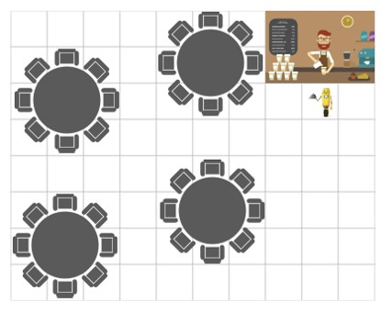

(a) Draw a line on the table layout to show where the robot should go.

(b) Write instructions to make the robot visit all the tables. Use REPEAT wherever possible.

(c) Make the robot waiter take food to all four tables.

* The robot needs to visit each of the tables in turn
* To visit a table, the robot needs to go to a square where a chair is located
* The robot needs to return back to the chef at the end
* The robot should keep repeating this algorithm forever
* Aim to have as few instructions as possible by using REPEAT statements. Your target is fewer than 20 instructions, including REPEAT statements.
* Use only the following instructions:

|  |  |  |  |
| --- | --- | --- | --- |
| **Down** | **Up** | **Left** | **Right** |
| **REPEAT *number*** | **REPEAT FOREVER** |  |  |

*Please use the following table to write out your program.*

|  |  |  |
| --- | --- | --- |
|  |  |  |

(d) How many instructions did you use? (The target is fewer than 20 instructions).

Task 4 – Computer version

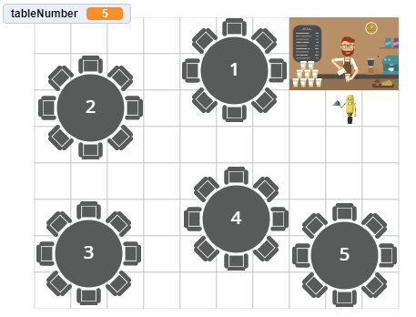

Look at the new table layout.

(a) Load the file “Table numbers – Student version.sb3

(b) Make the robot waiter take food to the tables once it is ready.

* The skeleton of the program has been given
* The robot asks which table the food is for; you then enter which table to go to
* Use IF statements to direct the robot to the table
* Five new blocks have been defined – table1, table2, table3, table4 and table5
* Complete the block for table1 and test it
* Now complete the IF statements in the main program so that it calls the other table blocks
* Complete each of the table blocks to make the robot travel to the correct table
* Other than the blocks that have been given, only use the following blocks:

|  |  |  |  |
| --- | --- | --- | --- |
|  |  |  |  |
|  |  |  |  |
|  |  |  |  |

Task 4 – Paper version

Look at the new table layout.

1. Load the file “Table numbers – Student version.sb3
2. Draw lines to show how the waiter will take the food to the tables depending on which table is required.

(c) Write an algorithm that will take the food to the correct table.

* The algorithm should use an IF statement that looks at the tableNumber given by the waiter
* Use only the instructions given below
* The first few instructions have been completed for you

|  |  |  |  |
| --- | --- | --- | --- |
| **Down** | **Up** | **Left** | **Right** |
| **REPEAT *number*** | **REPEAT FOREVER** | **INPUT tableNumber** | **IF tableNumber = *number* THEN** |

*Please use the following table to write out your program.*

|  |  |  |
| --- | --- | --- |
|  |  |  |