**Lesson 7** **and 8** Two lessons worth!

Can we / should we prove that God exists?

Here are some extracts from five thinkers about the big question:

**Your task** is to read and understand each one and decide which has a strong or weak arguments. You will then have an opportunity to reflect on your own view.

1)**Richard Dawkins.**

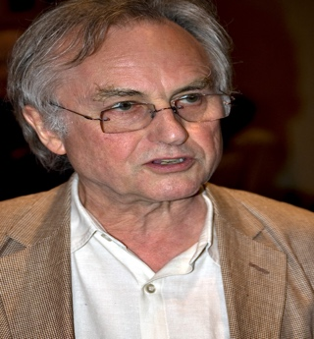

[This Photo](http://rationallyspeaking.blogspot.com/2011/12/jerry-coyne-loses-his-cool-dawkins-his.html) by Unknown Author is licensed under [CC BY-NC](https://creativecommons.org/licenses/by-nc/3.0/)

‘Much of what people do is done in the name of God. Irishmen blow each other up in his name. Arabs blow themselves up in his name. Imams and ayatollahs oppress women in his name. Celibate popes and priests mess up people’s sex lives in his name. Jewish s*hohets* cut live animals throats in his name, The achievements of religion in past history --- bloody crusades, torturing inquisitions, mass-murdering conquistadors, culture-destroying missionaries, legally enforced resistance to each new piece of scientific truth until the last possible moment—are even more impressive. And what has it all been in aid of? I believe it is becoming increasingly clear that the answer is absolutely nothing at all.

There is no reason for believing that any sort of gods exist and quite a good reason for believing that they do not exist and never have. It has all been a gigantic waste of time and a waste of life. It would be a joke of cosmic proportions if it weren’t so tragic.’

2)**Bertrand Russell, Philosopher, (1872-1970)**



‘When I come to my own beliefs, I find myself quite unable to discern any purpose in the universe, and still more unable to wish to discern one. Those who imagine that the course of cosmic evolution is slowly leading up to some consummation pleasing to the Creator, are logically committed (though the usually fail to realize this) to the view that the Creator is not omnipotent or, if He were omnipotent, He could decree the end without troubling about the means…I do not mean to assert with any positiveness that this is the case. That would be to assume more knowledge than we possess. I can only say that it is what is probable on present evidence.

I will not assert dogmatically that there is no cosmic purpose, but I will say that there is no shred of evidence in favour of there being one.

3)**Alister Macgrath.**



Spiritually, God is the oxygen of my existence: I would find it very difficult to thrive without a belief in God. Of course, the word ‘God’ needs some clarification. It means different things to different people, even though there are often clear areas of overlap. To clarify: I believe in the God who is made known and made available through Jesus-that-is , a personal God who I believe knows me as an individual, cares for me, and enables and inspires me to live my life with a firm sense of purpose and a deep satisfaction in the service of others.

I haven’t always seen things this way. When I was growing up… I came to the view that God was an infantile illusion… It was the received wisdom of the day that religion was on its way out, and that a glorious Godless dawn was just around the corner… until I arrived in Oxford in October 1971.

Atheism I began to realise, rested on a less-than-satisfactory evidential basis. The opportunity to talk with Christians about their faith revealed to me that I understood little about their religion… I also began to realize that my assumption of the automatic link between the natural sciences and atheism was rather naïve and unformed.

I see the natural sciences from a Christian perspective.

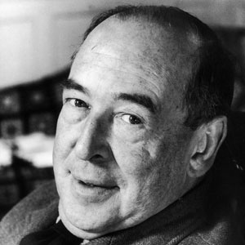

[This Photo](http://www.christiansincontext.com/2010/05/saturdays-with-c-s-lewis-some-pleasant.html) by Unknown Author is licensed under [CC BY-ND](https://creativecommons.org/licenses/by-nd/3.0/)

4) **C.S.Lewis (1898-1963)**

My argument against God was that the universe seemed so cruel and unjust.

But how has I got this idea of just and unjust? A man does not call a line crooked unless he has some idea of a straight line. What was I comparing this universe with when I called it unjust? What was I comparing this universe with when I called it unjust? If the whole show was bad and senseless from A to Z, so to speak, whu did I, who was supposed to be part of the show, find myself in such violent reaction against it?

Of course I could have given up my idea of justice by saying that it was nothing but a private idea of my own. But if I did that, then my argument against God collapsed too – for the argument depended on saying that the world was really unjust, not simply that it did not happen to please my private fancies. Thus in the very act of trying to prove that God didn’t exist – in other words that the whole of reality was senseless – I found I was forced to assume that one part of reality – namely my idea of justice – was full of sense. Consequently atheism turns out to be too simple. If the whole universe has no meaning, we should never have found out that it has no meaning; just as, if there were no light in the universe and therefore no creatures with eyes, we should never know it was dark. Dark would be without meaning.

5)**Bill Schultz**



[This Photo](https://en.wikipedia.org/wiki/Bobby_Orr) by Unknown Author is licensed under [CC BY-SA](https://creativecommons.org/licenses/by-sa/3.0/)

There has been a trend among some strong atheists to savagely attack any who declare themselves to be agnostics. The usual mode of attack is to bifurcate the decision, claiming that if you fail to assert that God exists (and to thereby become a theist) the only other option available is to declare that you lack a belief in any God or gods, and that this is one of the accepted definitions for atheism. I have long opposed such people…

If no knowledge of what is true or not true can reach the senses of the observer, then the observer cannot draw any inference at all.

Accordingly, agnosticism is not only a valid choice for those of us who see insufficient evidence to decide the matter as to the truth or falsity of some particular God concept, Agnosticism is, in fact, the only valid choice…

***This work must be at least 1 ½ to 2 sides of A 4***

1. Having read and discussed these extracts with someone else, which of these thinkers do you feel makes the best case for their position? Why?
2. Explain the different beliefs of a theist, an atheist and an agnostic.
3. What is your view? (it’s fine to say that you don’t know, so long as you give reasons for your answer.)